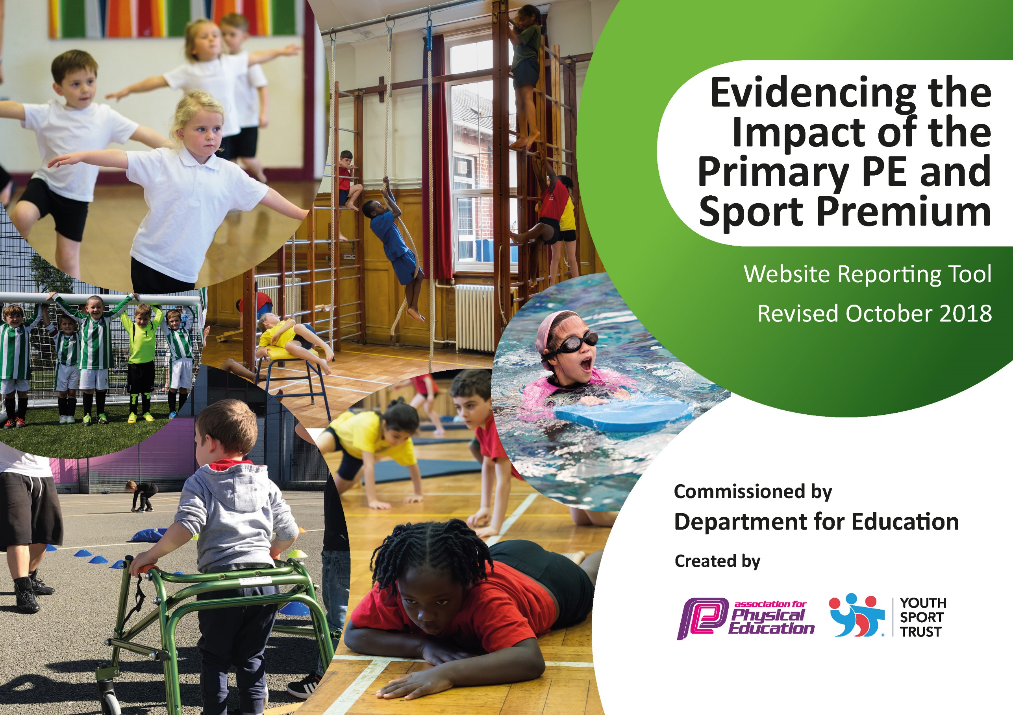
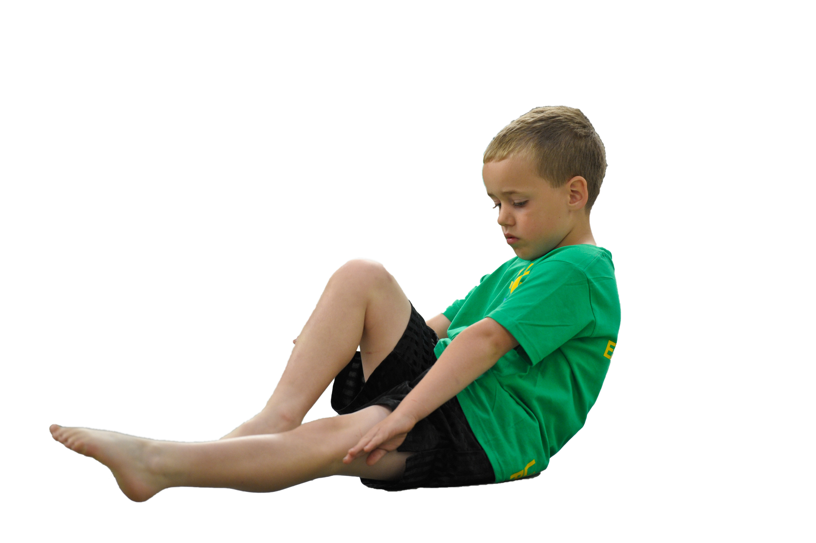
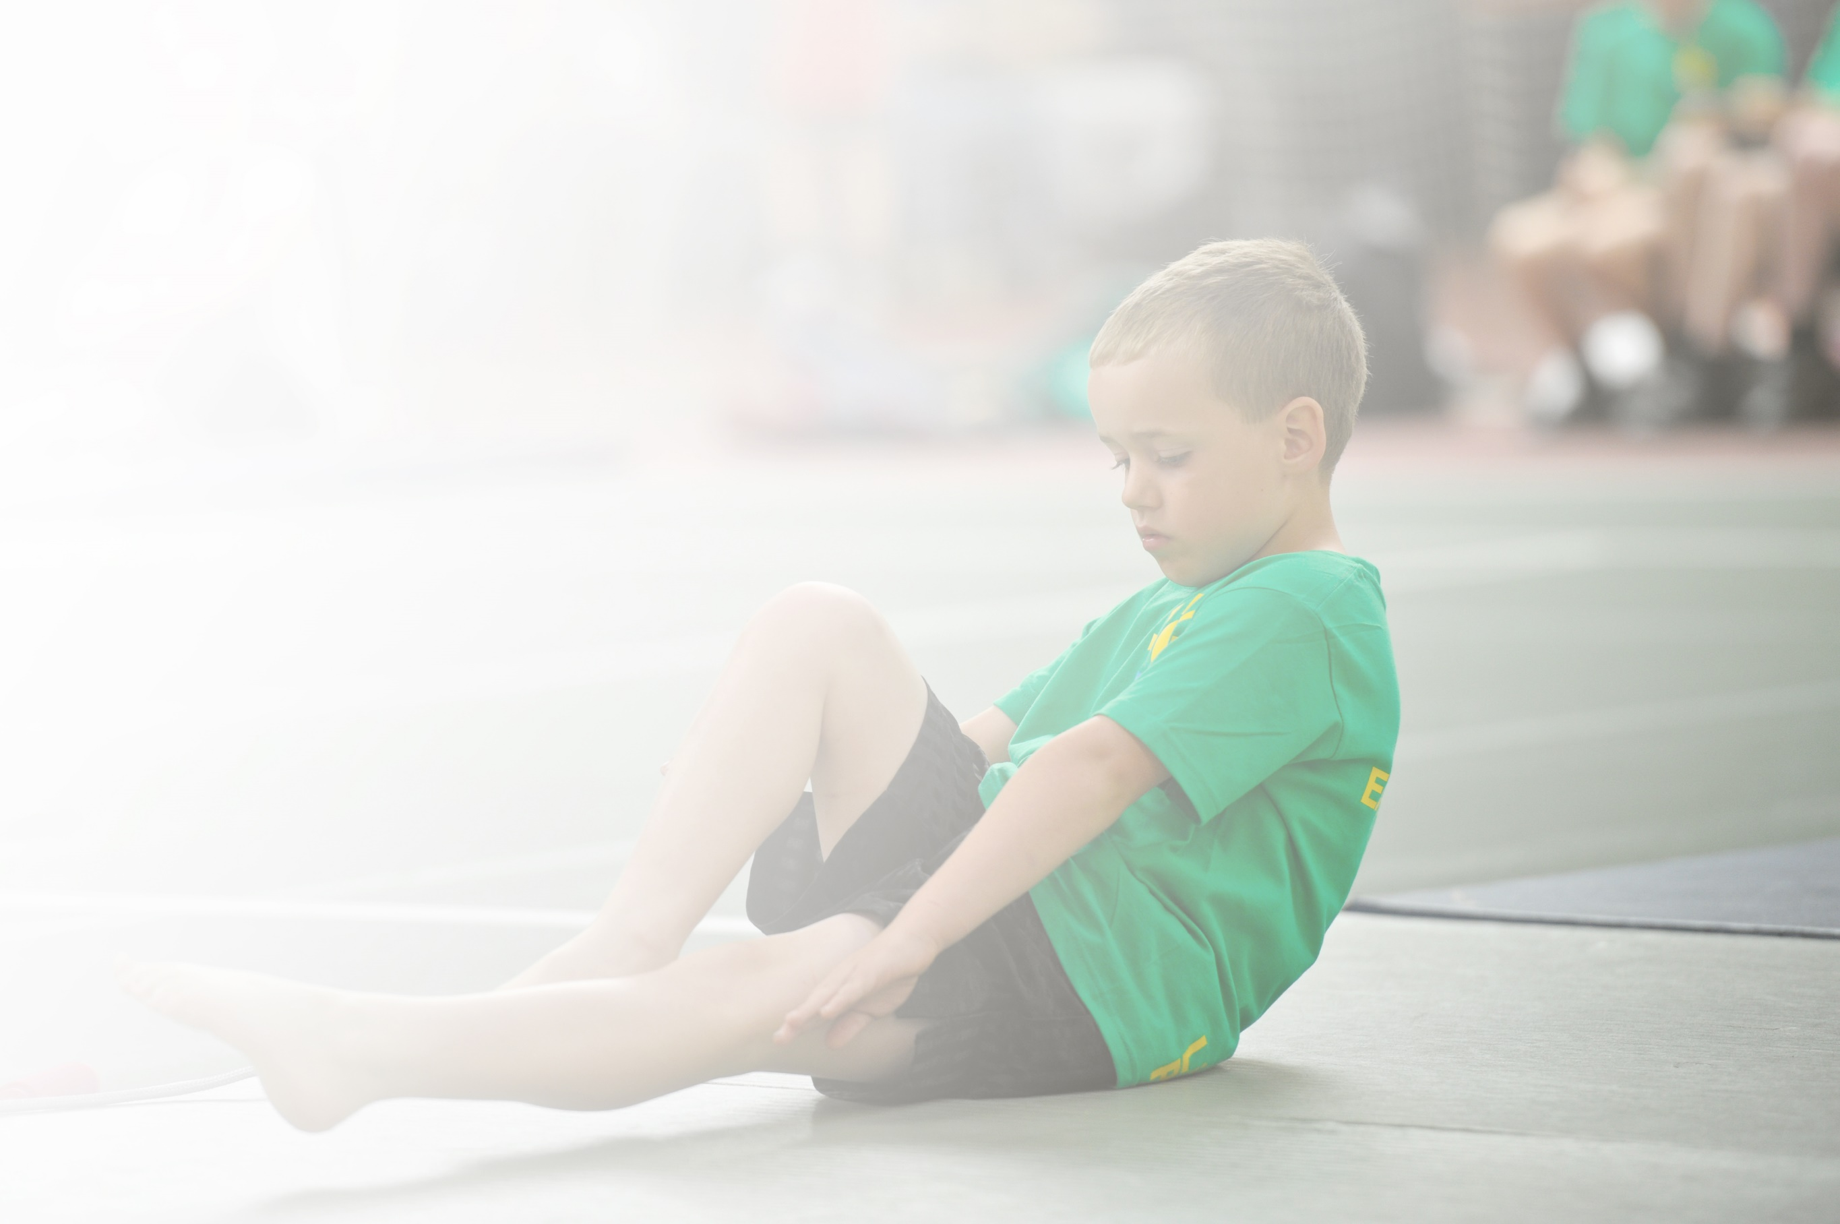
Schools must use the funding to make additional and sustainable improvements to the quality of Physical Education, Sport and Physical Activity (PESPA) they offer. This means that you should use the Primary PE and Sport Premium to:

- Develop or add to the PESPA activities that your school already offer
- Build capacity and capability within the school to ensure that improvements made now will benefit pupils joining the school in future years

Please visit gov.uk for the revised DfE guidance including the 5 key indicators across which schools should demonstrate an improvement. This document will help you to review your provision and to report
your spend. DfE encourages schools to use this template as an effective way of meeting the reporting requirements of the Primary PE and Sport Premium.

We recommend you start by reflecting on the impact of current provision and reviewing the previous
spend. Under the Ofsted Schools Inspection Framework, inspectors will assess how effectively leaders use the Primary PE and Sport Premium and measure its impact on outcomes for pupils, and how effectively governors hold them to account for this.

Schools are required to publish details of how they spend this funding as well as on the impact it has on pupils’ PE and sport participation and attainment by the end of the summer term or by 31 July 2019 at the
latest.
We recommend regularly updating the table and publishing it
on your website throughout the year, as evidence of your
ongoing review into how you are using the money to
secure maximum, sustainable impact. To see an
example of how to complete the table please
click HERE.

Support for review and reflection - considering the 5 key indicators from DfE, what development needs are a priority for your setting and your students now and why? Use the space below to reflect on previous spend, identify current need and priorities for the future.

Key achievements to date: September 2018 | Areas for further improvement and baseline evidence of need:
- Sports coaches work with our pupils over the lunchtime period. This has led to increased participation in physical activity in particular of girls  - We installed 6 exercise machines into the playground to be used both in curriculum time and over the lunchtime period.  - We installed 2 table tennis tables for the children to use over lunchtime and within curriculum time | - There is a need to sustain and broaden participation in sporting activates in particular for girls.  - There is a need to use the exercise machines in a more structured way to develop pupil fitness.  - The table tennis tables are not regularly in use and there is no structure to their use.  - There are few opportunities for pupils to engage in sporting competition.

Meeting national curriculum requirements for swimming and water safety | Please complete all of the below:
What percentage of your current Year 6 cohort swim competently, confidently and proficiently over a distance of at least 25 metres?  N.B. Even though your children may swim in another year please report on their attainment on leaving  primary school. | 77%
What percentage of your current Year 6 cohort use a range of strokes effectively [for example, front crawl, backstroke and breaststroke]? | 70%
What percentage of your current Year 6 cohort perform safe self-rescue in different water-based situations? | 70%
Schools can choose to use the Primary PE and Sport Premium to provide additional provision for swimming but this must be for activity over and above the national curriculum requirements. Have you used it in this way? | Yes

Action Plan and Budget Tracking
Capture your intended annual spend against the 5 key indicators. Clarify the success criteria and evidence of impact that you intend to measure to evaluate for students today and for the future.

Academic Year: 2018/19 | Total fund allocated: £16000 | Date Updated: September 2018
Key indicator 1: The engagement of all pupils in regular physical activity – Chief Medical Officer guidelines recommend that primary school children undertake at least 30 minutes of physical activity a day in school |  |  |  | Percentage of total allocation:
 |  |  |  | 46 %
School focus with clarity on intended impact on pupils: | Actions to achieve: | Funding allocated: | Evidence and impact: | Sustainability and suggested next steps:
- To ensure that pupils have opportunities to be actively engaged in a range of fitness and sporting activities on a daily basis over the break and lunchtime period.  - Use coaches to develop game specific skills and increase self-esteem and confidence when playing a variety of sports and when using the exercise equipment. | - Employment of lunchtime sports coaches. Activities timetabled to provide a range of activities that may appeal to different groups of pupils over the course of the week and ensure fair access for all.  - Development of personal best challenges in order to motivate and engage pupils. and creation of inter house tournaments for different sports, eg table tennis league. | £7500 | - Since the introduction of Sports coaches in 2013/14 staff and pupils have reported that pupils are actively and productively engaged in physical activity over the lunch period.  - Over the period 2017/18 6 exercise machines, 2 MUGA ends and 2 table tennis tables were installed. The MUGA is well used for a range of sports in both curriculum and non- curriculum time. | - Continue to use sports funding to provide sports coaches.  - With PE coordinator guidance, sports coaches to develop game specific skills and increase self-esteem and confidence of pupils when playing a variety of sports.  - When using the exercise equipment, PE coordinator to devise personal best challenges in order to motivate and engage pupils and develop use of the table tennis tables through inter house tournaments.  - Development of lunchtime staff confidence in leading small group activities.

Key indicator 2: The profile of PESSPA being raised across the school as a tool for whole school improvement |  |  |  | Percentage of total allocation:
 |  |  |  | %
School focus with clarity on intended impact on pupils: | Actions to achieve: | Funding allocated: | Evidence and impact: | Sustainability and suggested next steps:
- Lunchtime Active Minutes linked to rewards and celebrating success.  - Reward trips to sporting venues for children making increased progress in PE activities and across whole school curriculum.  - Setting up of the CCA PE Charter with links to the values of determination, honesty, respect, self-belief and teamwork to run alongside the whole school values and aspirations. | - Employment of lunchtime sports coaches. Activities timetabled to provide a range of activities that may appeal to different groups of pupils over the course of the week.  - Setting up of Fitness circuit challenges on the new Fitness equipment and organisation of interhouse competitions in a range of sports to enhance the PESSPA opportunities for all children.  - Employment of after school sports coaches. Activities timetabled to extend and provide a broad a range of activities that may appeal to different groups of pupils over the course of the year. |  | - More children actively competing in organised activities at lunchtimes and afterschool clubs.  - Certificates and trophies presented in assembly for improved effort and achievement of personal challenges.  - Sports captains in each year group to drive the values and lead on the CCA Sports Charter. | - With PE coordinator guidance, sports coaches to develop game specific skills and increase self-esteem and confidence of pupils when playing a variety of sports.  - When using the exercise equipment PE coordinator to devise personal best challenges in order to motivate and engage pupils.  - Production of certificates and time allocated in celebration assembly to recognise achievements in PE and Physical Activity.

Key indicator 3: Increased confidence, knowledge and skills of all staff in teaching PE and sport |  |  |  | Percentage of total allocation:
 |  |  |  | %
School focus with clarity on intended  impact on pupils: | Actions to achieve: | Funding  allocated: | Evidence and impact: | Sustainability and suggested  next steps:
- To use our specialist PE teacher to develop the quality of teaching of PE of all teaching staff. | - PE coordinator/Curriculum team to monitor the quality of planning, delivery and outcomes.  - Cover to be provided so PE coordinator could pair teach/observe all members of staff at least once.  - PE coordinator to identify individual and whole school strengths and areas for development.  - PE coordinator to run CPD in staff meeting time for staff to improve subject knowledge, confidence and the skills needed for teaching of PE areas. |  | - Planning and delivery of high quality PE in lessons is evident for lesson Observations, planning scrutiny and pupil voice.  - A greater number of children achieving the standards needed for their age group.  - Staff questionnaires on individual strengths and areas of development and CPD opportunities needed to address these.  - PE coordinator to Liaise with SLT to ensure staff meeting time was allocated is order to disseminate to staff.  - Provided cover so PE coordinator/Curriculum team could team teach/observe all members of staff at least once. | - The PE coordinator will be allocated ongoing staff meeting time; together with slots in CPD twilights to ensure all staff are kept up to date and that new staff are brought up to speed.  - Create links with sporting organisations to open up extended CPD opportunities if staff require/need them.

Key indicator 4: Broader experience of a range of sports and activities offered to all pupils |  |  |  | Percentage of total allocation:
 |  |  |  | %
School focus with clarity on intended  impact on pupils: | Actions to achieve: | Funding  allocated: | Evidence and impact: | Sustainability and suggested  next steps:
- To ensure that pupils have opportunities to be actively engaged in a range of fitness and sporting activities on a termly basis that are different to the ones covered at lunchtimes and in curriculum time.  - Opportunity to achieve additional achievements in sports that may be inaccessible due to constraints of community or home life. EG karate,  - Reward trips to sporting venues for children making increased progress in PE activities and across whole school curriculum. | - Employment of after school sports coaches. Activities timetabled to extend and provide a broad a range of activities that may appeal to different groups of pupils over the course of the year.  - Liase with professional sports clubs/organisations to provide opportunities for pupils to see live competitive sport. |  | - More children accessing a variety of extra-curricular clubs.  - Targeted clubs at particular groups of pupils, eg Girls, SEN, | - Continue to use sports funding to provide sports coaches.  - Create links with local sports clubs to advertise where pupils can go to continue to participate in chosen sports after school and at weekends.  - Create a sporting chance notice board to signpost to local clubs.

Key indicator 5: Increased participation in competitive sport |  |  |  | Percentage of total allocation:
 |  |  |  | %
School focus with clarity on intended  impact on pupils: | Actions to achieve: | Funding  allocated: | Evidence and impact: | Sustainability and suggested  next steps:
- Increased number of extra-curricular competitive school fixtures/festivals with local schools.  - Setting up of inter-house sporting events through the BASE teams.  - Continuation and development of sports day to create a competitive sporting chance. | - PE coordinator to set up links and contacts with local schools and School games organisers to access any available competitive sporting events.  - Try to attend at least one competitive fixture/event per half term linked to extra-curricular clubs.  - Money for transport and coaches to take pupils to and from venues.  - Whole school BUY IN of sports day and the way it is run. |  | - Teaching/support staff/sports coaches to take pupils to sporting events.  - Increased number of sporting events attended and increased number of pupils accessing competitive sport both during and after school. | - Continue to use sports funding to provide sports coaches to take pupils to venues.

