Christ Church Academy long term plan, Key stage 1 and 2
Year group | Term | Theme | Learning Experience | Maths | Reading | Writing Focus | Science | RE | History/ Georgaphy | Computing | Art | DT | PE | BASE (PHSCE)]  Learning behaviours/Christian values British Values | MFL
1 | Autumn 1 | How can we welcome little bear? | Theatre Visit | Place Value  Addition and Subtraction | 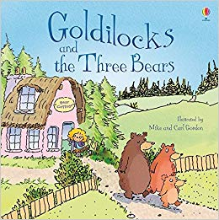 | Story  Sentence structure  Non fiction  Labels and captions | Humans | Harvest  Who am I? What does it mean to belong?  What do Christians believe God is like? | Personal History | Mouse skills | Drawing  Is spontaneously expressive, using marks, lines and curves.  Use lines to represent objects seen remembered or imagined  Explores tone using different grades of pencil, pastel and chalk. |  | games | service | Birthdays  Reacting to food
 | Autumn 2 | Where in the world is Baby bear? | Take baby bear on a trip | Geometry  Multiplication and division | 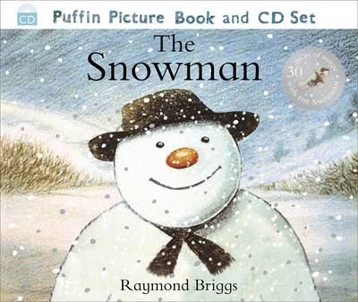 | Story  Characters and setting  Non fiction  instructions | Light | Why does Christmas matter? | Maps and Location  Remembrance day  Bonfire plot- Guy Fawkes | Research different countries of the world  Exploring a keyboard | Painting and Printing  Uses a range of tools to spread paint, in addition to brushes E.g. Straws, match sticks etc.  Experiments with and enjoys mixing colour  Creates patterns using different tools and colours  Uses one colour of paint or ink to create patterns; random or organised  Extends repeating patterns – overlapping, using 2 contrasting colours etc.  Explored and recreates patterns and textures with an extended range of materials. E.g. sponges, leave, fruit |  | gymnastics | Problem solver | Learning everyday language through song  Counting  Christmas
 | Spring 1 | Kings and Queens | Pantomime | Place Value  Calculations  Fractions | 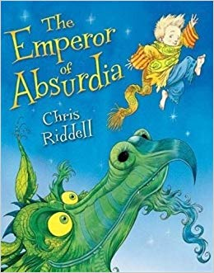 | Story  Story sequence  Non fiction  Recount-pantomime visit | Materials | Who is Muslim and what do they believe? | Learning about famous people in the past  King Henry 8th  Queen Victoria  Elizabeth 1 | Ipads  Handwriting  Letter formation | Textiles  Is aware of colour, texture and shape  Sorts, collects, discusses and pulls apart cloths and threads  Stitches and cuts threads and fibres |  | dance | curious | Emotions  counting
 | Spring 2 | How can I stay Healthy? | School Nurse | Measurement  Statistics  Time | Favourite Books  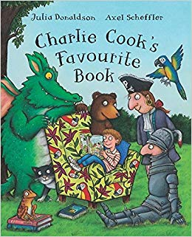 | Story  Write your own story  Non fiction  Explanation text | Plants | Why does Easter matter? | Foods from around the worlds  Healthy Eating | Find a recipe on the internet  Phonics games on ipads and computer | Photography  Collects photographs for a theme  Is aware that there are famous or specialist photographers  Develops an awareness of scale, perspective, movement and colour in photography |  | games | positive | Emotions
 | Summer 1 | How can we save the world? | Tropical World/  Ponderosa | Place Value  Geometry recap | 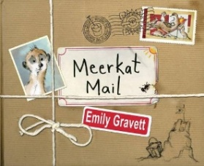 | Story  Comprehension  Questions  Non fiction  Recount trip-Ponderosa | Our world and weather | Who is Muslim and what do they believe?  Muslim festivals | Climate Change and environmental issues | Film children reporting on the weather as in a weather forcast | 3D  Pulls apart and reconstructs basic shapes  Becoming more aware of the form, feel, texture and pattern on objects  Experiments – with a purpose, using basic tools on rigid and plastic materials |  | gymnastics | Kind and caring | Playground games  Action songs
 | Summer 2 | What makes a great artist? | Salts Mills  Local Church(RE) | GAPs | 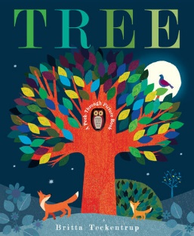  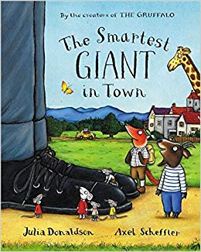 | Story  Write your own story  Rhyme  Poetry  Non fiction  Explanation text | Seasonal change | What is the good news that Jesus brings? | Artists through history  seasons | Research churches and what they are used for  Using a search engine | Collage  Selects and sorts materials into given criteria/qualities e.g. warm, cold, shiny, smooth  Engages in more complex activities e.g. cutting and sewing a range of materials  Has an idea of adhesives and decides which might be the most effective for the task |  | dance | creative | Fables  Recognising and applying colour patterns  Easter
2 | Autumn 1 | Super Space | Dogs Trust Visitor link to animals and humans | Place Value | 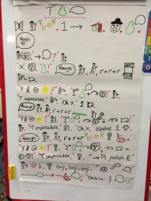  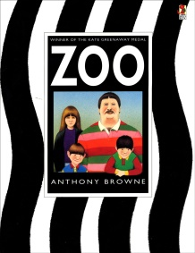  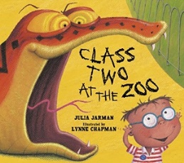  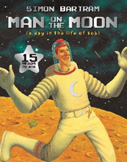 | Recite the story verbally and write my own story map to help me write using the story structure.  Story about Year 2 going to Shipley Zoo  Recount of Dogs Trust Visitor  Description about Winnie the Dogs Trust Dog | Animals and humans | Harvest  Who is Muslim and what do they believe? | Famous people in space locally  Helen Sharman the first woman in space from Sheffield | Using paint programme  Create a picture by exploring the different pens and brushes in the programme. | Look at the illustrations Tracie Andrews does of space and make some of our own. | Design and build a rocket like the Apollo 11 | Gymnastics | Service | Action songs  Story language
 | Autumn 2 | Food from around the world | Bonfire Bake Off  Visit from Warburtons  Food tasting  Pizza Express Trip  Making Father Christmas a sandwich  Growing of vegetables/ working with forest schools or in the school allotment. Understanding where our food comes from. | Addition and Subtraction | Firework Poetry  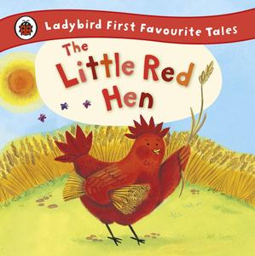  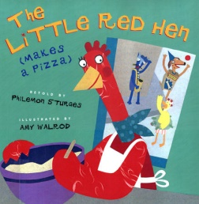  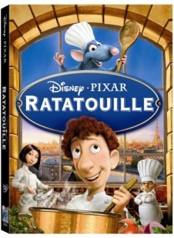  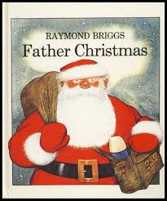  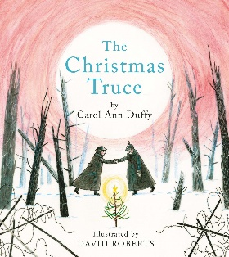 | Instructions  Story about the little red hen  Recount about our Trips to Pizza Express  Recount about our Warburtons Visitor  Instructional writing about how to make pizza’s  Character description and setting description Rataouille inspired  Christmas Poetry | Plants-  Growing of vegetables | Why does Christmas matter? | Location and culture  Guy Fawkes  Soldiers of the war- write a letter to one | Make a cooking show movie about making father Christmas a sandwich in groups.  Create a video advert for our Pronto Pizza shop. | Create firework paintings with paint and straws. Using the artistic technique of ‘blow painting’. | Design father Christmas the perfect sandwich.  Design the best pizza. | Football | Problem Solver | Colours and patterns  Christmas
 | Spring 1 | Kings and Queens | Pantomime  Pancake making  Left alone in the dark book for story time | Multiplication and Division | 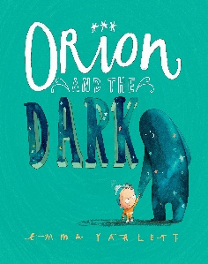 | Story about something else Orion is scared of. | Light and Dark | How should we care for the world and why does it matter? | England’s monarchy link to British Values | Use bitmoji on the iPads to make yourself into a king or queen. | Look at how Vincent Van Gough shows light and dark in his paintings and create some of my own based on the starry night. | Design the queens castle | Benchball | Curious | Playground games
 | Spring 2 | How can I stay Healthy? | School Nurse  Trip to a farm (Meanwood valley trail urban farm)  Shelter Building | Fractions  Geometry  Measurement | Rainbow Bear 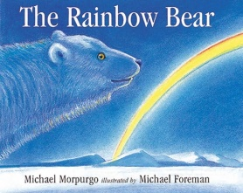  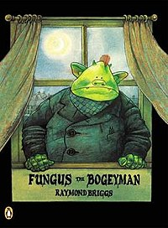 |  | Living things and habitats | Why does Easter Matter? | Plants across the world compared to ones we find in our school woods. (geography) |  | Draw and observe the schools surroundings using rubbings and observational drawings. |  | Rounders | Postive | In the fruit shop
 | Summer 1 | How can we save the world? | Tropical World  Get caterpillars to grow into butterflies  Chicks  Piper Pixar Film | SATs Revision | 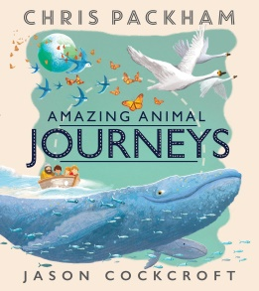  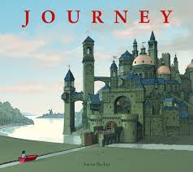 | Sandpipers Pixar Film- report about Sandpipers  Instructions on how to look after and grow butterflies  Setting description about what the Monarch Butterfly will find in South America.  Recount of our trip to Tropical World | Animal adaptations | What makes some places and things sacred to believers? | Environmental issues  Mapping migration routes of the Monarch Butteryfly | Slo-Mo films of butterflies growing using stop motion fim. | Observational drawings of the butteflies.  Link to cubism art on butterflies which uses geometry and bright colours to cubistically represent the butterflies. | Look at the work of David Kracov with the ‘Butterflies Bursting from the book’ and design, make and construct our own designed and made butterflies bursting out of our ‘Amazing Animal Adaptations’ Book | Athletics | Kind and Caring | Exploring dance
 | Summer 2 | What makes a great artist? | Salts Mills to see Hockneys work | SATs RECAP | 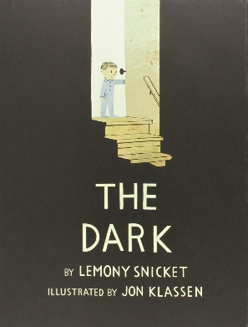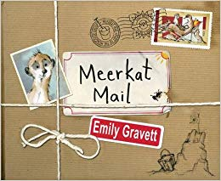 | Meerkats post card  Diary entry about the fire of London  Story about a fear link to The Dark | Seasons- link to David Hockney iPAD drawing showing the same locations in different locations | Who made the world? | Artists from around our area: David Hockney | iPADs drawing app to create pictures in the style of Hockney | Go outside and do observational drawings in the woods. Take photographs on the iPADs to draw from. Do these using the app Hockney used and do pastel picture in Hockneys style. |  | Sports Day games | Creative | At the seaside
YEAR 3 | Autumn 1 | Diniosaur egg  Cliffe castle  Prehistoric animal description | Land of the Dinosaurs | Place value  Addition and subtraction | To be completed as texts with themes identified. | Story  Report on prehistoric creature | Rocks and fossils | What do Christians learn from the creation story 6 - 8 | Changes in Britain from the stone age |  | 3.1 – We are programmers | Drawing observation – pencil control – cave painting | Benchball |  | Numbers  Greetings  Christmas
 | Autumn 2 | Great Britain – BRITISH MYTHS  Plan and instructions for travelling around Britain | The magic of light – travelling, shadows,Christmas lights etc. | Place value  Multiplication and division |  | Story  Instructions – Christmas tree decorating – lights planning a party etc. | light | What are the deeper meaning of festivals 6 - 8 |  | BRITAIN/  EUROPE AS A LOCATION  A tour of Britain focusing on key features such as cities, counties, rivers, mountains.  Look at land use across the nation | 3.2 – We are bug finders | British landscapes – painting techniques | netball |  | Questions  Numbers revision  Spelling words
 | Spring 1 | Mysterious objects fornd in a dig – man in the bog etc.  Advert for an artefact or settlement. | Bones - Forensics | fractions |  | Story  Persuasion advert for tourist attractions – Skae Brae | Animals and humans movement and growth | What kind of world did Jesus want 6 – 8 | Bronze and iron Age to the beginning of the Roman invasion |  | 3.3 – We are presenters |  | comic charcters based on various movement - Lichenstein pop art  Skeletons used and models.  hockey |  | Colours  Spelling words
 | Spring 2 | Charity event to raise awareness.  Report on a disaster- surviving a disaster | The Earth as we don’t know it | measures |  | Story  newspaper report – natural disaster | forces | Why do Christians name the day Jesus died “Good Friday” 4 - 6 |  | THE EARTH  Geographical study of volcanoes, earthquakes, Tsunamis (tectonic plate based). Work linked with the mountains later? | 3.4 – We are network engineers | Collage materials to create the effects of fire, water, wind .etc | Gymnastics/  dance/  aerobics |  | Food  Easter  Spelling words
 | Summer 1 | Class invasion  Roman Day – Murton park  Recount of a Roman character | Invasion and change | Statistics and shape |  | Story  Recount – biography diary of a famous Roman |  | When Jesus left what was next 6 - 8 | The Roman Empire and its impact on Britain |  | 3.5 – We are communicators |  | Designing and Building and constructing – aqueducts etc.  Athletics |  | Days of the week  Known vocabulary reinforcement  Speeling
 | Summer 2 | Climbing wall  Letter to save the mountains | The sound of Music – Skiing a holiday | Shape and revision |  | Story  Persuasion  Save the mountains | Plants | What does it mean to be a Hindu in Britain today 10-12 |  | MOUNTAINS AND WATER  Geographical study of mountain formation and life in the mountain environments  Link with the water cycle – snow, ice, etc. | 3.6 – We are opinion pollsters | Different media – pastel, charcoal etc – use of artists techniques Warhol with mountains and scenery. | Rounders |  | Months of the year  Known vocabulary reinforcement
YEAR 4 | Autumn 1 | Mysterious note, passport, strange lost traveller package.  Instructions for travelling etc. | Travelling the world | Place value  Addition and subtraction | See Yr4 teacher and their story links  See RI for term 1 | Visual literacy for story  Film based on world travel  instructions | Habitats | What is it like to follow God 8 - 10 |  | THE WORLD  Locate countries of the world, recognise seas, major capital cities etc.  Look at land use across the world. | 4.1 – We are software developers | Art from around the world – techniques such as painting etc, willow patterns, tribal art | Ball Games  Netball/Basketball | See new BASE planning | Colours  Parts of the body  Adjectives  spelling
 | Autumn 2 | Food tasting – blindfolded  Instructions for making an Anglo Saxon meal | Food | Place value  Multiplication and division |  | Story  Persuasion - food | Diet and digestion | What is the trinity 6 - 8 | Britain’s settlement by the Anglo Saxons and Scots  The Viking and Anglo Saxon struggle for the Kingdom of England to the time Edward the Confessor |  | 4.2 – We are designers |  | Food technology – healthy meals and food preparation anglo saxon recipes etc.  Gynastics |  | Questions  Zoo animals  Christmas
 | Spring 1 | Family tree – fake – Who do you think you are?  Recount of the day in the life of an Anglo saxon | Materials | fractions |  | Story  recount | States of matter | Why do Christians name the day Jesus died “Good Friday” 4 – 6 |  |  | 4.3 – We are musicians | Exploring media – charcoal, pastel, ink etc  Use collage/paper skills | Dance |  | Verbs  (etre)
 | Spring 2 | Coal mining museum  Persuasive letter about saving the world – recycling etc | Saving the planet | measures |  | Story  persuasion | electricity | How and why do believers show their commitments during the journey of life 8 - 10 |  | 4 NATURAL RESOURCES  Sources of energy on the planet etc. | 4.4 –We are HTML editors. |  | Contruct some form of electrical circuit with a purpose i.e. fairground.  Swimming  Archery |  | Receptive vocabulary through song  Easter
 | Summer 1 | Viking visitor  Report on Viking life | The music of the North – the sound of the Viking Fjords | Statistics and shape |  | Story  report | Sound | What does it mean to be a Sikh in Britain today 10 12 | Including a local history study of Viking York |  | 4.5 – We are co-authors | Textile work  Weaving  Sewing  Darning knitting | Swimming  Rounders/Cricket |  | French story language  Recognising nouns and verbs
 | Summer 2 | Trip to York  Recount of trip  Diary extract Viking warrior sailing to America - discovery | Transport – the sea | Shape and revision |  | Story  recount |  |  |  | 4 AMERICA  Use the idea of Vikings to introduce North America. Look at the countries major cities, industries and infrastructure. Select a city to compare to our own Shipley. | 4.6 –We are meteorologists | Design a Viking boat | Swimming  Athletics |  | Pets  Single and plural  Following a text
5 | Autumn 1 | BRITAIN  Maps – Game of thrones – 3D Create your own country map.  A visit from the tourist board. AA our local tourist board.  Country Trust talk about their work and why it is important  Hindu temple visit? | Factual report on cities etc. – compared to a description of local beauty spot.  Leaflet on famous British landmark. | Place value  Addition and subtraction | New teacher to decide | Story  Instructions explanantion | Properties and changes |  | A study of an aspect or theme in British history that extends pupils chronological knowledge beyond 1066 - The changing power of the monarchy  Ancient Greece and influence of Ancient Greece on our democratic systems. | BRITAIN AS A LOCATION  A tour of Britain focusing on key features such as cities, counties, rivers, mountains.  Look at land use across the nation  Year5 will focus on the man-made aspects of Britain cities/industrial areas i.e. coal, tin mines etc. and tourist attractions – areas of natural beauty and compare to another | 5.1 – We are game developers | Sketching  British landscapes | Benchball/ball skills | See new BASE planning | Creating and manipulating simple sentences  Using negatives  Directions
 | Autumn 2 |  |  | Place value  Multiplication and division |  | Story  recount | Properties and changes |  |  |  | 5.2 – We are cryptographers |  | Product design and evaluation – food products from Britain  hockey |  | Asking directions  Days of the week and times in the day  Christmas
 | Spring 1 | South America  Exploration of the woods – mystery country – how to survive in the New World.  Tropical World 5/6 | Persuasive argument on saving the rainforest. | fractions |  | Story  persuasion | Earth and space |  |  | SOUTH AMERICA  Look at the countries major cities, industries and infrastructure. Select a city to compare to our own Shipley. | 5.5 – We are bloggers | Exploring media – charcoal, pastel, ink etc. Animal wallpaper – repeating patterns using a stencil – rainforest style | Netball |  | Understanding and giving opinions
 | Spring 2 |  |  | measures |  | Story  News report | Forces |  |  |  | 5.3 – We are artists |  | 3D construction a whole class favela or Amazon jungle.  Dance aerobics |  | Days of the week  Hobbies  Easter
 | Summer 1 | The Deep  The Deep  River study Nell Bank | Recount of a rivers journey  Flood instructions | Statistics and shape |  | Story  Non chronological report | Animals – human and animal development |  |  | CLIMATE,  BIOMES & RIVERS.  Explore different locations around the world such as deserts, the Antarctic, swamps.  A focus on the element of water with rivers as a key geographical feature | 5.6- We are architects | Water – seascapes – colour – painting skills | rounders |  | Future tense  Months of the year
 | Summer 2 |  |  | Shape and revision |  | Story  PERSUASION | Living things and their habitat  Lifecycles of plants etc. |  |  |  | 5.4 – We are web developers |  | 3D construction  OF BOATS  athletics |  | Sports and hobbies  Making comparisons
6 | Autumn 1 | Where are we? | Visit to Cliffe Castle (Keighley) | Place value  Calculations | 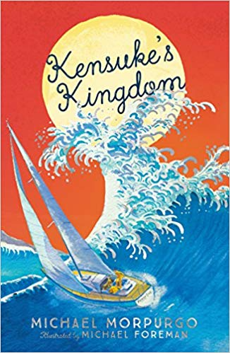 | Story involving journey – KK  Recount writing | Evolution and inheritance |  | Map skills, use of positional language / atlases | We are App planners | Sketching and shade in style of book Kensuke’s Kingdom and Charles Darwin sketches |  | Benchball  Ball skills | Being positive, developing self-esteem – books: Floss the Playground Boss / We are all Wonders | Classroom instruction  Conversation  Clothes  Family  Verb (etre)
 | Autumn 2 | What a wonderful world! | Visit from Electricity Board and also No electricity day | Place value, calculations, fractions | 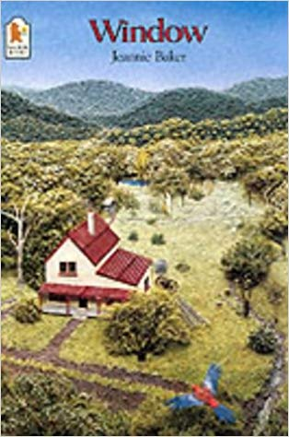  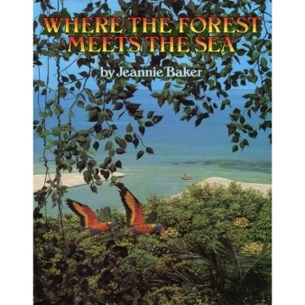 | Jungle Book visual literacy  Non-chronological reports, persuasion | Electricity |  | Human and physical geography and changes over time | We are project managers |  | 3D modelling of church / prayer space | Aerobics  Hockey | We are blessed | Christmas
 | Spring 1 | Walk like an Egyptian | Visit to Leeds museum | PV, calc, fractions decimals and percentages | 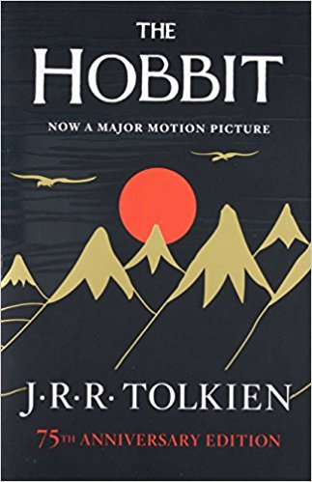 | Quest stories |  |  | Ancient Egypt | We are market researchers |  | Egyptian buildings / structures | Team games  Netball | We can achieve anything – Giraffes can’t dance | Homes  Adjectives
 | Spring 2 | Staying healthy | Shakespeare day | Calc, FDP.  Geometry  Statistics | 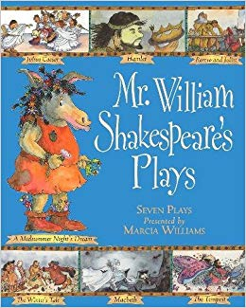 | Story writing – Shakespeare  Discussion text | Animals – human health |  |  | We are inferface designers | Abstract art, Picasso – children create Egyptian art in this theme |  | Dance / aerobics | We are fortunate! Squash and a squeeze (JD) and Quaky Cat | Easter
 | Summer 1 | The Maya | Dr Diane Davies, archeologist – morning workshop | Revision | 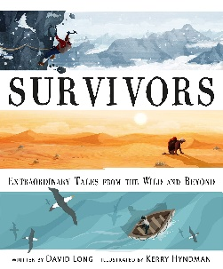 | The Arrival – Shaun Tan  Survival stories | Light |  | Mayan Civilization | We are App developers |  | Maya jewellery / pottery (work with clay) |  |  | Families
Gymnastics
Rounders
 | Summer 2 | Leaving our mark! | Visit to F4S depot, work with Kevin M | Project based maths – Fuel for school, recycling  Visit to Tropical World, Hirst Wood | 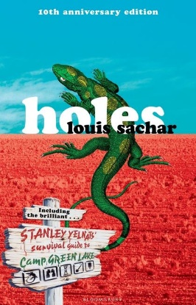 | Holes by Louis Sachar | Living things and their habitats |  | human geography, including: types of settlement and land use, economic activity including trade links, and the distribution of natural resources including energy, food, minerals and water | We are marketers | Maya patterns  Henri Rousseau – animal prints and paintings | DT work focused on adding element to bungalow as Y6 legacy | Athletics  Rounders | Leaving a legacy – circle time focused on transition and positive end to time at primary | Holidays  performance

