 | Term 1 | Term 2 | Term 3 | Term 4 | Term 5 | Term 6
Topic | Colours  How and why do the colours around us change? | Cold  Who likes the cold? | Extinct  What happened to the dinosaurs? | Gods World  Who are my woodland neighbours? | Heroes and Villains  Can villains be heroes? | It’s Good to Be Me  How can I be the best I can be?
Reading Texts | 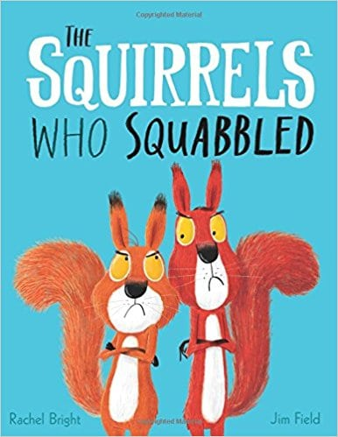  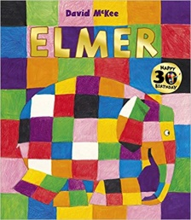  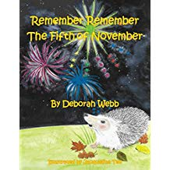 | 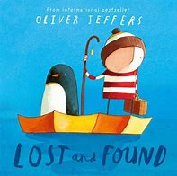  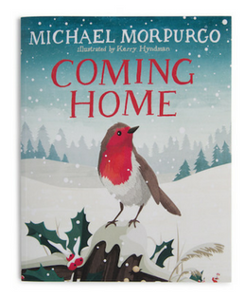  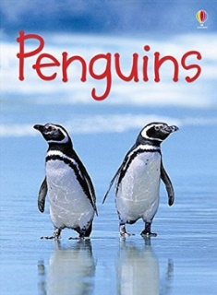 | 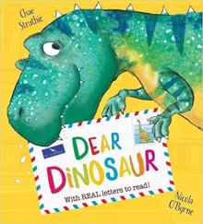  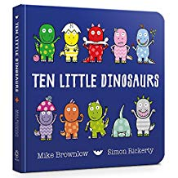  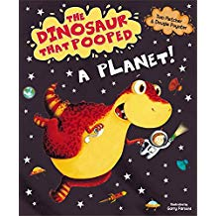 | 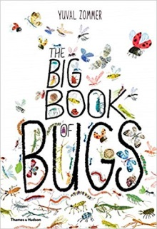  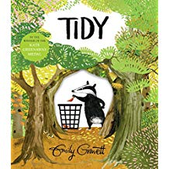  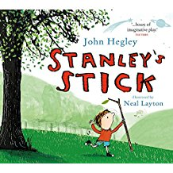 | 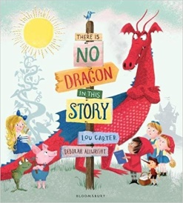  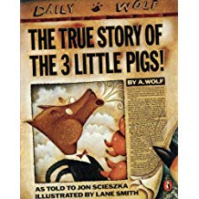  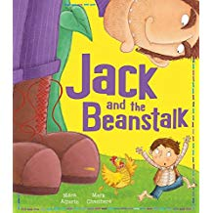 | 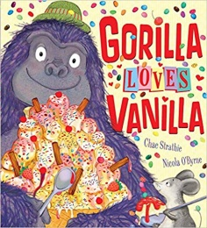  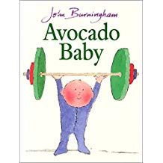  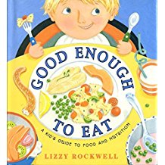
Writing Genres | - Names  - Mark making and giving meaning to marks  - CVC words | - Labels  - Lists  - Letters  - Cards  - Labels  - Invitations | - Captions  - Lists  - Sentences | - Sentences with phase 2 tricky words  - Information sentences  - Signs and labels  - Information posters | - Story maps  - Narrative writing  - Joining sentences ‘with’ ‘and’ | - Sentences using polysyllabic words  - Labels  - Posters  - Recipes/Lists
Developing Language | Colour names  Seasons | Temperature words  Names of ‘cold’ animals. | Dinosaur names  Time frames | Insects  Habitats | Language relating to telling/structuring a story  Once upon a time…  The end…  After that… | Sentence structures – modelled and then written.
Maths | - Identifying and saying the numbers 1-10 and ordering and comparing  - Counting objects and counting out objects  - Pattern making | - Identifying numbers 1-20 and ordering and comparing  - Using the language of more and fewer to describe amounts/two sets.  - Finds one more and ones less from  a group of up to 10 objects.  - 2D and 3D shapes | - Find the total amount of objects in two groups and using language of adding and subtracting.  - Adding- counting on/ finding the difference between/ combining groups | - Subtracting- counting backwards/finding the difference between/physically taking away  - Separating amounts into unequal and equal groups (sharing/division) | - Doubling and halving  - Problem solving  - Use everyday language and understand the concept of capacity/ distance/ time | - Weighing/measuring  - Size and position  - Language of money  - Review areas that are weak
Enabling Environments | Basic provision at the start  Colour mixing  Different media to make colourful pictures, stamping, pastels, paint, paper… | Arctic small world areas  Books about animals  Nativity small world  Christmas in the home corner  Maths problems involving presents | Dinosaur small world  Dinosaur books  Maths problems involving dinosaurs | Mini beast collecting kits  Symmetry | Home corner reflects a traditional tale  Story baskets  Small world traditional tales  Language prompts | Healthy foods in role play  Trying different foods  Writing in all areas
Festivals/ British Values | Bonfire Night  Harvest  Diwali | Bonfire Night  Diwalli  Christmas  Advent  Armistice day  Nativity | Shrove Tuesday  Ash Wednesday  Chinese New Year  Mother’s Day  Chinese new year | Easter  Seasons | Ramadan | Father’s Day
R.E syllabus | Why is God special to Christians?  God created the universe. The earth and everything in it are important to god. Humans should care for the world. | Christians celebrate Jesus birth and advent for Christians is a time for getting ready for Jesus coming  Christians believe that Jesus is God and that he was born as a baby in Bethlehem. | I am special. Stories that are special to Christians.  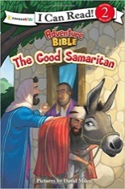 | Easter is very important in the bible, Jesus chowed that he was willing to forgive all people even for putting him on the cross.  Christians believe Jesus rose from the dead, giving people hope of a new life. | God created the universe. The earth and everything in it are important to god. Humans should care for the world.  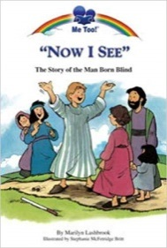
Learning Experiences | Walk in the local woods  Fire pit in ARC  Sparklers and visit to Ark fire pit | Nativity Play  Ice in the classroom  Christmas Crafts- invite parents | Parents story time  Dinosaur Dig – outdoor sandpit | Caterpillar’s/ Butterfly  Tropical world | Author  Superhero costume day | Baking/ Food tasting  Warburton’s bread making

