Report for Govenors on the spending of the School PE Sports Funding and the impact of it. (July 2018)
Mathew Cox – Sports Grant and PE lead
Context
The school received £16.900 in sports funding for this academic year. £7000 of this was allocated to continue to provide sports coaching to pupils over the lunch break. This is intended to provide pupils with access to a wider range of additional sporting activities.
Review
In order to decide on the best use for the remaining funding, the existing provision was reviewed in the autumn term. The review process included pupil questionnaires as well as discussion with SLT, lunchtime staff and sports coaches.
Review Outcomes
The pupil questionnaire found that only 48% of pupils had worked with the sports coaches at least once and 20% did so regularly. Of the pupils regularly working with the coaches only one was a girl. Staff reported that the range of activities offered was limited and was dominated by older boys playing football.
The Sports Coaches were open to change but felt that their options were limited by the facilities and equipment available.
It was decided that funding would be used to provide sustainable improvements to the equipment and activities available to the pupils. The school council was consulted and they produced a plan to develop the playground.
Outcomes
The following items have been installed:-
- 101 construction erected 2 new wooden Muga ends with basketball hoops to replace the old metal pole goals that were at the end of the playground. This will enable different sports to take place on the end of the playground.
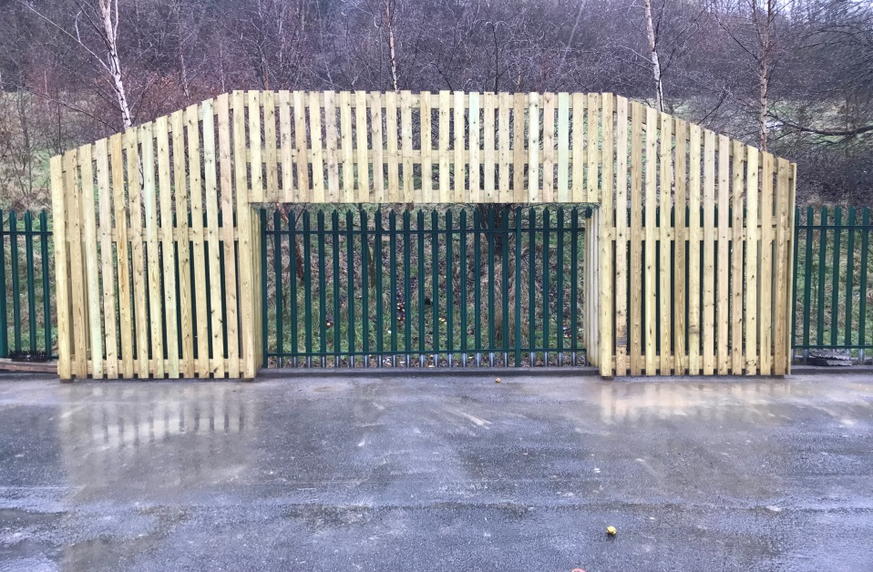

- Fresh Air fitness supplied and fitted 6 multi person fitness machines.

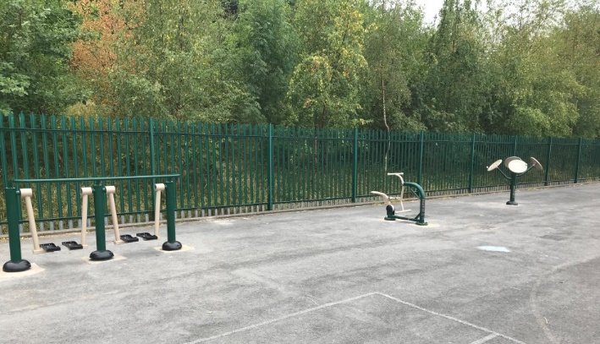
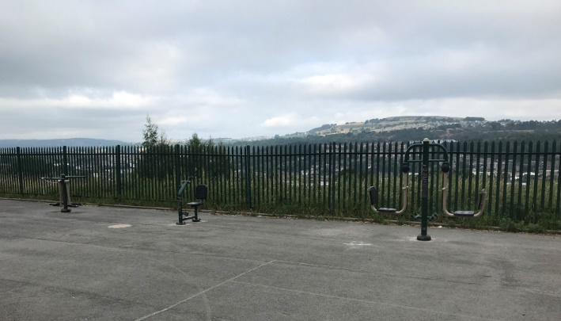

- 2 outdoor metal table tennis tables and outdoor paddles.
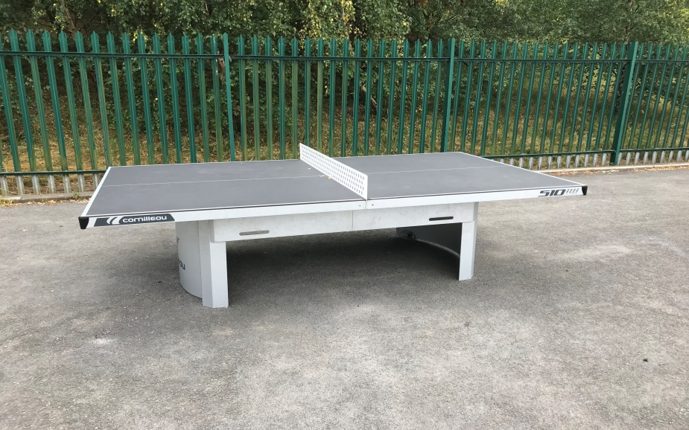
Impact
- 96% of pupils have accessed sporting activities at lunchtime at least once. This is an increase of 48% and double the number of children accessing sporting or fitness activities at the beginning of the year.
- 85% of pupils are now regularly using either the equipment or accessing sports coaching. This is an increase of 65 from earlier in the year.
- The number of girls accessing activities has increased from 15 to 65.
- The range of activities delivered by sports coaches has also been increased and a timetable put in place to ensure a range of sports are covered.
- The purchase of sustainable equipment means that the provision will be in place for years to come.

Next Steps
The equipment is beginning to be used in PE lessons. It is expected that all year groups will have it incorporated into their PE curriculum in 2018-19.
Whilst girls’ participation has improved, this will remain a focus for the coming year.
We will review resources and any remaining funding will be used to replace items such as balls which can become damaged or lost over time.

