Key Vocabulary
Jesus | God’s son on Earth
Creator | Someone who makes something new
Incarnation | Means to be born again. God was born again on Earth in the form of Jesus.  - Why is the baby so big in this picture?  - What the people doing at the front and why?
Advent | Important time in the Christian calendar is Christians prepare for Christmas
Mary | 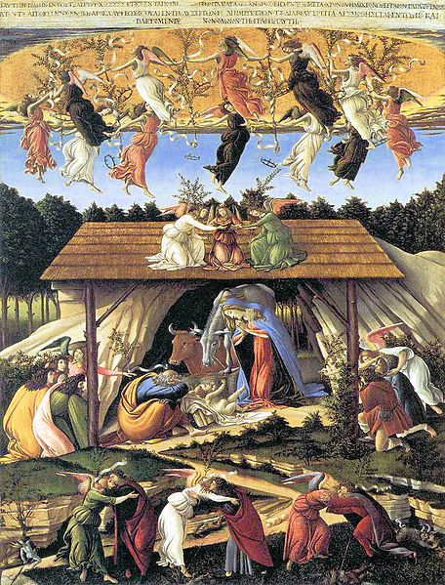  Jesus’s mother
Christmas | A special time in the Christian calendar to celebrate Jesus’s birth.
Why does Christmas matter to Christians?
In R.E we will be doing all about why Christmas is such a special time of year for Christians.

Year 2 R.E Knowledge Organiser Autumn 2 2019

Can you remember why we have Advent? What is the purpose of opening a door every day?
- Why is the sky so dark?
- What might the cross show?

