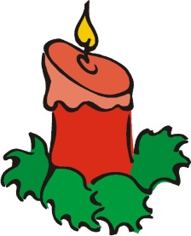
Christmas Activities

We would like to inform you of some exciting dates for December 2017

Friday 1st December
Whole School – Non Uniform day- Children need to bring in some chocolate in exchange not to wear uniform
Wednesday 6th December – Christmas Fayre – 3.15pm – 4.30pm

Monday 11th December – Nursery, Reception, Year 1 and Year 2 - Dress Rehearsal for Nativity

Tuesday 12th December – Nativity Day

Wednesday 13th December – Non Uniform Day – Christmas Dinner and School Disco
Years 1 to Year 6 – Christmas parties in the afternoon.

Thursday 14th December – Nursery and Reception Christmas Party (afternoon)

Thursday 14th December – Years 3 to Year 6 - Carol Service in the Hall
at 2.30pm – 3.10pm

More information will be given closer to the time. This is just so that you are aware of what is happening on what date.
Thank you

