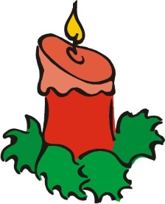
Christmas Activities

We would like to inform you of some exciting dates for December 2018

Friday 30th November - Non Uniform day- Children need to bring in some chocolate as a
Donation!
Wednesday 5th December – Christmas Fayre – 3.00pm – 5.00pm

Wednesday 12th December – Christmas Dinner Day
School Disco’s (extra letters will be sent in due course)

Thursday 13th December – KS2 Carol Service – 2pm

Friday 14th December – Christmas Jumper Day - £1 donation for Save The Children
Nativity Day
Nursery & Reception – 9.15am – 10.15am
Key Stage 1 – 10.15am – 11.15am

Tuesday 18th December – Christmas Parties Day

Wednesday 19th December – Christingle Service – 2pm – 3pm
School Closes for Christmas 3.10pm

School re-opens Monday 7th January 2019
Thank you

