**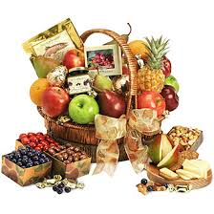

11th October 2017

Dear Parent/Carer,

**Harvest Festival**

We would like to invite you to our harvest festival in the school hall on Wednesday 18th October at 2.00pm. The festival will be led by Reverend Mark, and each class will be singing a special harvest song.

This year we are supporting a local food bank that offers food parcels to people in crisis from the Bradford area. Due to a large increase in demand recently they are appealing for food donations to aid their project. We are asking if you would be kind enough to send a food contribution (tins and packets only please) in support of our Harvest celebrations, which will then be collected and used by the Bradford Food Bank.

We would like to thank you in advance for your generous support, and look forward to seeing you all at the assembly.

Yours Sincerely,

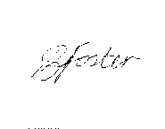

Mrs P Foster

Head Teacher