

*Christ Church CE Academy*



Dear Parent/Carer,

We are holding a Macmillan coffee morning on Wednesday 18th October from 9am to 10.00am in the school hall and would love it if as many of you as possible would join us to raise money for such a worthy cause.

We will be asking for a donation in return for a cup of tea or coffee and a bun, biscuit or piece of cake of your choice.

In preparation for the coffee morning, we are kindly asking if you could donate any buns, cakes or biscuits. Please send any donations to school with your child on Tuesday 17th October.

All proceeds will go straight to Macmillan cancer support.

If any parents would like to help out on the morning, please let either the office or Mrs Nightingale know as soon as possible.

Thanks for your support, and we hope to see you all there.

Yours faithfully,

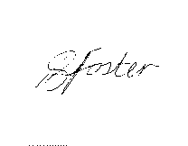

Mrs P Foster

Head Teacher

