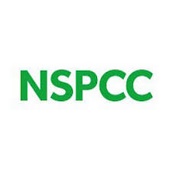
Date: 12th November 2018

Dear Parent/Carer,
Free online safety workshop for parents and carers
Muddled by Minecraft or rattled by Roblox? NSPCC and O2 are running an hour-long interactive workshop with tips, tools and advice on how to keep your child safe online. Talking about online safety with your child doesn’t need to be difficult –build your confidence to have those important conversations, get to know your child’s online world and learn where to go for help and advice.
The workshop will take place at 2pm on Wednesday 14th November in the school hall. Don’t miss out on this great opportunity! Make sure you RSVP by responding to Mrs Morris at the office.
Tea, coffee and biscuits will be provided. We hope to see many of you there but please do book at the office to ensure you get a place.

Date: 12th November 2018

Dear Parent/Carer,
Free online safety workshop for parents and carers
Muddled by Minecraft or rattled by Roblox? NSPCC and O2 are running an hour-long interactive workshop with tips, tools and advice on how to keep your child safe online. Talking about online safety with your child doesn’t need to be difficult –build your confidence to have those important conversations, get to know your child’s online world and learn where to go for help and advice.
The workshop will take place at 2pm on Wednesday 14th November in the school hall. Don’t miss out on this great opportunity! Make sure you RSVP by responding to Mrs Morris at the office.
Tea, coffee and biscuits will be provided. We hope to see many of you there but please do book at the office to ensure you get a place.

