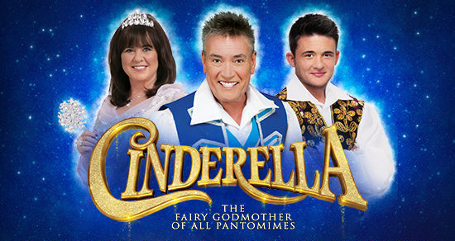

Date: 23rd November 2017

Dear Parent / Carer,

Educational Visit to Alhambra Theatre – Years 1 & 2
Tuesday 9th January 2018

As part of the children’s learning experiences, we have planned a visit to the Alhambra Theatre in Bradford to see this year’s pantomime, Peter Pan! This visit is aimed at helping children develop their love for literacy and to give them the experience of going to the theatre.

We will leave school at 1.15pm and travel by coach to the theatre and return to school at approximately 5.15pm. We intend to have lunch before we leave school.

We are asking for a contribution of £5.00 per child for this exciting experience. Please can you return the reply slip below to school by Friday 9th December 2017

We understand that family budgets may be tight in the run up
to Christmas and whilst we would appreciate your donations before the trip we will be accepting contributions up until 30th January 2018. Please ensure you sign and return the permission slip as soon as possible to allow your child to attend this valuable part of their learning, regardless of contributions.

Yours sincerely,

Mrs Foster
Headteacher

I give permission for my child……………………………….…………………...in year…………. to visit Bradford Alhambra on the 9th January 2018 to see Cinderella.

Signed …………………………………………………………………………

Name…………………………………………………………………………..

