Date: 15th January 2017

Dear Parent/carer,

Year 4 pupils will be starting swimming lessons each week at Shipley Pool from Thursday 22nd February these will continue every Thursday until February 2019.

Girls need a one piece swimming costume (no bikinis allowed) and a towel. Long hair MUST be tied up and jewellery must not be worn.

Boys need swimming trunks/swimming shorts, but these must not be long ones, and a towel. Again, jewellery must not be worn.

PLEASE MAKE SURE THAT YOUR CHILD BRINGS THEIR KIT IN A NAMED BAG EVERY THURSDAY AS WE ARE UNABLE TO PROVIDE SPARES.

If your child suffers from Asthma and uses an inhaler before exercise you need to make sure that it is in school for this purpose. Swimming is a strenuous exercise.

Please make sure your child wears a good coat, with a hood and appropriate footwear every Thursday because they do walk to the swimming pool and back each week.

Yours sincerely,
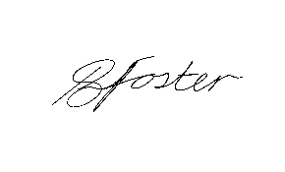

Mrs. Foster
Headteacher

