S:\BDAT Comms and Marketing\Logo\BDAT Logo_final_low res.tif



**Administration Assistant**

**Application Pack**

**June 2019**

**Contents**

* Letter from the Head Teacher
* Advertisement
* Bradford Diocesan Academies Trust
* In and around Shipley
* How to find us
* Job Description and Person Specification
* The selection process

S:\BDAT Comms and Marketing\Logo\BDAT Logo_final_low res.tif

Dear Applicant,

Thank you for your interest in the post of Administration Assistant at Christ Church Church of England Academy. I would like to take this opportunity to tell you a little about our school. Christ Church Academy is a one form entry school for pupils aged 3 to 11 years. We are part of the Bradford Diocese Academies Trust (BDAT) and serve the community of Shipley in West Yorkshire.

The school became an Academy in August 2013. Our latest Ofsted in October 2016 judged our school as GOOD, showing we have high standards for teaching and learning and we are working hard to ensure that Christ Church Academy becomes the local school of choice.

Our children enjoy coming to school and are keen to learn. Our staff are passionately committed to ensuring that our pupils achieve and they have high expectations for the children and for themselves. Many of our pupils are vulnerable in terms of their socio economic background and it is vital that their primary school experience is of a high quality and has a positive impact on their future life chances.

The role of Administration Assistant is key to the success of our pupils and our school. The successful candidate will work on our reception desk and act as the first point of contact for parents and visitors so exceptional communication skills are essential.

I would strongly recommend that you come to visit us in order to gain insight into the deeply rewarding career that working with our pupils and staff has to offer.

Kind regards,



**Philippa Foster**

**Headteacher**



**Administration Assistant – 38hours TTO**

Christ Church Academy is looking for an exceptional customer service professional to work in our school office.

Working under the direction of the School Business Manager you will handle enquires, assist with the school attendance work and assist in supporting the schools financial systems. This is a challenging and varied role; therefore the ability to use your own initiative, work independently and manage your own workload are essential.

|  |  |
| --- | --- |
| We would love to hear from you if you are:   * an excellent communicator with good interpersonal skills * some administrative experience * enthusiastic, creative, innovative and are prepared to ‘roll your sleeves up and get stuck in’ * well organised, yet flexible * hard-working and a good team player * can look and think ‘outside the box’ | We can offer:   * The opportunity to be part of BDAT and work with schools and colleagues across the trust for career progression * The opportunity to be part of a dedicated staff team * A competitive employee benefits scheme through BDAT * A committed and creative team |

For further details please contact Mrs Annwen Ackroyd, Business Manager on Annwen.ackroyd@cca.bradford.sch.uk or telephone 01274 410349

**Closing Date: Monday 8th July 2019**

**Shortlisiting: Monday 8th July 2019**

**Interviews: Thursday 11th July 2019**

Visits to the school are warmly welcomed by prior arrangement. Please contact our Business Manager, Mrs Annwen Ackroyd on 01274 410349 to arrange a mutual appointment. Applications can be made via e – mail to [admin@cca.bradford.sch.uk](mailto:admin@cca.bradford.sch.uk) or through prospects online.

Christ Church Academy is committed to safeguarding and promoting the welfare of our pupils and expect all staff and volunteers to share this commitment. All staff are subject to an enhanced DBS check.



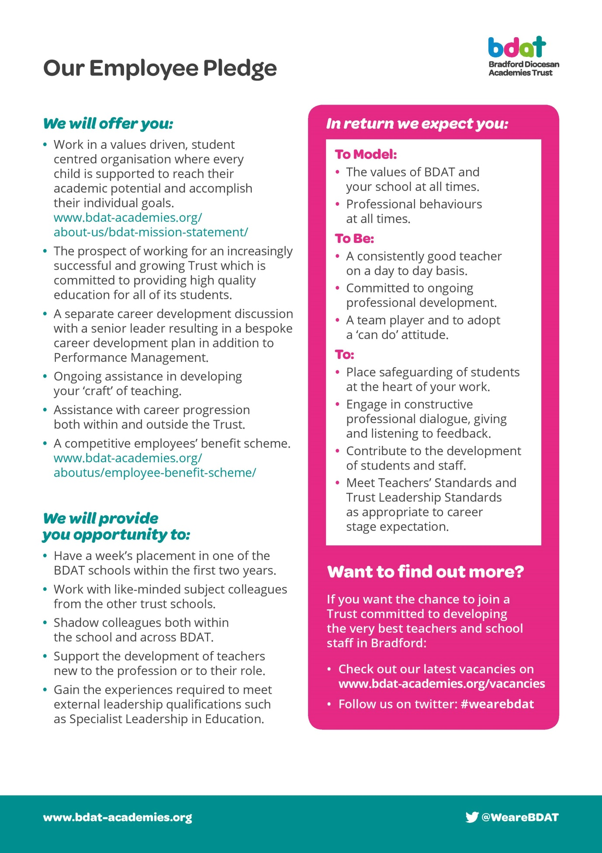

**In And Around Shipley**





Situated as it is on the Aire Valley, it has excellent rail and road links not only to the university cities of Bradford and Leeds (with their theatres, museums, restaurants and shops) but also to Ilkley (with its famous moor), Haworth and the Bronte country and, via the Settle-Carlisle railway, to the more distant Dales and the Lake District. The Leeds/Liverpool canal takes you across to the other side of the Pennines and Leeds/Bradford airport connects to the four corners of the globe.

Shipley is an old market town and it retains a strong sense of identity. It still has its weekly market, though the market place itself has been rebuilt and is surrounded by modern shops. The adjacent library, health centre and swimming pool are also of recent origin.

Shipley's immediate neighbour is the UNESCO World Heritage Site of Saltaire, a model village built in the 19th century by the mill-owner Titus Salt to house his workers. The impressive mill buildings no longer produce textiles but have been converted into offices, shops, a restaurant, and the 1853 Gallery, which holds a large collection of the works of Bradfordian David Hockney. Most of the original community buildings are now occupied by Shipley College.

Over the bridge across the river is another remnant of the Victorian era, the Shipley Glen Tramway, built to carry people up to the village of Baildon and now operated by volunteers as a tourist attraction. It leads onto Baildon moor and the stone circle known as Soldier's Trench, which is thought to date from the Bronze Age.



Shipley is a pleasant place to live and work, with housing of all descriptions and access to every kind of sporting and leisure activity.

**How to find us**

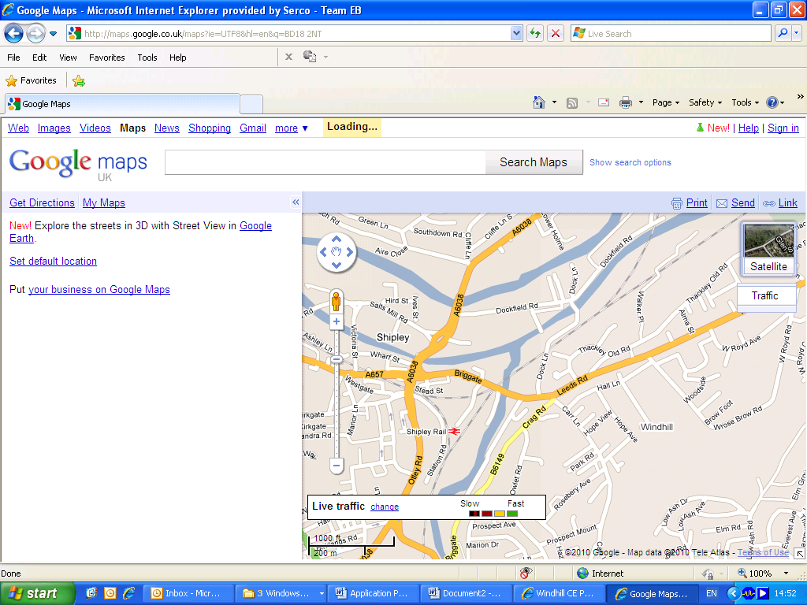

**We Are Here**

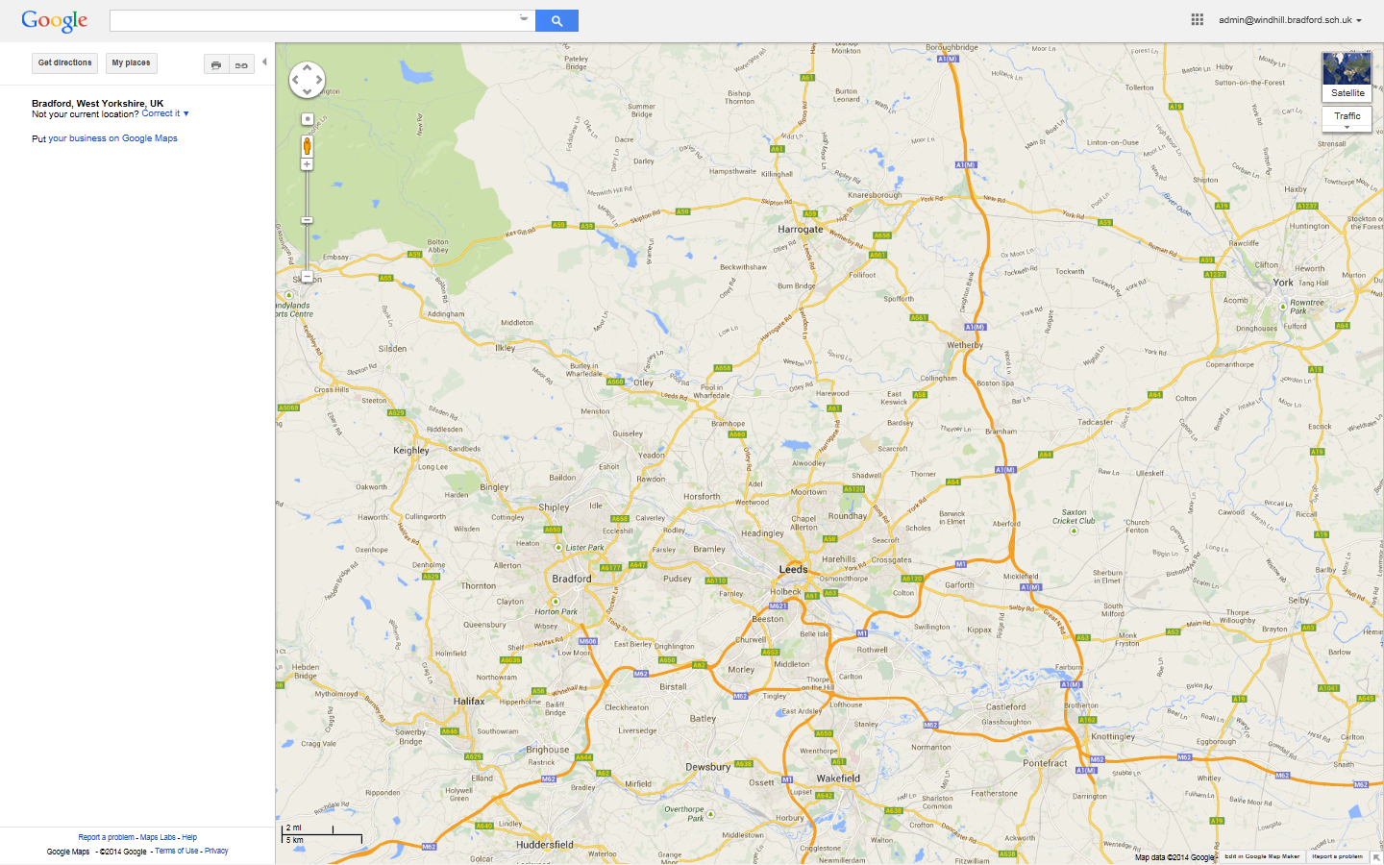

**Christ Church Academy**

**Wrose Brow Road, Shipley, BD18 2NT**

**Tel: 01274 410349**

**www.christchurchacademy.org.uk**

Christ Church Academy

**Outline Job Description**

|  |  |
| --- | --- |
| **Post Title:** | **Administration Assistant** |
| **Post Ref:** | **AC1** |
| **Grade:** | **SCP 4/5/6 £15725 to £16361 (actual salary correct june 2019)** |

The following information is furnished to assist staff joining the School to understand and appreciate the work content of their post and the role they are to play in the organisation. The following points should be noted:

1. Whilst every endeavour has been made to outline the main duties and responsibilities of the post, a document such as this does not permit every item to be specified in detail. Broad headings, therefore, may have been used below, in which case all the usual associated routines are naturally included in the job profile.
2. Employees should not refuse to undertake work, which is not specified on this form, but they should record any additional duties they are required to perform and these will be taken into account when the post is reviewed.
3. Christ Church Academy is an Equal Opportunities Employer and requires its employees to comply with all current equality policies in terms of equal opportunity for employment
4. Christ Church Academy is committed, where possible, to making any necessary reasonable adjustments to the job role and the working environment that would enable access to employment opportunities for disabled job applicants or continued employment for any employee who develops a disabling condition.

**Prime Objectives of the Post:**

To assist in the provision of high quality professional, flexible, proficient and constructive clerical, administration including finance administration, attendance monitoring and reception service to the school.

Responsible to the Business Manager/Headteacher from whom they will receive formal supervision and who will allocate work when necessary. However, much of the work is self-generating, and the post holder will be expected to work within established procedures and guidelines and to prioritise day-to-day work, referring only exceptional or complex queries to senior members of staff. In the absence of the Business Manager would be expected to liaise with senior team members to ensure continuation of essential services.

To provide prompt and effective information, advice and access to services provided by the School to parents/carers, governors, community groups, members of the public and other agencies, dealing with requests for help and intervention, seeking guidance from and working in conjunction with senior/qualified professional staff on more complex requests. Undertaking and promoting the School to public and external agencies.

May from time to time be required to undertake other duties commensurate with the grade and level of responsibility defined in this job description.

**Knowledge and Skills:**

*(See Personnel Specification)*

**Effort Demands:**

* Will work under supervision and on occasion under own initiative, working to the priorities set by the Business Manager/Headteacher.
* To contribute to the overall ethos/work/aims of the school.
* Will make decisions regarding individual visitors/callers in terms of the advice and information provided, liaising with other staff within the school and assessing the level of urgency.
* Day to day decisions regarding the organisation of the working area/workload and school priorities.
* To participate in in-school training and other training programmes as required, and maintain personal and professional development in order to meet the changing demands of the post.

**Responsibilities:**

ORGANISATION

* To give advice and guidance as appropriate, making decisions regarding individual visitors/callers in terms of the advice and information provided and using some judgement within established procedures and guidelines, liaising with other staff within the school and assessing the level of urgency.
* Undertake reception duties, answering routine telephone and face to face enquiries and signing in visitors.
* Assist with pupil first aid/welfare duties, looking after sick pupils, liaising with parents/staff etc.
* Assisting with arrangements for visits by school nurse, photographer etc.

ADMINISTRATION

* Provide routine clerical support e.g. record and circulate messages to other members of staff, photocopying, filing, scanning, faxing, emailing, complete routine forms, sort and distribute mail, ensuring supplies of internal forms are kept well stocked.
* Maintain manual systems.
* Maintain and collate pupil reports.
* Data inputting of computerised records/management information systems.
* Produce data/information/basic reports as required e.g. pupils’ data.
* Undertake typing, word-processing and other IT based tasks (letters, memos, minutes etc).
* Undertake routine administration, e.g. registers/school meals/arranging and coordinating meetings on behalf of other school staff/room bookings/minute taking/retrieve and disseminate information as appropriate to the needs of the school/school lettings and other uses of school premises.
* Input financial documents to PSF under the supervision of the Business Manager
* Order goods/services following the academies approvals system and under the supervision of the Business Manager

ATTENDANCE MONITORING

* Under direction of the Attendance Lead;
* Record pupil Attendance on SIMS daily, contacting absent pupils and in partnership with the Learning Mentor carrying out home visits where no contact can be made
* Monitoring attendance for all pupils and reporting to SLT as appropriate
* Compiling attendance data for governors/SLT/BDAT
* Assisting with the running of Attendance events and assemblies

RESOURCES

* Responsible for the safe keeping of office equipment and secure storage of supplies.
* Operate office equipment e.g. photocopier, computer.

OTHER

* Use good common sense and initiative in all matters relating to the conduct and behaviour of individuals, groups of pupils and whole classes; the correct use and care of materials by individual and small groups of pupils, the safety, mobility (if required) and hygiene and well being of the pupils.
* Make travel arrangements.
* Assist with arrangements of school events/trips etc.
* Preparing refreshments and clearing away.
* Receiving and escorting visitors around the School.
* To be responsible for reporting building maintenance in accordance with health and safety requirements.

**environmental demands/Working Conditions:**

* Available to work during school hours during term time and a willingness to be flexible as may be required to attend staff meetings/training sessions outside of usual hours.
* Will have contact with members of the public/other professionals e.g. teaching staff, governors, parents/carers, community groups, local education authority, external providers etc.
* The post holder may occasionally be subjected to antisocial behaviour from members of the public/parents/site users.
* This post may include a degree of manual lifting and handling. You are expected to be aware of health and safety polices and procedures and frequently assess your ability to carry out the lifting tasks required of you.
* Report all concerns to an appropriate person.

**Special Conditions of Service:**

* No contra-indications in personal background or criminal record indicating unsuitability to work with children/young people (An enhanced DBS check is required).

**Other considerations**

* To be aware of and comply with policies and procedures relating to child protection; being vigilant for signs that children may be being abused and to report any such suspicions to the school’s nominated Designated Safeguarding Lead or the Headteacher.
* To act in accordance with GDPR and maintain confidentiality at all times e.g. access to staff/student/parent and carers information and files.
* Accept and commit to the principles underlying the Schools Equal Rights policies and practices.
* Be able to perform all duties and tasks with reasonable adjustments, where appropriate, in accordance with the Equality Act.
* Must be legally entitled to work in the UK.**PERSONNEL SPECIFICATION:**

|  |  |
| --- | --- |
|  | **ESSENTIAL (E)/ DESIRABLE (D)** |
| **Experience:** | * Experience using Microsoft Office. (E) * Experience of working in an office environment.(D) * Customer Service experience (E) * Experience of working in a school (D) * Provide evidence of having previously spoken fluently to customers at an Intermediate Threshold Level (E) |
| **Qualifications/**  **Training:** | * Minimum of GCSE English and Mathematics at grade C or above (or equivalent). (E) |
| **Knowledge/Skills:** | * Knowledge/experience of general office work. (E) * Good literacy and numeracy skills. (E) * Excellent communication skills including telephone/reception skills. (E) * Knowledge of and the ability to use office machinery e.g. photocopiers, scanners, shredding machine etc. (E) * Working knowledge/use of databases and other software packages e.g. Microsoft Office (Word/Excel/Outlook etc.). (E) * Working knowledge of SIMS (D) * Knowledge of maintaining financial information systems and making payments. (D) * Have a neat and organised approach to work. (E) * Be willing, courteous and able to work both using your own initiative and in a team. (E) * Respect confidentiality. (E) * In line with the Immigration Act 2016; you should be able to demonstrate fluency of the English Language at an Intermediate Threshold Level (E) |

**OFFICE USE ONLY:**

|  |  |
| --- | --- |
| **Compiled by:** | A Ackroyd |
| **DaTe of Issue:** | 07/05/2019 |

## **Administration Assistant Selection Process Guidance**

Our aim is to ensure that we recruit the right person for the job. We will ensure that the selection process is fair and without discrimination for or against any candidate based on age, ethnicity, sex, marital status, or sexual orientation. The person specification sets out the criteria used to assess candidates through the selection process.

We are committed to safeguarding our pupils and will assess the candidate’s suitability for working with children as part of the selection process. We will check the accuracy of all information and investigate any perceived anomalies. We take up references prior to interview and use these to verify the information you have given us. Firm offers of employment are never made without satisfactory references. All potential employees are subject to an enhanced disclosure form the Disclosure and Barring Service.

**Visits to the school**

Visits to the school are warmly welcomed by prior arrangement, you will not be disadvantaged if you are unable to visit. Please contact Mrs Annwen Ackroyd on 01274 410349 to arrange a mutual appointment. The visit will give you an opportunity to ask questions about the role and the school to assess if this is somewhere you would like to work.

**Applications**

Please ensure that all parts of the application are completed. We do not accept CVs as part of the selection process. Please ensure that you demonstrate how your experience and skills make you suitable for the position. Applications can be submitted online, via email or via paper copy.

**Shortlisting**

We assess all applications against the person specification criteria using the evidence you provide in your application. This is done by a panel of senior staff. We carefully check all applications for anomalies.

Candidates who best meet the person specification will be invited to an interview. We will notify you by telephone with e-mail confirmation to follow. If you have not heard from us within 3 days of the shortlisting date, you have not been successful at this stage.

**References**

We request references for all candidates who are invited to interview. Requests will be made at the same time that candidates are invited to interview. Your first referee should be your current or last, employer.

**Interview Day**

The interview day will consist of several tasks and activities including a formal interview. These are designed to allow you to demonstrate your skills and abilities. You will be asked to bring proof of qualifications and identity on the day.

**Final Selection**

Following the tasks and formal interview, we will use the person specification as a guide to select the most suitable candidate for our school. We will then telephone each candidate to inform them of the outcome. We will give brief feedback during this telephone conversation.

**Offer of Employment**

We will make a verbal offer of employment by telephone on the day of the interview and this will be confirmed in writing. Any offer is made subject to:

* References satisfactory to us
* A satisfactory DBS check
* Provision of proof of identity and qualifications

**Terms and Conditions**

* The employer for this post is the Bradford Diocesan Academies Trust.
* An Enhanced DBS is required for this post.
* The post is subject to a three-month probationary period.

**Time line**

**Closing Date: Monday 8th July 2019**

**Shortlisiting: Monday 8th July 2019**

**Interviews: Thursday 11th July 2019**