S:\BDAT Comms and Marketing\Logo\BDAT Logo_final_low res.tif



**Deputy Headteacher**

**Application Pack**

**January 2019**

**Contents**

* Letter from the Head Teacher
* Advertisement
* Bradford Diocesan Academies Trust
* In and around Shipley
* How to find us
* Job Description and Person Specification
* The selection process

S:\BDAT Comms and Marketing\Logo\BDAT Logo_final_low res.tif

Dear Applicant,

Thank you for your interest in the post of Deputy Headteacher at Christ Church Church of England Academy. I would like to take this opportunity to tell you a little about our school. Christ Church Academy is a one form entry school for pupils aged 3 to 11 years. We are part of the Bradford Diocese Academies Trust (BDAT) and serve the community of Shipley in West Yorkshire.

The school became an Academy in August 2013. Our latest Ofsted in October 2016 judged our school as GOOD, showing we have high standards for teaching and learning and we are working hard to ensure that Christ Church Academy becomes the local school of choice.

Our children enjoy coming to school and are keen to learn. Our staff are passionately committed to ensuring that our pupils achieve and they have high expectations for the children and for themselves. Many of our pupils are vulnerable in terms of their socio economic background and it is vital that their primary school experience is of a high quality and has a positive impact on their future life chances.

The role of Deputy Headteacher is key to the success of the school and this post will provide excellent developmental opportunities to anyone aspiring to, ultimately, become a Headteacher. The Deputy Head will be instrumental in raising the standards of teaching and learning across the school through a coaching model and more formal CPD sessions. It is essential that they are able to model high standards of teaching within their own practise. They will play a significant role in the leadership and management of the school and will lead on areas of the development plan according to skills and interests

I would strongly recommend that you come to visit us in order to gain insight into the deeply rewarding career that working with our pupils and staff has to offer.

Kind regards,



**Philippa Foster**

**Headteacher**



**Deputy Headteacher  
Full Time, Permanent  
Required for September 2019**  
**Salary L7 – 11**

Christ Church Academy is a one form entry primary academy situated above Shipley with fantastic views across the valley and the UNESCO world heritage site at Saltaire. We are proud that visitors comment on what a lovely place it is and how well-mannered and enthusiastic our pupils are. We are looking for an outstanding leader with a proven track record of leading teaching and learning who can assist our existing leadership team to drive and sustain school improvement

|  |  |
| --- | --- |
| The successful candidate will:   * Be an excellent teacher with a proven track record of securing outstanding outcomes for pupils and the ability to model high standards in their own teaching. * Have a positive impact on standards of teaching and learning across the school through modelling, coaching and quality CPD. * Be able to lead key areas of the school development plan according to skills and interests. * Be committed to maintaining and developing the Christian character of the school. * Be committed to the safeguarding and welfare of children. | We can offer:   * The opportunity to be part of BDAT and work with schools and colleagues across the trust for career progression * Career development opportunities for the successful candidate to shape the role according to interests and skills * Dedicated time to carry out leadership activities (0.5 Teaching) * A stepping stone to headship * Opportunities to have a positive impact on the lives of our enthusiastic learners * The opportunity to be part of a dedicated staff team * The opportunity to play a pivotal role in shaping the future of our school * A competitive employee benefits scheme through BDAT |

Visits to the school are warmly welcomed by prior arrangement. Please contact our Business Manager, Mrs Annwen Ackroyd on 01274 410349 to arrange a mutual appointment. Applications can be made via e – mail to [admin@cca.bradford.sch.uk](mailto:admin@cca.bradford.sch.uk) or through prospects online.

  
Christ Church Academy is committed to safeguarding and promoting the welfare of our pupils and expect all staff and volunteers to share this commitment. All staff are subject to an enhanced DBS check.

 

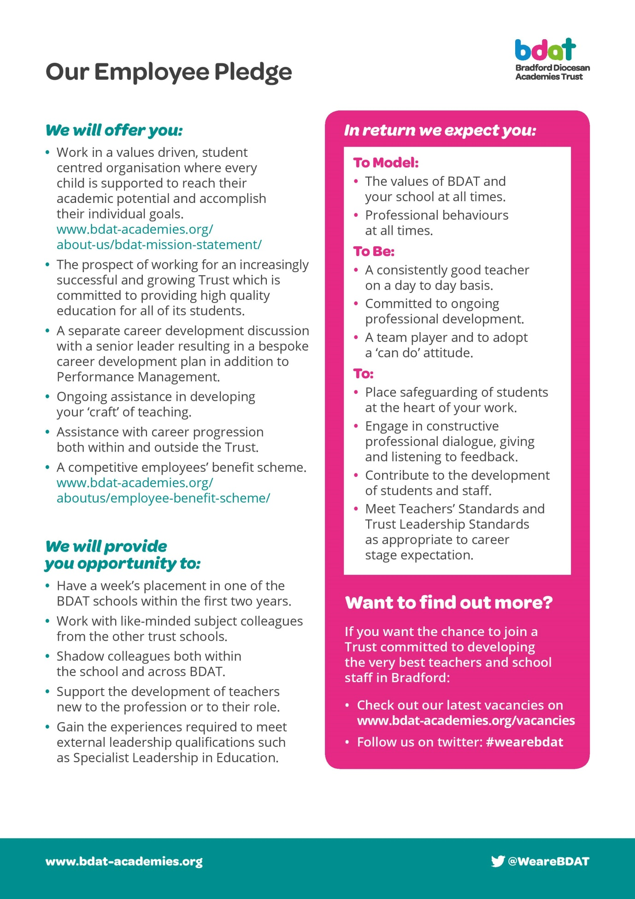

**In And Around Shipley**



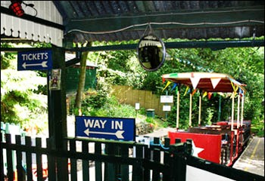

Shipley's immediate neighbour is the UNESCO World Heritage Site of Saltaire, a model village built in the 19th century by the mill-owner Titus Salt to house his workers. The impressive mill buildings no longer produce textiles but have been converted into offices, shops, a restaurant, and the 1853 Gallery, which holds a large collection of the works of Bradfordian David Hockney. Most of the original community buildings are now occupied by Shipley College.

Situated as it is on the Aire Valley, it has excellent rail and road links not only to the university cities of Bradford and Leeds (with their theatres, museums, restaurants and shops) but also to Ilkley (with its famous moor), Haworth and the Bronte country and, via the Settle-Carlisle railway, to the more distant Dales and the Lake District. The Leeds/Liverpool canal takes you across to the other side of the Pennines and Leeds/Bradford airport connects to the four corners of the globe.

Shipley is an old market town and it retains a strong sense of identity. It still has its weekly market, though the market place itself has been rebuilt and is surrounded by modern shops. The adjacent library, health centre and swimming pool are also of recent origin.

Over the bridge across the river is another remnant of the Victorian era, the Shipley Glen Tramway, built to carry people up to the village of Baildon and now operated by volunteers as a tourist attraction. It leads onto Baildon moor and the stone circle known as Soldier's Trench, which is thought to date from the Bronze Age.



Shipley is a pleasant place to live and work, with housing of all descriptions and access to every kind of sporting and leisure activity.

**How to find us**

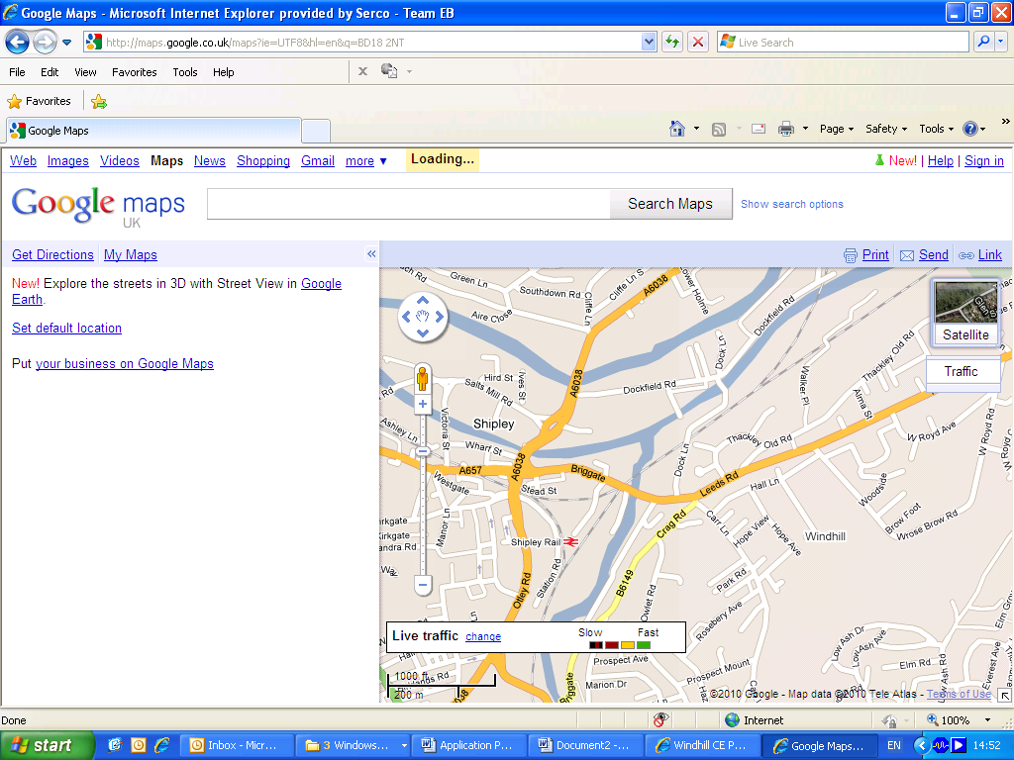

**We Are Here**



**Christ Church Academy**

**Wrose Brow Road, Shipley, BD18 2NT**

**Tel: 01274 410349**

**www.christchurchacademy.org.uk**

|  |  |
| --- | --- |
| **Job Title:**  **JOB DESCRIPTION** | **Deputy Head Teacher** |
| **Grade:** | **Range L7-11** |

The core purpose of the Deputy Headteacher is to support the Headteacher in providing professional leadership and management for our school. This will secure success and improvement for the school; ensure high quality education and personalised learning for all its pupils and high standards and achievement in all areas of the school’s work. The Governing Body will expect the deputy Headteacher to lead by personal example in demonstrating a full and professional commitment to excellence in primary education.

The postholder will carry out the duties of a Deputy Headteacher as set out in the current edition of the School Teachers’ Pay and Conditions Document issued by the Department for Education.

**A = assessed at application I = assessed at interview T = assessed through selection test**

**F = Faith Reference**

|  |  |
| --- | --- |
| **Leading Learning and Teaching**   To provide high quality learning and teaching to enable our pupils to become effective, enthusiastic, independent learners, committed to life-long learning. This implies setting high expectations so that pupils achieve their maximum potential. | **Essential**   * Be a good or outstanding classroom practitioner. **(A,I)** * Has a proven track record of excellent teaching and pupil progress   and outcomes. **(A, I)**   * Has substantial, effective and successful experience as a member   of the senior management team in primary schools. **(A)**   * Has a good understanding of the National Curriculum, Foundation   Stage Curriculum and statutory assessment arrangements. **(A, I, T)**   * Has a good knowledge of education effective for a multi-faith   society and the role of the community involvement in its  development. **(A, I, F)**   * Has in depth knowledge to ‘*excellence and enjoyment’* in primary teaching practice, including appropriate teaching and learning   styles and Assessment for Learning. **(A, I, T)**   * Substantial and successful experience of monitoring and   evaluation, target setting, school improvement planning, and curriculum leadership. **(I, T)**   * Understands available school performance data, its analysis and   uses to secure school improvement. **(I, T)**   * Has a good knowledge and understanding of the principles that   underpin inclusion and equal opportunities and a commitment to implementing these in practice. **(A, I, T)**   * Has a good understanding of SEN code of practice and wider   inclusion strategies **(A, I, T)**   * Understands school self-evaluation and its link with school   improvement and Ofsted inspection process. **(I, T)**   * Able to manage and develop a culture of high expectations and appropriate challenge and lead by personal example. **(I, T)** * Is committed to delivering a broad and balanced curriculum, which   includes innovative approaches to enrich the spiritual, cultural,  social, emotional and sporting experiences of all pupils. **(I) (F)**   * Is committed to personalised learning approaches, in order to   ensure success for every child. **(I, T)**   * Has experience of observing and feeding back on learning and   teaching to staff in order to improve further the quality of learning  and teaching across the school. **(A, I)**   * Has substantial, effective and successful experience as a   curriculum leader. **(A)**  **Desirable**  Has confidence in leading a core curriculum area (A, I) |
| **Developing Self and Working with Others**  To work with the Headteacher and through others, including our pupils, staff, governors, parents and other members of the community to build a professional learning community, which enables others to achieve. | **Essential**   * Demonstrate high standards of personal integrity, loyalty,   discretion and professionalism (A,I)   * Has a DfE recognised teaching qualification. **(A)** * Is an active learner and can show evidence of own continuing professional development and is committed to learning, listening   and reflecting. **(A, I)**   * Has a good knowledge and understanding of relevant legislation   and current educational developments, including the safeguarding  of children. **(A, I)**   * Treats all people fairly, equitably and with dignity to create and   maintain a positive school culture. **(I)**   * Able to develop a rapport with the children. **(A, T, I)** * Has a calm and authoritative manner with a visible presence   around school. **(A, I, T)**   * Able to promote team and individual working as appropriate to   fulfil school objectives. **(I)**   * Able to establish excellent working relationships with others. **(I**) * Experience of developing individuals and teams in order to achieve personal and shared goals in the drive for school improvement.   **(A, I)**   * Has empathy with pupils from a range of cultural and faith   traditions and socio-economic circumstances. **(A, I)**  **Desirable**   * Have further relevant qualifications. **(A)** * Has NPQH or a determination to achieve the NPQH qualification.   **(A)**   * Able to balance work and personal life and is considerate of the   well-being of others. **(A, I)**   * Has experience of leadership in rigorous Performance   Management. **(A, I)** |
| **Managing and Leading the Organisation**  To support the Headteacher in providing effective organisation and management for our school, and to lead and seek ways of improving organisational structures and functions. Ensure that the school and the people and resources within it are organised and managed to provide an efficient, effective and safe learning environment, managing available resources and ensuring value for money through effective performance management. | **Essential**   * Able to promote good behaviour, a positive school ethos and   high attendance. **(I)**   * Demonstrate high standards of personal integrity, loyalty,   discretion and professionalism **(A,I)**   * Able to identify successes and failures and positively embrace   change to secure continuous school improvement including taking  risks in order to find improved ways of working. **(A, I)**   * Prepared to challenge staff and established ways of working in   order to move the school forward **(I)**   * Has experience of leading or participating in the implementation   of school or educational initiatives. **(A, I)**   * Will be expected to work evenings or weekends on occasion. **(A, I)** * Has a good knowledge of safeguarding and child protection. **(A,I)**   **Desirable**   * Some understanding or experience of managing a budget. **(I)** * An understanding of strategic planning, monitoring and evaluation.   **(I)** |
| **Securing Accountability**  With values at the heart of their leadership, the Deputy Headteacher at our school will have a professional responsibility to the whole school community. The Deputy Headteacher is also legally and contractually accountable to the Headteacher and governing body for the school, its environment and all its work. Additionally, the Deputy Headteacher is responsible for supporting the Headteacher in ensuring collective responsibility in order that all members of the school community accept they are accountable for the contribution they make to school outcomes. | **Essential**   * Is prepared to be accountable along with the Headteacher for the school’s performance. **(I)** * Is prepared to take direction from the Headteacher and governing   body. **(I)**   * Understands the need to maintain a safe and healthy environment   for all users of the school. **(I)**   * Understands the school’s responsibilities for child protection and   the safeguarding of pupils. **(I)**   * Has high expectations of all teaching and support staff and is   prepared to support the Headteacher in dealing with any underperformance in a firm and fair way. **(I)**  Desirable   * Has some experience of encouraging and coaching   underperforming staff. **(I)**   * Some experience of working with a governing body. **(I)** |
| **Strengthening Community through Collaboration**  To engage with the internal and external school community, thus modelling the principles of equity and entitlement. To work with the Headteacher to encourage and engage in collaboration with other schools in order to bring positive benefits to the school and share its expertise more widely. | **Essential**   * Has a commitment to the principles of Every Child Matters and   inclusive practices ensuring equal rights for all. **(A, I)**   * Recognises the vital partnership with parents/carers and in   particular, their role in contributing to the child’s education and  positive school life. **(A, I)**   * Has some experience of working effectively with parents and the community. **(A, I)** * Committed to networking and collaboration with partners,   including the Church other schools, the LA, businesses and  community organisations. **(A, I,)**   * Committed to developing the Christian character and ethos of our   school **(A,F)** |

## **Deputy Headteacher Selection Process Guidance**

Our aim is to ensure that we recruit the right person for the job. We will ensure that the selection process is fair and without discrimination for or against any candidate based on age, ethnicity, sex, marital status, or sexual orientation. The person specification sets out the criteria used to assess candidates through the selection process.

We are committed to safeguarding our pupils and will assess the candidate’s suitability for working with children as part of the selection process. We will check the accuracy of all information and investigate any perceived anomalies. We take up references prior to interview and use these to verify the information you have given us. Firm offers of employment are never made without satisfactory references. All potential employees are subject to an enhanced disclosure form the Disclosure and Barring Service.

**Visits to the school**

Visits to the school are warmly welcomed by prior arrangement, you will not be disadvantaged if you are unable to visit. Please contact Mrs Annwen Ackroyd on 01274 410349 to arrange a mutual appointment. The visit will give you an opportunity to ask questions about the role and the school to assess if this is somewhere you would like to work.

**Applications**

Please ensure that all parts of the application are completed. We do not accept CVs as part of the selection process. Please ensure that you demonstrate how your experience and skills make you suitable for the position. Applications can be submitted online, via email or via paper copy.

**Shortlisting**

We assess all applications against the person specification criteria using the evidence you provide in your application. This is done by a panel of senior staff, the Trust Education Director and governors. We carefully check all applications for anomalies.

Candidates who best meet the person specification will be invited to an interview. We will notify you by telephone with e-mail confirmation to follow. If you have not heard from us within 3 days of the shortlisting date, you have not been successful at this stage.

**References**

We request references for all candidates who are invited to interview. Requests will be made at the same time that candidates are invited to interview. Your first referee should be your current or last, employer.

**Interview Day**

The interview day will consist of several tasks and activities including a formal interview. These are designed to allow you to demonstrate your skills and abilities. You will be asked to bring proof of qualifications and identity on the day.

**Final Selection**

Following the tasks and formal interview, we will use the person specification as a guide to select the most suitable candidate for our school. We will then telephone each candidate to inform them of the outcome. We will give brief feedback during this telephone conversation.

**Offer of Employment**

We will make a verbal offer of employment by telephone on the day of the interview and this will be confirmed in writing. Any offer is made subject to:

* References satisfactory to us
* A satisfactory DBS check
* Provision of proof of identity and qualifications

**Terms and Conditions**

* The employer for this post is the Bradford Diocesan Academies Trust.
* An Enhanced DBS is required for this post.
* The post is subject to a three-month probationary period.

**Time line**

Application Closing Date: Monday 4th February 2019 9.00am

Shortlisting: Monday 4th February 2019

Interviews: Thursday 14th February 2019