S:\BDAT Comms and Marketing\Logo\BDAT Logo_final_low res.tif



**Teaching Assistant**

**Application Pack**

**June 2019**

**Contents**

* Letter from the Head Teacher
* Advertisement
* Bradford Diocesan Academies Trust
* In and around Shipley
* How to find us
* Job Description and Person Specification
* The selection process

S:\BDAT Comms and Marketing\Logo\BDAT Logo_final_low res.tif

Dear Applicant,

Thank you for your interest in the post of Teaching Assistant at Christ Church Church of England Academy. I would like to take this opportunity to tell you a little about our school. Christ Church Academy is a one form entry school for pupils aged 3 to 11 years. We are part of the Bradford Diocese Academies Trust (BDAT) and serve the community of Shipley in West Yorkshire.

The school became an Academy in August 2013. Our latest Ofsted in October 2016 judged our school as GOOD, showing we have high standards for teaching and learning and we are working hard to ensure that Christ Church Academy becomes the local school of choice.

Our children enjoy coming to school and are keen to learn. Our staff are passionately committed to ensuring that our pupils achieve and they have high expectations for the children and for themselves. Many of our pupils are vulnerable in terms of their socio economic background and it is vital that their primary school experience is of a high quality and has a positive impact on their future life chances.

The role of Teaching Assistant is key to the success of the individual pupils and their class. The ability to form good working relationships is key to the role of Teaching Assistant.

I would strongly recommend that you come to visit us in order to gain insight into the deeply rewarding career that working with our pupils and staff has to offer.

Kind regards,



**Philippa Foster**

**Headteacher**



**Teaching Assistant   
27.5 hrs per week TTO (potential for additional hours in our out of school provision, Jellybeans)  
Required ASAP**  
**Salary SCP 4/5/6 £11572 - £11939 (actual salary correct june 2019))**

Christ Church Academy is a one form entry primary academy situated above Shipley with fantastic views across the valley and the UNESCO world heritage site at Saltaire. We are proud that visitors comment on what a lovely place it is and how well-mannered and enthusiastic our pupils are.

|  |  |
| --- | --- |
| **We are looking for a person who:**   * wants to make a difference and ensure positive outcomes for children * has excellent literacy and numeracy skills * can use their initiative and have high expectations * has good interpersonal skills * is enthusiastic and keen to join a hard working team * is willing and able to work within the whole of the primary age range * is willing to work throughout the official lunch period to ensure supervision and safety of children | **We can offer:**   * The opportunity to be part of BDAT and work with schools and colleagues across the trust for career progression * Career development opportunities for the successful candidate to shape the role according to interests and skills * children who are keen to fulfil their potential * a positive and friendly working environment * a commitment to professional development |

Visits to the school are warmly welcomed by prior arrangement. Please contact our Business Manager, Mrs Annwen Ackroyd on 01274 410349 to arrange a mutual appointment. Applications can be made on our application form via e – mail to [admin@cca.bradford.sch.uk](mailto:admin@cca.bradford.sch.uk) or through prospects online.

Christ Church Academy is committed to safeguarding and promoting the welfare of our pupils and expect all staff and volunteers to share this commitment. All staff are subject to an enhanced DBS check.

Application Closing Date: Friday 5th July 2019

Shortlisting: Friday 5th July 2019

Interviews: Tuesday 9th July 2019



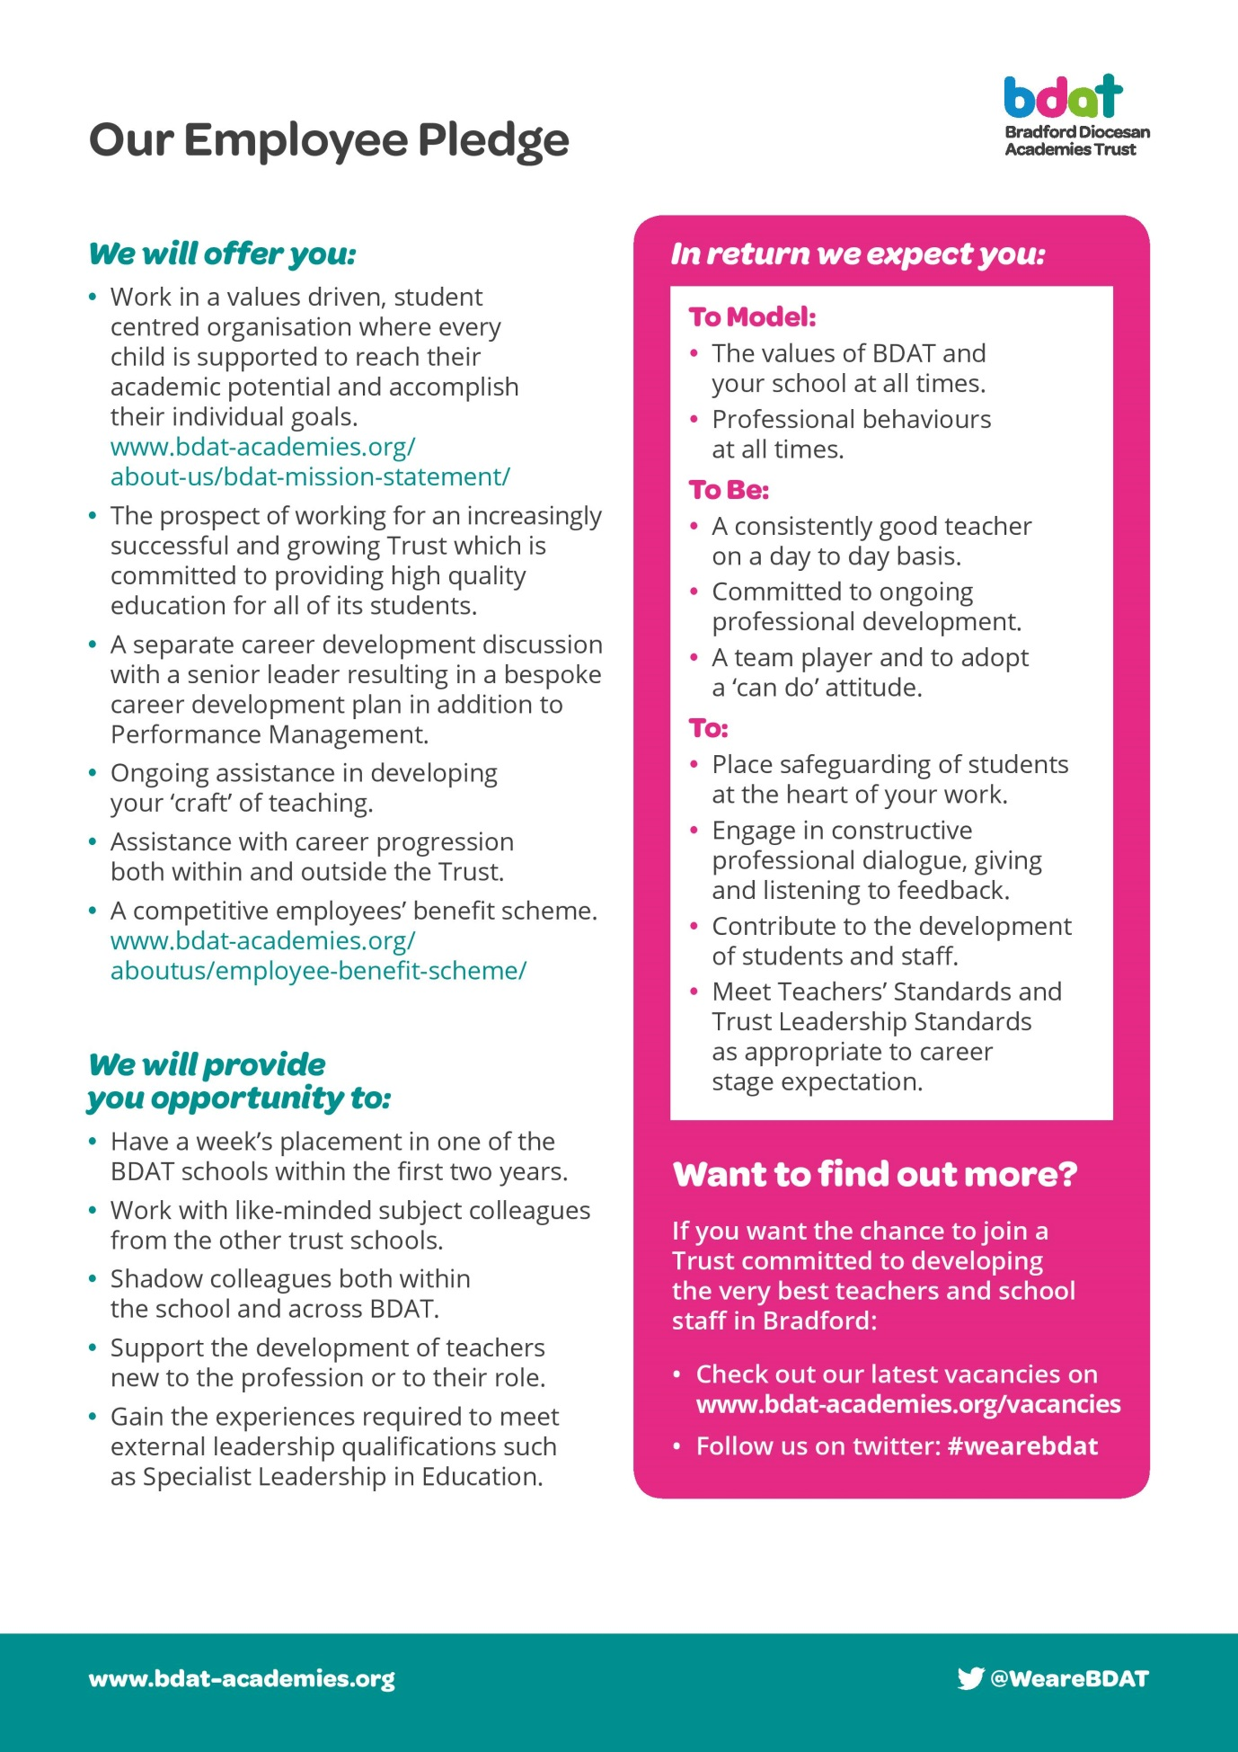

**In And Around Shipley**

Shipley is an old market town and it retains a strong sense of identity. It still has its weekly market, though the market place itself has been rebuilt and is surrounded by modern shops. The adjacent library, health centre and swimming pool are also of recent origin.



Situated as it is on the Aire Valley, it has excellent rail and road links not only to the university cities of Bradford and Leeds (with their theatres, museums, restaurants and shops) but also to Ilkley (with its famous moor), Haworth and the Bronte country and, via the Settle-Carlisle railway, to the more distant Dales and the Lake District. The Leeds/Liverpool canal takes you across to the other side of the Pennines and Leeds/Bradford airport connects to the four corners of the globe.

Shipley's immediate neighbour is the UNESCO World Heritage Site of Saltaire, a model village built in the 19th century by the mill-owner Titus Salt to house his workers. The impressive mill buildings no longer produce textiles but have been converted into offices, shops, a restaurant, and the 1853 Gallery, which holds a large collection of the works of Bradfordian David Hockney. Most of the original community buildings are now occupied by Shipley College.

Over the bridge across the river is another remnant of the Victorian era, the Shipley Glen Tramway, built to carry people up to the village of Baildon and now operated by volunteers as a tourist attraction. It leads onto Baildon moor and the stone circle known as Soldier's Trench, which is thought to date from the Bronze Age.

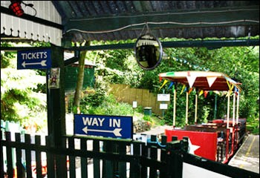

Shipley is a pleasant place to live and work, with housing of all descriptions and access to every kind of sporting and leisure activity.

**How to find us**

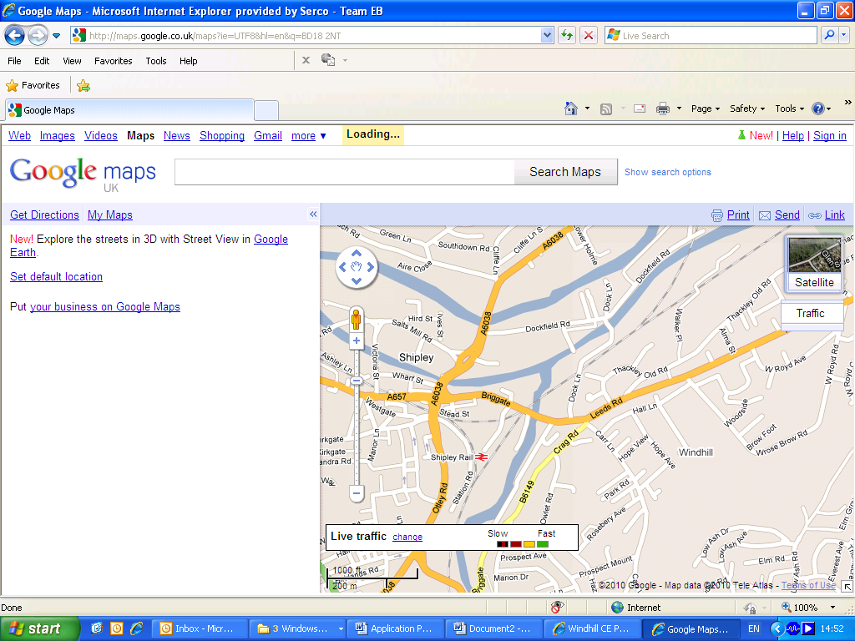

**We Are Here**



**Christ Church Academy**

**Wrose Brow Road, Shipley, BD18 2NT**

**Tel: 01274 410349**

**www.christchurchacademy.org.uk**

**Outline Job Description**

|  |  |
| --- | --- |
| **Post Title:** | **TEACHING ASSISTANT**  **TTO - 27.5 hours per week** |
| **Post Ref:** | **20194** |
| **Grade:** | **Salary SCP 4/5/6 £15725 to £16361 (actual salary correct june 2019))** |

**Introduction:**

The following information is furnished to help Christ Church Academy staff and those people considering joining the academy to understand and appreciate the work content of their post and the role they are to play in the organisation. However, the following points should be noted:

*1 Whilst every endeavour has been made to outline all the duties and responsibilities of the post, a document such as this does not permit every item to be specified in detail. Broad headings, therefore, may have been used below, in which case all the usual associated routines are naturally included in the job description.*

1. *Employees should not refuse to undertake work, which is not specified on this form, but they should record any additional duties they are required to perform and these will be taken into account when the post is reviewed.*
2. *Christ Church Academy is an Equal Opportunities Employer and requires its employees to comply with all current equality policies.*
3. *Christ Church Academy is committed to making any necessary reasonable adjustments to the job role and the working environment that would enable access to employment opportunities for disabled job applicants or continued employment for any employee who develops a disabling condition*

**PRIME OBJECTIVES OF THE POST:**

To complement, appreciate and support the role of teachers and other professionals by undertaking work/care/support programmes which enables access to learning in the community as part of a teacher planned approach.

To support the class teacher in the management of pupils in the classroom, and other senior staff on a range of teaching and learning experiences which deliver an appropriately differentiated and suitably challenging curriculum for all pupils whilst meeting statutory requirements.

Work within school policies and procedures under the direction and guidance of senior staff and within an agreed system of supervision.

May from time to time be required to undertake other duties commensurate with the grade and level of responsibility defined in this job description.

**Knowledge and Skills:**

*(See Personnel Specification)*

**Effort Demands:**

* Will assist in maintaining the nurturing ethos of the school using Restorative Practice and good common sense, as well as use initiative in all matters relating to the conduct and behaviour of individual pupils, groups of pupils and whole classes, the safety, mobility (if required), hygiene and well being of the pupils; making decisions within established working practices and procedures.
* Will recognise and challenge any incidents of racism, bullying, harassment, victimisation and any form of abuse of equal opportunities, ensuring compliance with the relevant school policy and procedures.
* Will deal with any issues, immediate problems or emergencies that arise in line with school policies and procedures liaising with colleagues where necessary e.g. dealing with a sick, injured or distressed child.
* Acting as a role model, will establish productive and constructive working relationships with pupils, setting high expectations, and providing high levels of support. Motivating and interacting with pupils, being aware of their individual needs, supporting difference and ensuring all pupils have equal access to opportunities to learn and develop whilst responding appropriately.
* Will have the ability to cope with the requirements of the post, which may include working with pupils who have emotional/behavioural/physical difficulties and requiring close supervision and/or personal care.
* Will contribute to the overall ethos/work/aims of the school.
* Will appreciate and support the role of other professionals.
* Be vigilant and sensitive to any child protection/safeguarding concerns that arise, reporting any concerns to the designated officer in line with school policy and procedure.

**Responsibilities:**

* Assist in the management of pupils in the learning environment.
* Work with pupils on a 1:1 and small group basis supporting their learning and access
* Assist in the planning of learning activities.
* Will administer routine tests, invigilate exams and undertake routine marking of pupils’ work.
* Undertake structured and agreed learning activities/teaching programmes appropriate to the pupil’s needs to ensure physical, social, emotional and intellectual development, taking into account diversity e.g. language, culture, ability, race and religion.
* Will supervise and support pupils consistently at all times including those with special needs; recognising and responding to their individual needs including personal care whilst ensuring their safety and education in the learning environment.
* Assist with the development and implementation of Individual Education Plans and Personal Care Programmes; attending to the pupils’ personal needs and maintaining related personal programmes with the correct use of care materials including the safety and well being of the pupils, therapy and medical intervention needs of the pupil and first aid, paying attention to social, health, physical and welfare matters as well as high standards of cleanliness and hygiene e.g. washing, dressing, toileting, and, if applicable, mobility.
* For posts working with pupils who are physically less able, it may be necessary to be able to physically assist the pupil in line with school polices and good practice.
* Will occasionally be required to supervise the class for brief periods
* Promote and reinforce the inclusion, acceptance and integration of all pupils, including those with specific and special needs and those from different cultures and/or with a different first language as appropriate.
* Set challenging and demanding expectations whilst promoting self-esteem and encouraging pupils to act independently as appropriate as well as interact and work co-operatively with others and engage in activities led by the teacher.
* Will prepare, create and maintain a purposeful, orderly and supportive learning environment to meet the lesson plans. Take responsibility for the care, preparation, maintenance and use of relevant equipment, assisting pupils in its use and clearing/storage afterwards.
* Will be aware of pupil progress, monitor/record pupil responses against pre-determined learning objectives as well as provide accurate, constructive and detailed feedback/reports to the teacher and pupils.
* Promote positive values, attitudes and good pupil behaviour and encourage pupils to take responsibility for their own actions whilst supporting the teacher in managing this. Deal promptly with conflict and incidents (including those involving restraint) and reporting challenging behaviour where appropriate in line with established policy and restorative practices.
* Will gather/report information from/to parents/carers as directed, taking into account parental/carer concerns, dealing with them sensitively under the direction of the teacher.
* Will provide clerical/administrative support as directed by the teacher.
* In respect of local and national learning strategies, will support pupils to achieve learning goals e.g. literacy, numeracy, KS1, KS2, early years as directed by the teacher.
* Will support pupils in the use of ICT in learning activities as directed by the teacher, and develop pupils competence and independence in its use.
* Will participate in own performance development, identify and address any training needs/other learning activities.
* Will assist with the supervision of pupils out of lesson times, including before and after school and at lunchtimes, accompanying teaching staff and pupils on visits, trips and out of school activities; taking responsibility for a group under the supervision of the teacher.
* Will assist in the supervision of students on work experience, trainees and voluntary helpers.

**environmental demands/Working Conditions:**

* Will have long periods of sitting or standing.
* May be required to move quickly to ensure pupil safety
* Available to work during school hours during term time and a willingness to be flexible as may be required to attend staff meetings/training sessions outside of usual hours.
* Will have contact with members of the public/other professionals e.g. teaching staff, governors, parents/carers, community groups, local education authority, external providers etc.
* The post holder may occasionally be subjected to antisocial behaviour from members of the public/parents/site users.
* This post may include a degree of manual lifting and handling. You are expected to be aware of health and safety policies and procedures and frequently assess your ability to carry out the lifting tasks required of you.
* Report all concerns to an appropriate person.

**Special Conditions of Service:**

* No contra-indications in personal background or criminal record indicating unsuitability to work with children/young people/vulnerable clients/finance (An enhanced DBS check is required).

**Other considerations**

* To be aware of and comply with policies and procedures relating to child protection; being vigilant for signs that children may be being abused and to report any such suspicions to the school’s nominated Designated Safeguarding Lead, a named person or the Headteacher.
* To act in accordance with the General Data Protection Regulation and maintain confidentiality at all times e.g. access to staff/student/parent and carers files.
* Accept and commit to the principles underlying the Schools Equal Rights policies and practices.
* Be able to perform all duties and tasks with reasonable adjustment, where appropriate, in accordance with the Equality Act.
* Must be legally entitled to work in the UK.

**PERSONNEL SPECIFICATION:**

|  |  |
| --- | --- |
|  | **ESSENTIAL (E)/DESIRABLE (D)** |
| **Experience:** | * Experience of working with or caring for children of relevant age e.g. voluntary organisation or parental/caring responsibilities. (E) * Experience of working in a team situation.(D) |
| **Qualifications/**  **Training:** | * GCSE English and Maths or equivalent e.g. Adult Literacy/Numeracy at level 1. (E) * Evidence of further training/development and/or willingness to participate in further training and development opportunities. (E) * Other relevant qualifications relating to the post e.g. Level 2 NVQ in Health/Childcare, first aid qualification.(D) |
| **Knowledge/ Skills:** | * Will possess knowledge procedures or practices relevant to schools (E) * Will have an outline understanding of relevant legislation. (E) * Problem solving skills. (E) * Good communication skills. (E) * Exercising advisory, guiding, negotiating and persuasive skills at a developed level. (E) * Good numeracy/literacy skills. (E) * Basic ICT skills. (E) * An understanding of the needs of a multicultural society. (E) * An understanding of the issues relating to pupils who have additional learning needs, more able and special educational needs. (E) * Knowledge of childcare. (E) * Awareness of child development. (E) * Knowledge and commitment to schools Equality policy. (E) * Ability to relate well to pupils and adults. (E) * Ability to work constructively as part of a team. (E) * Ability to remain calm under pressure. (E) * Demonstrate a commitment to working with children of the relevant age. (E) * Demonstrate good co-operative, interpersonal and effective listening skills. (E) * Maintain confidentiality in matters relating to the school, its pupils, parents or carers. (E) * Ability to perform all duties and tasks with reasonable adjustments where necessary. (E) * Ability to cope with the requirements of the post, which will include working with pupils who have emotional/ behavioural/physical difficulties. (E) * Willingness to work in out of school provision (Jellybeans) (D) |

**OFFICE USE ONLY:**

|  |  |
| --- | --- |
| **Compiled by:** | A Ackroyd, P Foster |
| **Date of Issue:** | June 2019 |

## **Teaching Assistant Selection Process Guidance**

Our aim is to ensure that we recruit the right person for the job. We will ensure that the selection process is fair and without discrimination for or against any candidate based on age, ethnicity, sex, marital status, or sexual orientation. The person specification sets out the criteria used to assess candidates through the selection process.

We are committed to safeguarding our pupils and will assess the candidate’s suitability for working with children as part of the selection process. We will check the accuracy of all information and investigate any perceived anomalies. We take up references prior to interview and use these to verify the information you have given us. Firm offers of employment are never made without satisfactory references. All potential employees are subject to an enhanced disclosure form the Disclosure and Barring Service.

**Visits to the school**

Visits to the school are warmly welcomed by prior arrangement, you will not be disadvantaged if you are unable to visit. Please contact Mrs Annwen Ackroyd on 01274 410349 to arrange a mutual appointment. The visit will give you an opportunity to ask questions about the role and the school to assess if this is somewhere you would like to work.

**Applications**

Please ensure that all parts of the application are completed. We do not accept CVs as part of the selection process. Please ensure that you demonstrate how your experience and skills make you suitable for the position. Applications can be submitted online, via email or via paper copy.

**Shortlisting**

We assess all applications against the person specification criteria using the evidence you provide in your application. This is done by a panel of senior staff. We carefully check all applications for anomalies.

Candidates who best meet the person specification will be invited to an interview. We will notify you by telephone with e-mail confirmation to follow. If you have not heard from us within 3 days of the shortlisting date, you have not been successful at this stage.

**References**

We request references for all candidates who are invited to interview. Requests will be made at the same time that candidates are invited to interview. Your first referee should be your current or last, employer.

**Interview Day**

The interview day will consist of several tasks and activities including a formal interview. These are designed to allow you to demonstrate your skills and abilities. You will be asked to bring proof of qualifications and identity on the day.

**Final Selection**

Following the tasks and formal interview, we will use the person specification as a guide to select the most suitable candidate for our school. We will then telephone each candidate to inform them of the outcome. We will give brief feedback during this telephone conversation.

**Offer of Employment**

We will make a verbal offer of employment by telephone on the day of the interview and this will be confirmed in writing. Any offer is made subject to:

* References satisfactory to us
* A satisfactory DBS check
* Provision of proof of identity and qualifications

**Terms and Conditions**

* The employer for this post is the Bradford Diocesan Academies Trust.
* An Enhanced DBS is required for this post.
* The post is subject to a six-month probationary period.

**Time line**

Application Closing Date: Friday 5th July 2019

Shortlisting: Friday 5th July 2019

Interviews: Tuesday 9th July 2019