
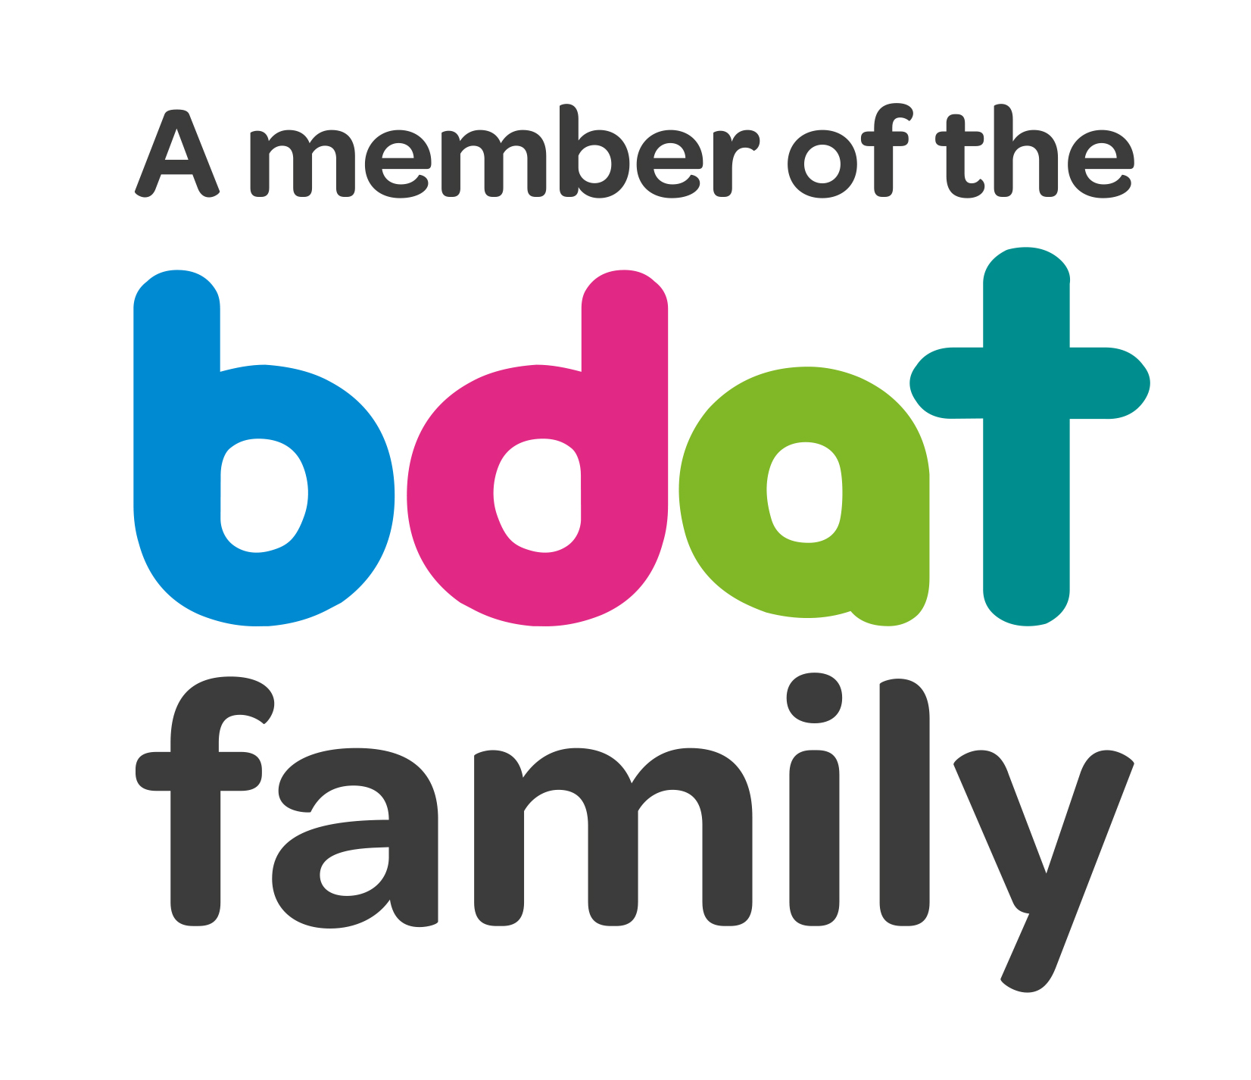
Christ Church Academy
Wrose Brow Road
Shipley
Bradford
BD18 2NT
01274 410349
admin@cca.bradford.sch.uk
Headteacher: Mrs Philippa Foster

Date: 4th December 2019

Dear Parents/Carers,

It has come to our attention that the sickness bug known as Norovirus is circulating. This virus is highly contagious and will, according to the NHS, continue to be active through to February and March.

There is no treatment needed for the virus and it will pass on its own usually within two days.

Symptoms include:

- Stomach cramps
- Projectile vomiting
- Watery diarrhea

To help prevent the virus spreading in school we are consistently promoting good hand hygiene by encouraging the children to wash their hands, and use the hand gel located around school. We ask that you do the same at home.

Ensuring the health and happiness of each child is a priority, and we ask that if your child develops any of the symptoms (especially vomiting and diarrhea), that you keep them at home. The NHS has advised that children must not return to school until 48 hours after symptoms have ended.

Thank you for your support.

Miss K Bellwood
First Aid Coordinator

