 |  | Term 1 |  | Term 2 | Term 3 |  | Term 4 | Term 5 | Term 6
Why is it good to be me? (senses)
Prayer –
Thank you God for feet to run,
Thank you for my play and fun,
Thank you God for eyes to see,
Thank you for making me a special me.

Thank you God a nose to smell,
Thankyou for making me fit and well,
Thank you God for hands to touch,
Thankyou God so very much.

Topic |  | Let’s Explore!  What do I like to do best? |  | All that glitters.  I can explore, what can I see?  (Shiny and dull) | Pirates  What can I feel?  (touch) |  | Weather  What is it like to be warm and cold? | Traditional tales  What do my taste buds and nose tell me?  (taste) | Growing  How do things change when they grow?
Key knowledge  (skills taken from Development Matters) |  | The children will know the rules and expectaions of the areas of learning. |  | The children will know the words shiny and dull. | The children will know different types of transport. |  | The children will know the difference between hot and cold. | The children will know the sequence of a traditional story. | The children will know the life cycle of an animal.
Reading Texts |  | 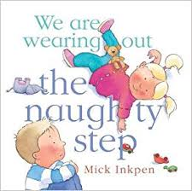  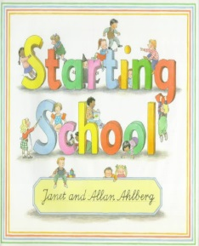  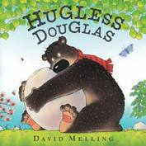 |  | 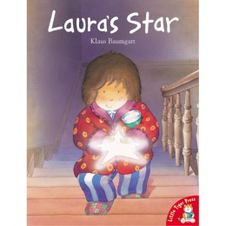  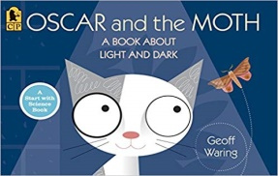  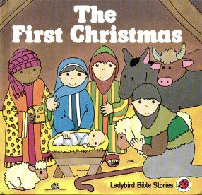 | 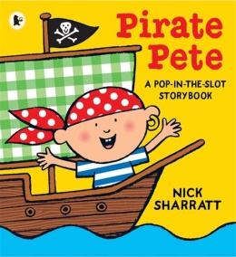  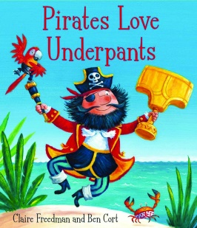  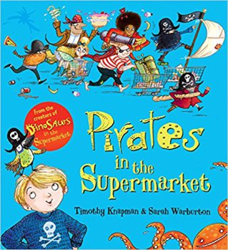 |  | 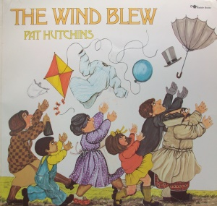  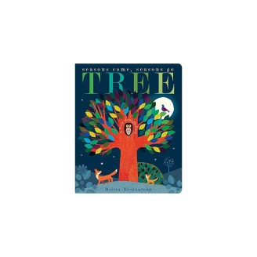  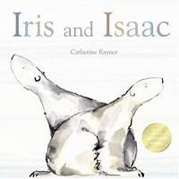 | 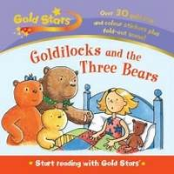  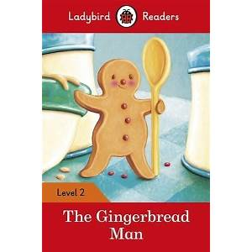  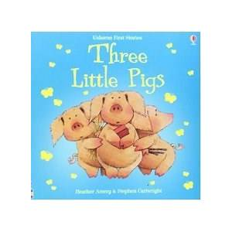 | 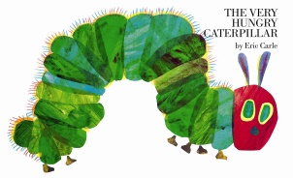  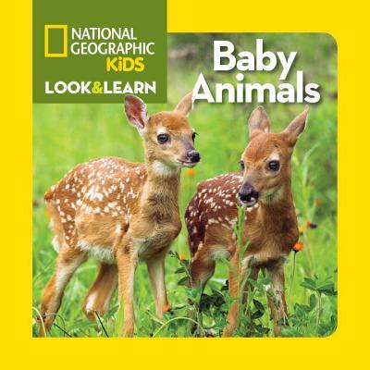  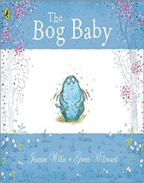  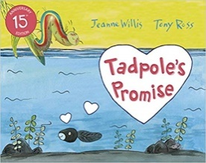
Writing Genres |  | Pencil grip  Mark making  Writing patterns  Name writing |  | Pencil grip  Mark making in all areas  Writing patterns  Name writing  Letters to Santa | Pencil grip  Mark making  Writing patterns  Name writing  Labels  Treasure maps  Clues |  | Pencil grip  Mark making  Writing patterns  Name writing  Labels | Retelling stories, through drawing and writing.  Word banks to support writing of familiar stories.  Writing in role play areas. | Information posters  How to look after…  Initial letter sounds and simple words  Phase 1 and 2 phonics.  Lists, labels and other writing for purpose.  Word banks inside and outside.
Developing Language |  | Area names- vocabulary  Knowing other children’s names  Talk frames  Developing an environment secure for talk.  Autumnal vocab |  | To use vocabulary relating to Nativity.  Main character names.  Bethlehem.  Stable  Manger  Reflector  Shiny, sparkly, glitter, glow, | To use vocabulary relating to Pirates |  | Hot and cold vocabulary  Weather words | Traditional story vocab,  Once upon a time…  Happily ever after…  Hero  Villain  Recipe language | Life cycles  Animal names and their babies  Habitat vocab  Observations
Maths |  | - correspondence  Matching objects to shapes on the shelves  Counting back resources, i.e 2 pens, 3 scissors… |  | Advent.  Sizes, shapes and weights of presents.  Number lines  Pattern | Number rhymes and songs with resources.  Numicon intro |  | Matching pairs  Number recognition, 0-5, 0-10  Counting animals | Counting and measuring ingredients.  4 spoons of flour…  Positional language | Sorting and making patterns with seeds.  Counting on  Symmetry
Enrichment activities |  | Basic provision  Where do things go?  What do we do in each area?  Becoming independent in each area |  | Light box.  Torches and reflectors.  Dark area  Books telling the Nativity story  Small world nativity | Pirate small world  Pirate number problems  Different types of transport out, land, see and air.  Pirate costumes  Enhanced provision in the pirate ship outside. |  | Ice in the classroom  Cold small world areas.  Clothes for different weather  Kite making equipment  Weather stations | Small world traditional tales.  Home corner as a traditional tale setting.  Lots of traditional tale books in areas, especially reading and small world. | Life cycle resources  Symmetry work  Animal number problems  Non fiction books about animals and their young.
Festivals/ British Values |  | Staff support decisions children make and provide activities that involve turn taking, sharing and collaboration.  An atmosphere where questions are valued.  'the rule of law'. Teaching that there are boundaries and consequences  respect and tolerance for others is about learning to understand and appreciate each other's differences
 |  | Bonfire night  Harvest  Diwali  Table etiquette  Manners  Community |  | Christmas  Advent  Armistice Day  Why do Christians perform a Nativity play at Christmas? | Shrove Tuesday  Ash Wednesday  Chinese new year  Mother’s day |  | Easter  Seasons | Traditional tales and their messages to us.  Traditional British food  Queen’s birthday picnic | Eid – developing respect for other peoples values and beliefs.  Sports day
R.E syllabus |  | New babies, weddings, christenings, death of a pet, celebrations of children’s faiths…ongoing
 |  | Being special. Where do we belong?  Why is God is an important person to Christians?  The lunch time prayer |  | Nativity story  Small world nativity  Nativity play  Advent calendar  Books telling the Nativity story  Pictures of the children dressed up. | Which places are special and why? |  | Which stories are special and why?  Why do Christians put a cross in an Easter garden?  Easter story  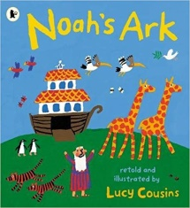 | Which stories are special and why?  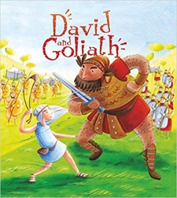  Eid | God created all of the creatures  We need to look after everything for God.  Eid
Learning Experiences |  | Walk in the woods  Outside areas. |  | Nativity play  Parents to come in and do Christmas crafts with their children.  Invite parents in for a Christmas story.  Road safety demonstration.  Fire in Arks fire pit  Sparklers  Light a candle  (risk assessments to be completed) | Dress up as a pirate day  Face painting  Visit to the Church |  | Playing in the snow.  Ice  Mr Freeze visits | Visit to a bakery.  Warburton’s in school.  Baking for the queens b day  Baking for traditional  Porridge/ginger bread men,… | Visit to the farm/animals into school  Hatching chicks  Hatching butterflies.  Tadpoles
 | EYFS
 | Area of learning and development |  | Aspect |  |  | How we build a Cultural Capital
 | Personal, Social, and Emotional Development |  | Making Relationships |  |  | We provide children with the experiences to collaborate with others and to broaden children’s knowledge and reflect an inclusive ethos. Children have opportunities to share their thoughts and opinions and build positive relationships. Children are given time to reflect upon their own lives and those which are unfamiliar.
 |  |  | Self-Confidence and Self-awareness |  |  | Children are regularly praised for their achievements and have opportunities to reflect on their own successes. Every adult values the child’s ideas and ways of doing things therefore becoming a partner in each child’s learning.
 |  |  | Managing feelings and behaviour |  |  | All children’s imaginative play is supported. Children are encouraged to recognise how and when their behaviour impacts others. Feeling are regularly discussed openly.
 | Understanding the World |  | People and Communities |  |  | We celebrate and value cultural, religious and community events and experiences. We encourage children to discuss their own life and compare it with others.

