


Nurture Plus Lead
Application Pack

February 2020
Contents
- Letter from the Head Teacher
- Advertisement
- Bradford Diocese Academies Trust
- In and around Shipley
- How to find us
- Job Description and Person Specification
- The selection process

Dear Applicant,
Thank you for your interest in the post of the Nurture Plus Lead at Christ Church Church of England Academy. I would like to take this opportunity to tell you a little about our school. Christ Church Academy is a one form entry school for pupils aged 3 to 11 years. We are part of the Bradford Diocese Academies Trust (BDAT) and serve the community of Shipley in West Yorkshire.

Our children enjoy coming to school and are keen to learn. Our staff are passionately committed to ensuring that our pupils achieve and they have high expectations for the children and for themselves. Many of our pupils are vulnerable in terms of their socio economic background and it is vital that their primary school experience is of a high quality and has a positive impact on their future life chances.
Nurture + is an intervention class within our school. It is aimed at meeting the needs of pupils who find the demands of the classroom distressing. Pupils access Nurture + either full or part time. The role provides opportunities for an enthusiastic and dedicated practitioner to shape the intervention to make it an excellent and innovative response to pupil needs.
I would strongly recommend that you come to visit us in order to gain insight into the deeply rewarding career that working with our pupils and staff has to offer.
Kind regards,
Philippa Foster
Headteacher



Nurture Plus Lead

The salary scale for this role spans from NJC SCP 11-16 through UQT1 – UPS (dependent upon experience and qualifications)

We are open to applications from qualified teachers, NQTs and from non-qualified teaching staff with suitable experience.

Required ASAP

Nurture + is a successful provision within our school that supports pupils experiencing complex emotional/behavioural needs.

We are looking for a unique individual who is willing to go above and beyond for our children; someone who can innovate and motivate.
We are looking for a person who:- | We can offer:
- Is able to provide a high level of challenge and support for all children  - Is flexible in their approach to ensure that can work across key stages and settings/classrooms  - Can be proactive in ensuring that the school meets the needs of all pupils  - Can support staff and parents when dealing with a range of behaviours and challenges  - Can support the Christian ethos of the school  - Will be organised and methodical in their record keeping  - Be an integral part of the Christ Church Community | - A unique role and opportunity to shape the future of the provision  - The opportunity to be part of a whole staff team approach  - Appropriate levels of autonomy, challenge and support in order to build on our Nurture + offer  - Amazing pupils who want to do well  - High levels of CPD  - The opportunity to work as part of the BDAT family of schools

Visits to the school are warmly encouraged. Please contact Annwen Ackroyd on 01274 410349 to arrange a time. Applications can be made via e – mail to admin@cca.bradford.sch.uk . The application form is on our website http://www.christchurchacademy.org.uk/our-school__trashed/job-vacancies/
Closing date for applications: Monday 9th March 2020
Interviews: Wednesday 11th March 2020
Christ Church Academy is committed to safeguarding and promoting the welfare of children and expects all staff and volunteers to share this commitment. Any appointment is subject to an enhanced DBS check and references.
.

BAC
In And Around Shipley


Shipley's immediate neighbour is the UNESCO World Heritage Site of Saltaire, a model village built in the 19th century by the mill-owner Titus Salt to house his workers. The impressive mill buildings no longer produce textiles but have been converted into offices, shops, a restaurant, and the 1853 Gallery, which holds a large collection of the works of Bradfordian David Hockney. Most of the original community buildings are now occupied by Shipley College.

Situated as it is on the Aire Valley, it has excellent rail and road links not only to the university cities of Bradford and Leeds (with their theatres, museums, restaurants and shops) but also to Ilkley (with its famous moor), Haworth and the Bronte country and, via the Settle-Carlisle railway, to the more distant Dales and the Lake District. The Leeds/Liverpool canal takes you across to the other side of the Pennines and Leeds/Bradford airport connects to the four corners of the globe.

Shipley is an old market town and it retains a strong sense of identity. It still has its weekly market, though the market place itself has been rebuilt and is surrounded by modern shops. The adjacent library, health centre and swimming pool are also of recent origin.

Over the bridge across the river is another remnant of the Victorian era, the Shipley Glen Tramway, built to carry people up to the village of Baildon and now operated by volunteers as a tourist attraction. It leads onto Baildon moor and the stone circle known as Soldier's Trench, which is thought to date from the Bronze Age.


Shipley is a pleasant place to live and work, with housing of all descriptions and access to every kind of sporting and leisure activity.

How to find us

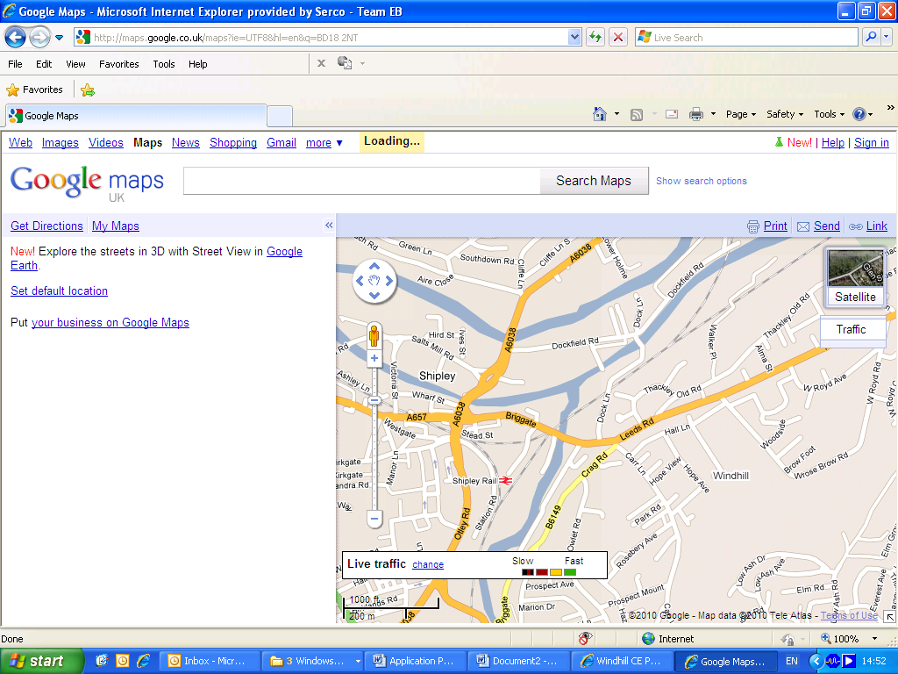
We Are Here



Christ Church Academy
Wrose Brow Road, Shipley, BD18 2NT
Tel: 01274 410349
www.christchurchacademy.org.uk

OUTLINE JOB DESCRIPTION

SUMMARY OF MAIN DUTIES / RESPONSIBILITIES

Post Title: | Nurture + Lead
REPORTING TO: | HEADTEACHER
PAY SCALE: | The salary scale for this role spans from NJC SCP 11-16 through UQT1 – UPS (dependent upon experience and qualifications)

PRIME OBJECTIVES OF THE POST

To manage the day to day running of the provision in order to meet the needs of pupils with complex social and emotional needs. To support professionals to assess needs of pupils in order to secure the correct provision

To support the reintegration of pupils with social and emotional needs, to the main body of the school.

SUPERVISORY/MANAGERIAL RESPONSIBILITIES

To be responsible for the safety and work of support staff, students, parent helpers and work experience personnel, ensuring that they are well briefed and fully prepared to undertake their respective duties. To provide feedback to colleagues. To maintain records and assessments. To lead in areas of the curriculum as required.

SUPERVISION AND GUIDANCE

Directly responsible to the SENDCO and Headteacher through the school management structure. The Headteacher will set overall objectives and priorities. The post-holder is expected to exercise considerable initiative and professional judgement in the performance of their duties.

PRINCIPAL RESPONSIBILITIES AND ACCOUNTABILITIES

Planning and Preparation
- Work within the curriculum policies of the school, following the Curriculum set by the school, bearing in mind the cultural, religious and social backgrounds of the children.
- Develop and implement teaching programmes to meet the learning needs of all pupils in accordance with Curriculum set by the school and the overall aim and curriculum policies of the school.

Teaching
- Teach children within the Ark provision.
- Carry out teaching of allocated pupils to achieve specific curriculum and social/emotional objectives, consistent with the aptitudes and abilities of the pupils.
- To model and encourage appropriate social behaviour in and out of school and to cater for the general welfare of students
- Promote the development of language and mathematical skills.
- Promote pupil wellbeing and social and emotional health.
- Aim to achieve the highest possible teaching standards.
- Liaise with parents and encourage their involvement in line with school’s Parental Involvement policy.
- Liaise with outside agencies to meet the needs of the pupils within the Ark.

Assessment and Record Keeping
- Carry out recording and monitoring of pupils’ achievement and the maintenance of records as
required.
- Complete and maintain Boxall profiles for all children
- Assess pupils’ performance by discussion and observation and ensure that progress is monitored.
- Set challenging but achievable targets on a regular basis.
- Record pupils’ achievements and progress
  - as ongoing formative records of achievement
  - as records at each year end or upon transfer to another school
  - Provide at each year end a written report to parents summarising achievement in all areas of learning.
  - Provide a monthly leadership report to keep the leadership team of the school informed.

Classroom Learning Environment
- Maintain a good educational ethos including the control of storage and use of teaching
materials/resources/books relating to the outdoors and curriculum responsibilities.
- Maintain a stimulating and inspiring classroom which promotes learning through practical Approaches and interactive displays.

ADDITIONAL RESPONSIBILITIES AND ACCOUNTABILITIES

School Development
- Be involved in the ongoing development of the school and its curriculum.
- Contribute effectively to the development of school policy and the identification of priorities for school improvement.
- Participate in staff meetings so as to make an effective contribution to school policies.
- Cooperate with colleagues in the preparation and development of materials to ensure
consistency, continuity and progression.

Public Relations
- Share responsibility for promoting the school to parents and the community.
- Liaise with parents to involve them in supporting their child’s learning.
- Foster relationships with individuals, groups and organisations in the community as appropriate.

Pastoral Care
- Promote the general progress and welfare of the pupils to ensure that their educational and social needs are being met.
- Maintain class and school ethos and discipline among pupils.
- Safeguard their health and safety in accordance with agreed policies, standards and procedures.
- Nurture

School Learning Environment
- Take an appropriate share of the responsibility for the school’s learning environment.
- Cooperate with colleagues in establishing and maintaining an organised, attractive and
stimulating school learning environment.
- Ensure the school’s learning environment reflects the community and the wider world.
- Organise and contribute to displays as required by key leaders.

For qualified teachers - Curriculum Leadership (Post NQT year)
- Lead an area of the curriculum.
- Ensure the development of agreed area(s) of the curriculum to meet National Curriculum
requirements and the aims of the school.
- Identify targets to raise standards of achievement across school.
- Monitor and review on a regular basis.
- Provide support/advice for colleagues as required.
- Identify development priorities for incorporation into the school plan.
- Report to the leadership team on a regular basis and to the governing body when required.

PERSONNEL SPECIFICATION
POST TITLE: Nurture + LEAD
SUMMARY OF JOB:

To be a good or outstanding practitioner.
To work in co-operation with teaching colleagues and other classroom staff to ensure that children assigned to you receive teaching and learning opportunities that meet statutory requirements .
To provide the development of varying skills that support the children’s learning making full consideration for their individual social, emotional, physical and intellectual needs.
To lead and manage the Ark provision within the school
To support colleagues in developing a strong and consistent approach to managing pupil behaviour across the school.

ATTRIBUTES | ESSENTIAL | DESIRABLE | HOW IDENTIFIED
EXPERIENCE | Successful teaching experience | Qualified Teacher Status  Experience of working across the Key Stages  Experience of working with pupils with complex emotional and behavioural needs. | Application Form
 | Experience of working in co-operation with colleagues | Experience of working with children from a wide variety of ethnic, cultural and social backgrounds | Application form, interview.
QUALIFICATIONS | Degree or equivalent experience | Further qualifications relating to education  Evidence of further study of an area of the curriculum.  Bachelor of Education or other recognised teaching qualification | Application form confirmed by sight of original certificates.
TRAINING | Commitment to own personal development, being prepared to undertake training relevant to the post.  Willingness to attend in-service training.  Willingness to lead staff meetings in designated area | Primary school training.  If already teaching, evidence of attendance at in-service training courses.  Training in:  Restorative practice in schools  Nurture approach  Team teach  Thrive  Ruth Miskin Read, Write Inc. (KS1)  (the school is committed to provide training in areas considered important to the role) | Application form, interview.  Interview  Application form, interview
SPECIAL KNOWLEDGE | Aware of current educational trends in classroom management and a willingness to implement them.  A curriculum strength that will be of benefit to a primary school.  Evidence of strength in a curriculum area |  | Interview  Application form, interview  Application form
PERSONAL CIRCUMSTANCES | Legally entitled to work in the United Kingdom (Asylum and Immigration Act 1996)  Willingness to devote time, out of contact time, to discuss and plan work, in a team planning situation, with colleagues.  Willingness to devote time, out of contact time, to consult and discuss with parents.  Willingness to work closely with and direct learning support and other staff. |  | Passport confirming right of abode in the UK or official documentation containing National Insurance number.  Application form, interview.  Application form, interview
EQUAL OPPORTUNITIES | Candidates should indicate an acceptance of and a commitment to, the principles of the School’s Equal Rights policies and practices as they relate to employment issues and to the delivery of services to the community. |  | Application form,  interview
DISPOSITION AND ATTITUDE | Good team worker with a co-operative attitude.  Flexible self motivated in attitude to respond to the changing needs of the school.  Sensitive, resilient, enthusiastic, patient and able to empathise with children’s individual needs.  Able to maintain a caring and professional approach when working with children.  Able to relate well to colleagues, parents and other adults.  Ability to maintain discipline.  Able to maintain confidentiality where appropriate.  Supportive of the church as part of this community. |  | Interview  Interview  Interview  Interview  Interview  Interview  Interview  Interview
PRACTICAL AND INTELLECTUAL SKILLS | Ability to plan, prepare and modify methods, programmes and materials.  Ability to assess and record children’s development and provide for their individual needs.  Ability to provide written assessments and reports for children to meet the requirements of the school and the DfES.  Good literacy, numeracy and organisational skills.  Good communication skills.  Capacity to ensure that teaching areas are orderly with necessary materials available.  Ability to manage time and stress effectively |  | Interview  Interview  Interview  Application form  Interview  Interview
PHYSICAL AND SENSORY | Must be physically, emotionally and mentally equipped to withstand the pressures of the job.  Articulate with clear speech.  Neat/tidy appearance and pleasant manner which is necessary as an example to young children. | Good health and attendance record | Interview  Interview  Interview

This Personnel Specification
This personnel specification describes the job requirements on which the shortlisting and selection decisions will be based. To be selected for appointment you must be able to show that you meet all the “essential” requirements for the post. The very best candidates are also likely to meet some or all of the “desirable” criteria. To ensure that the shortlisting panel can make a proper assessment of your suitability for the post, please ensure that your application shows how you meet the requirements for the post.

References and Disclosure and barring checks
All offers of appointment will be subject to receipt of satisfactory references. Specified posts, such as this one, which might involve substantial one to one access to children will be subject to a DBS check. Information from the DBS (or any other source) which causes concern about the person’s suitability to work with children may lead to a withdrawal of the offer of appointment.

Equal Rights
Christ Church Academy is an equal rights employer and requires its employees to carry out its policies concerning racial and sex equality and the rights of people with disabilities.

Selection Process Guidance
Our aim is to ensure that we recruit the right person for the job. We will ensure that the selection process is fair and without discrimination for or against any candidate based on age, ethnicity, sex, marital status, or sexual orientation. The person specification sets out the criteria used to assess candidates through the selection process.
We are committed to safeguarding our pupils and will assess the candidate’s suitability for working with children as part of the selection process. We will check the accuracy of all information and investigate any perceived anomalies. We take up references prior to interview and use these to verify the information you have given us. Firm offers of employment are never made without satisfactory references. All potential employees are subject to an enhanced disclosure form the Disclosure and Barring Service.
Visits to the school
Visits to the school are strongly encouraged however, you will not be disadvantaged if you are unable to visit. Please contact Annwen Ackroyd, business manager, on 01274 410349 to arrange a time for your visit. The visit will give you an opportunity to ask questions about the role and the school to assess if this is somewhere you would like to work.

Applications
Please ensure that all parts of the application are completed. We do not accept CVs as part of the selection process. Please ensure that you demonstrate how your experience and skills make you suitable for the position. Applications can be submitted online, via email or via paper copy.

Shortlisting
We assess all applications against the person specification criteria using the evidence you provide in your application. This is done by a panel of senior staff and governors. We carefully check all applications for anomalies.

Candidates who best meet the person specification will be invited to an interview. We will notify you by telephone with e-mail confirmation to follow. If you have not heard from us within 3 days of the shortlisting date, you have not been successful at this stage.

References
We request references for all candidates who are invited to interview. Requests will be made at the same time that candidates are invited to interview. Your first referee should be your current or last, employer.

Interview Day
The interview day will consist of several tasks and activities including a formal interview. These are designed to allow you to demonstrate your skills and abilities. You will be asked to bring proof of qualifications and identity on the day.

Final Selection
Following the tasks and formal interview, we will use the person specification as a guide to select the most suitable candidate for our school. We will then telephone each candidate to inform them of the outcome. We will give brief feedback during this telephone conversation.

Offer of Employment
We will make a verbal offer of employment by telephone on the day of the interview and this will be confirmed in writing. Any offer is made subject to:
- References satisfactory to us
- A satisfactory DBS check
- Provision of proof of identity and qualifications

Note: This job description is not exhaustive and will be subject to periodic review. It may be amended to meet the changing needs of the school. The post holder will be expected to participate in this process and we would aim to reach agreement on any changes.

