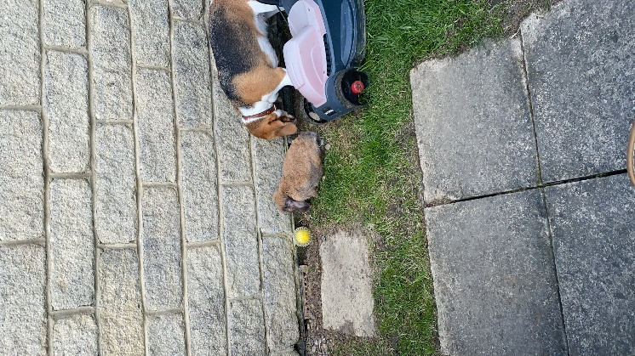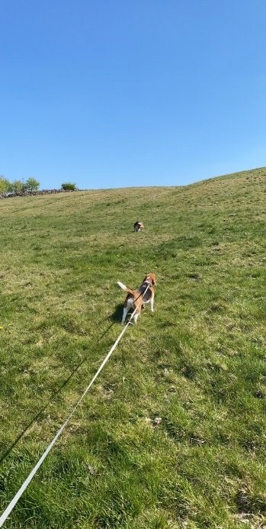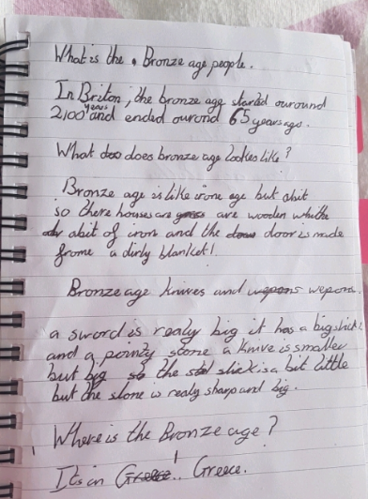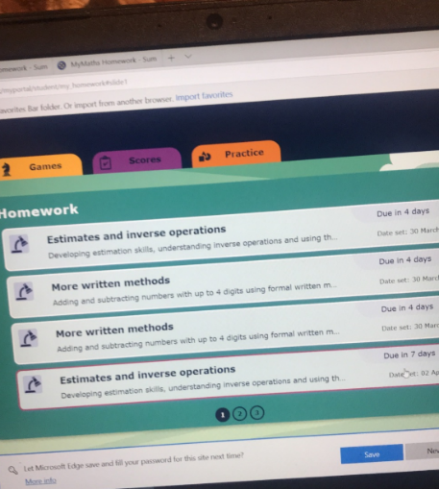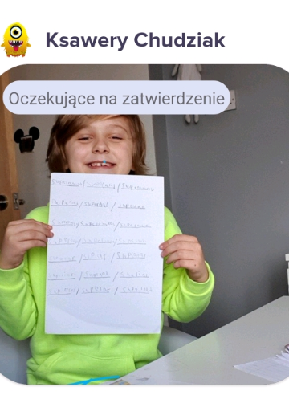

Kai has worked extremely hard to create a Bronze Age Fact file for our curriculum work. Here is one of the pages he has produced. Well done Kai – I find this time very interesting with what the people created and achieved. Your handwriting is also very well presented!

My week

Rabs is missing everyone but is enjoying relaxing at home and she was out in the garden earlier this week!

When I am not working I go out for a nice walk with my two dogs Lucy and Bella in the fields around our house.

Hello Year 3

It has been a lovely sunny week but this has not stopped all of you working so hard. I want to take the time to say how impressed I am with all the work I have seen on Class Dojo this week. I am very proud of you all but a big thank you also needs to go to your families at home with you who have been working hard to help you. I know this time is different and it can be difficult especially for adults at home who also need to work at the same time as helping you learn.

**Mrs Conroy’s Newsletter**

Work to celebrate

Odell has been working really hard on her maths work. On My Maths I can see your work and lots of Odell’s work is 90% correct well done and keep it up!

Ksawery has been sending me lots of his writing/ reading and spelling practice. Well done I can see you have been trying hard and your writing is looking good.