The big question in Year 3: How has the world around us shaped us as communities?
Children will understand how communities developed from individual hunter gatherer family group to farming communities and tribes. They will understand how changes in climate and weather drove changes in how humans organised themselves in order to survive. They will make links between modern community and those that existed in the past. They will begin to understand how the physical and human world interact. They will know how they can contribute positively.
Community prayer  A Safe Place for all  May our town be a safe place:  By day and by night  For young and for old  For rich and for poor  For people of every colour and every faith  May we be a community. |  |  |  |  |  |  |  | A fallen World  Our world is fallen  As if from heaven  Our world is broken  So we shall mend it  Our world is wounded  So we shall heal it  Our world is the lord’s  And God will bless it
Term |  | Theme | Learning Experience |  | Maths | Reading | Writing Focus |  | Science |  | RE | History/ Georgaphy | Computing | Art/DT | Music |  | PE |  | BASE (PHSCE)]  Learning behaviours/Christian values British Values | MFL
Autumn 1 | How has Britain’s climate and topography affected human activity from the stone age to the iron age? |  | Portals to the past visit into school – Ancient Britain History workshop | Place Value  Addition and subtraction |  | 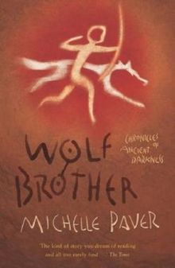 |  |  | Rocks and soils | What do Christians learn from the creation story 6 - 8 |  | Changes in Britain from the stoneage to the Iron Age  - Hunter Gathers  - Timeline  - everyday life  - impact of weather and climate on human activity  - Bronze age and changes that new thechnology brought to human activity  - Iron age reasons for the development of hill fort tribes. Why did communities organise themselves in this way.  Physical charateristics of Britain then and now  Topography of Britian – hills, mountains rivrer – map skills  Types of Settlement  Land use | 3.1 – We are programmers  Programming an animation. | Cave painting – using colours to make prints. Experimenting with different media. |  | Sing in tune.  Perform simple melodic and rhythmic parts.  Improvise repeated patterns.  Beginning to understand the importance of pronouncing the words in a song well.  Start to show control in voice.  Perform with confidence. |  | Bench ball | Positive |  | Numbers  Greetings  Christmas
Autumn 2 |  |  |  |  |  |  |  |  | light | What are the deeper meaning of festivals 6 - 8 |  |  | 3.2 – We are bug finders  Finding and correcting Bugs in systems | Food – cook iron age bread and stew using the fire pit (Forest School Practitioner) |  | To compose music that combines musical elements.  Carefully choose sounds to achieve an effect.  Create short musical patterns with long and short sequences and rhythmic phrases. |  | Netball | Resilient |  | Questions  Numbers revision  Spelling words
Spring 1 |  |  | Mysterious objects found in a dig – man in the bog etc.  . | Multiplication and division  fractions |  | 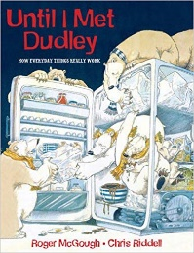 |  |  | Animals and humans movement and growth | What kind of world did Jesus want 6 – 8 |  |  | 3.3 – We are presenters  Videoing performance | Designing and Building a hillfort  Uses stimuli to create simple 2D and 3D images using a variety of tools and materials  Is able to recreate a 2D image in a 3D piece. |  | Types of music and composers  To notice and explore the way sounds can be combined and used expressively.  Listen to different types of composers and musicians. |  | Hockey | Problem solver |  | Colours  Spelling words
Spring 2 |  |  | Trip to Nell Bank - Orienteering | measures |  | 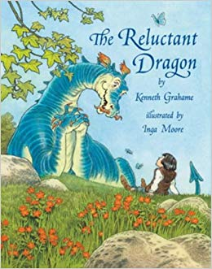 |  |  |  | Why do Christians name the day Jesus died “Good Friday” 4 - 6 |  |  | 3.4 – We are network engineers  Making a presentation a – Vlog | Landscape drawing and painting using different media |  | continued |  | Gymnastics/  dance/  aerobics | reflective |  | Food  Easter  Spelling words
Summer 1 | How did the British landscape impact on the Roman invasion and how did the Romans impact on Britain and the British? |  | Trip to Murton Park | Statistics and shape |  | 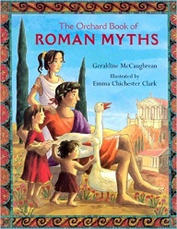  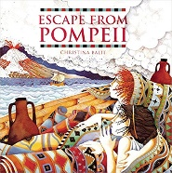 |  |  | Forces – magnets | When Jesus left what was next 6 - 8 |  | The Roman Empire and its impact on Britiain  Types of settlement  Land Use  Volcanoes | 3.5 – We are communicators  Communicating safely on the internet | Collage and mosaic using roman art as a starting point. |  | Develop an understanding of the history of music.  Describe the different purposes of music throughout history and in other cultures.  Understand that the sense of occasion affects the performance. |  | Cricket and Athletics | motivated |  | Days of the week  Known vocabulary reinforcement  Spelling
Summer 2 |  |  |  | Shape and revision |  |  |  |  | Plants |  |  |  | 3.6 – We are opinion pollsters  Collecting and analysing data |  |  | Appreciate and understand a wide range of live and recorded music.  Begin to recognise and identify instruments being played.  Comment on likes and dislikes.  Recognise how musical elements can be used together to compose music. |  | Rounders | independent |  | Months of the year  Known vocabulary reinforcement

The Big Question for Year 4: Are we stronger if we are together?
Children will demonstrate knowledge and awareness of how our country is composed of the coming together of peoples of different countries, cultures, backgrounds, ideas and belief systems. They will understand that over time there have been patterns of movement in and out of the British Isles. They will understand the unique elements that they, and others around them bring to the building of modern Britain.

Gather Us Together
O God,
Gather together as one
Those who believe in peace.
Gather together as one
Those who believe in justice
Gather together as one
Those who believe in love.

Term | Theme -  Topic |  | Learning Experience | Maths | Reading | Writing Focus | Science | RE | History/ Georgaphy | Computing | Art | DT | Music | PE | BASE (PHSCE)]  Learning behaviours/Christian values British Values | MFL  La Jolie Ronde
Autumn 1 |  | What did the Anglo-Saxons bring to Britain? | Ryedale Folk Museum  Northern Forge – Anglo-Saxon visitor |  | 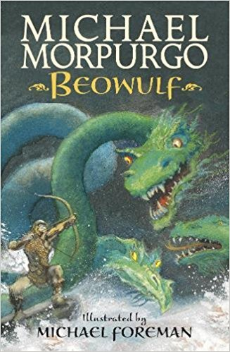 |  | Habitats | What is it like to follow God? | Roman withdrawal  Scots invade  Anglo-Saxon invasions, settlements and kingdoms, art and culture | 4.1 – We are software developers – children develop their own simple educational game |  |  | String music – reading and playing music using guitars | Ball Games  Netball/Basketball | Risk-takers  Positive  Motivated  Hope  Service  Trust | Colours  Parts of the body  Adjectives  spelling
Autumn 2 |  |  |  |  |  |  | Diet and digestion | What is the trinity? |  | 4.2 – We are toy designers  Children plan, design, program, test and evaluate an interactive toy | Stained glass – Christmas Art | Children will design a toy for Christmas, making sure it is functional and appealing to a chosen audience | String music – reading and playing music using guitars | Gymnastics | Independent  Creative  Resilient  Hope  Thankfulness  Peace | Questions  Zoo animals  Christmas
Spring 1 |  | What did the Vikings bring to Anglo-Saxon Britain? | Archery  (Jorvik Centre) |  |  |  | States of matter | Why do Christians name the day Jesus died “Good Friday”? | (Island nation?)  Viking invasion  Viking farmers and settlers  Local history study - York | 4.3 – We are  Musicians  Children produce digital music and share their composition with their peers |  | Weaving and other textile work linked to our Anglo Saxon work | String music – reading and playing music using guitars | Dance | Curious  Kind and caring  Honest  Compassion  Service  Forgiveness | Verbs  (etre)
Spring 2 |  |  |  |  |  |  | Electricity | How and why do believers show their commitments during the journey of life? |  | 4.4 –We are HTML editors  Children create webpages and use HTML code to do this |  |  | String music – reading and playing music using guitars | Swimming  Archery | Confident  Problem solvers  Resilient  Endurance  Thankfulness  Peace | Receptive vocabulary through song  Easter
Summer 1 |  | How have the cities of York and New York been shaped by people coming together? |  |  |  |  |  | What does it mean to be a Sikh in Britain today? | Local history study of York (focus on patterns of settlement)  Understanding similarities and differences through the study of human physical geography  Focus on impact of immigration and diversity in both cities | 4.5 – We are co-authors  Children will plan, write, edit and improve a Wikipedia entry | Sketching city scape as stimulus  3D work – plan, design, make (building for Viking York or New York)  Study of an architect |  | String music – reading and playing music using guitars | Swimming | Independent  Positive  Motivated  Compassion  Hope  Justice | French story language  Recognising nouns and verbs
Summer 2 |  |  |  |  |  |  | Sound |  |  | 4.6 –We are meteorologists  Children will use data-logging to record and monitor different forms of weather  They will then prepare and present their own TV-style weather forecast |  |  | String music – reading and playing music using guitars | Swimming  Athletics | Resilient  Reflective  Kind and caring  Justice  Forgiveness  Trust | Pets  Single and plural  Following a text

The Big Question for Year 5: How can people come together to shape the world around them?
Children will have knowledge and awareness of how they are connected to the people around them and beyond. They will know how people across time, place and culture, have come together to create movements that have shaped the world. They will understand how they too, can be part of the process of change in the world today.

Year 5 Prayer:  Gather Us Together  O God,  Gather together as one  Those who believe in peace.  Gather together as one  those who believe in justice.  Gather together as one  Those who believe in love. |  |  |  |  |  |  |  |  |  | For the Government  Dear God,  Guide those who govern this country.  May they make wise choices.  May they bear in mind the needs of  young and old, rich and poor, men and  women, people born in this country  and those from overseas.  May their decisions help everyone to live  their lives usefully, happily, and at peace  With one another.
Term | Theme | Learning Experience | Maths | Reading | Writing Focus | Science | RE | History/ Georgaphy | Computing |  | Art / DT | Music | PE | MFL  French | BASE (PHSCE)]  Learning behaviours/Christian values British Values
Autumn 1 | How has ancient Greece helped to shape the modern Western World ?  Where in the world is Greece? | City Museum trip |  | 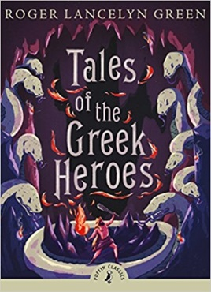 | Greek Myths | Earth and space including Greek beliefs and how these developed from flat Earth to Thales, Herodotus, Aristarchus, Eratosthenes. | What will make our city/town/village a more respectful place? | Ancient Greece  Focus on systems of government comparing Athens and Sparta.  How has ancient Greece influenced the modern world?  Greece as a European country - location , physical features | 5.1 – We are game developers  -pupils can create their own computer games. |  | Greek influence on art and artists – Plato (imitation of life) and Aristotle (representation of essence).  Reniesance art  Art of Ruben  In the home e.g. wedgewood  DT - Pulleys and link to ancienct Greece and Archimedes. What did the Grreks use mechanismas for? Design and make a mechanism that would have been useful to Greeks | Children will be learning to play guitars. | Swimming | Asking directions  Days of the week and times in the day  Christmas | What makes me, me?  Looking at our actions and how they impact on those around us.  Looking how our community helps us.
Autumn 2 |  |  |  | 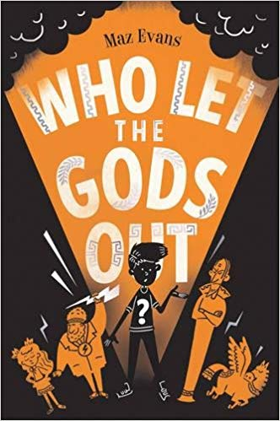 |  | Forces - including ancient Greek science that is still relevant today. | Incarnation- Was Jesus the messiah? |  | 5.2 – We are cryptographers |  |  | Children will be learning to play guitars. | Swimming |  | Why is my opinion important?
Spring 1 | How has the sufferage movement shaped our country since 1066? |  |  | 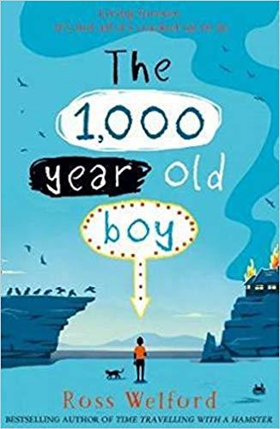  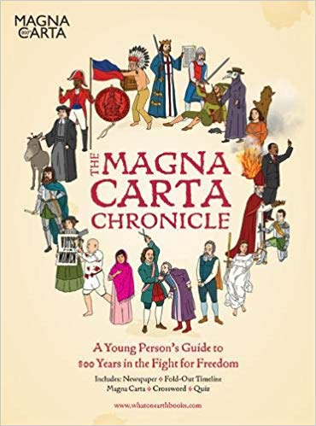  British Library short films explaining the Magna Carta | Argument and discussion | Animals – human and animal development  (block as an off timetable unit 2 – 3 days) | What does it mean for Muslims to follow God?  (block as an off timetable unit 2 – 3 days) | A study of the development of British Government from 1066 to present day.  Norman conquest, Magna Carta, Civil war, glorious revolution, Peterloo, 1832 reform bill, Ballot act, 1884 representation of the people Act,  The sufferagettes, 1918, representation of the people, 1928 equal franchise act,  1969 represntation of the people act. |  |  | DT – Textiles  Decorative works based on The Bayeux Tapestry depicting an episode in the development of British parliamentary democracy.  Art – Humans – portraits, moving figures. | Children will be learning to play guitars. | Swimming | Understanding and giving opinions
Spring 2 |  |  |  |  |  |  | Salvation- What did Jesus do to save human beings? |  | 5.3 – We are artists |  |  | Children will be learning to play guitars. | Dance aerobics | Days of the week  Hobbies  Easter | What would happen if I had no vote?
Summer 1 | How is the movement for environmental change shaping our world? | The Deep |  | 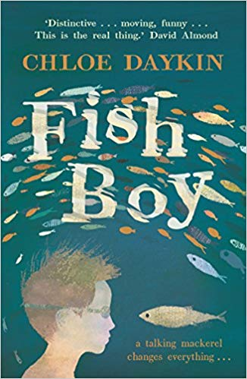 |  | Living things and their habitat  Lifecycles of plants etc.  Properties and changes  (two units in this half term – block time) | Gospel- What would Jesus do? | Human geography – use of natural resources – water.  The water cycle | 5.6- We are architects |  | Water – seascapes – colour – painting skills | Children will be learning to play guitars. |  | rounders | Future tense  Months of the year
Summer 2 | How can we come together to shape our world? |  |  | 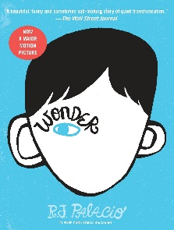 |  |  | God- What does it mean if God is holy and loving? |  | 5.4 – We are web developers |  | Using Augies graduation as a starting point. Plan and create a celebration buffet for Y6 leavers. | Children will be learning to play guitars. | (Two Units this half term as no Art/DT in summer 1) | athletics

The Big Question for Year 6: How can individual people shape the world around them?
Children will have knowledge and awareness of who they are, their place in time, space and culture. They will know how people across time, place and culture, through courageous advocacy, have shaped the world. They will understand how they too, can shape the world around them.
Year 6 Prayer
God grant me the serenity
to accept the things I cannot change;
courage to change the things I can;
and wisdom to know the difference.
Term | Theme | Learning Experience | Maths | Reading | Science | RE | History/ Geography | Computing | Art | DT | Music | PE | BASE (PHSCE)  Learning behaviours/Christian values British Values
Autumn 1 | Who was Charles Darwin and how did he change the world? |  | Place value  Calculation  Fractions | Origins of the species  Darwin’s letters  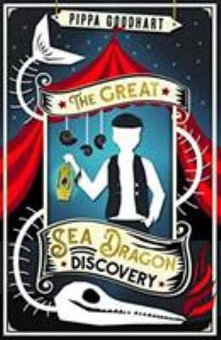 | Evolution and inheritance  Darwin, Anning, Wallace | U2.2 Creation and science: conflicting or complementary? | Charles Darwin  Victorian science and culture, including Christmas traditions.  Local history - Ilkley  Ilkley - compared to Rio De Janeiro including comparing Christmas traditions | We are adventure gamers | Observational drawing.  Natural History drawings  Darwin’s finches  Relief Printing from Natural history drawings |  | Samba music – drumming  Victorian Musical | Badminton | Courageous advocacy
Autumn 2 |  | Trip to Ilkley |  |  |  | U2.8 What Kind of King is Jesus |  | We are computational thinkers | ‘The great wave’ – what Darwin may have seen aboard the H.M.S. Beagle – in the style of Hokusai | Making own drums |  | Basketball / benchball
Spring 1 | How did Howard Carter change the world? | Visitor to come into school acting as Lord Carnarvon | Fractions  Decimals  Percentages  Algebra  Ratio  Position and direction | 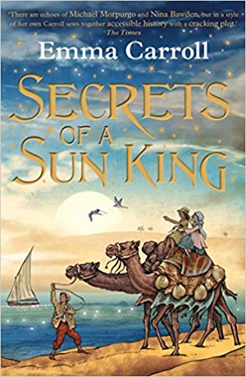  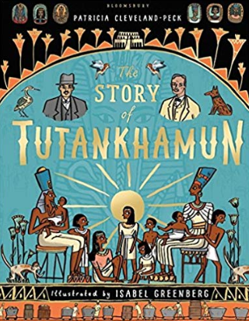 | Animals including humans | How does religion help people live through good times and bad? | Ancient Egypt  Rivers – the wharfe/ the Nile  Biomes - desert | We are advertisers |  |  | Charanga website – create music in Egyptian theme. | Gymnastics | Direct action and being an activist  ‘
Spring 2 | How did John Lloyd Stevens change the world? | Visitor to come into school for a ‘Mayans day’ |  |  | Animals and their habitats | U2.7  What difference does the resurrection make to Christians | Mayans  Biomes - Rainforest | We are network technicians | In the context of Mayan and Egyptian art and architecture:  Representing 3d shape in drawing and painting using shading, light and dark.  Produce own 3D work | Food tech - chocolate |  | Football
Summer 1 | How did Wiliam Wilberforce, Rosa Parks, Martin Luther King, Paul Stephenson, Floella Benjamin. Amelia Gentlemen and David Lammy Shape the world we live in? | Visit to Bradford Town Hall – meet policy makers- discuss ways people can influence social justice. | SATs revision  Time  Problem solving | 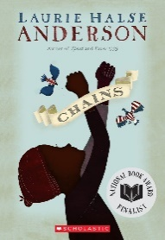  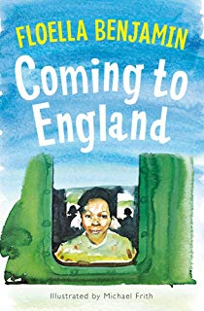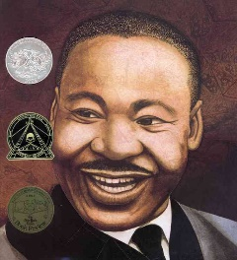 | Electricity | U2.3 How can following God bring freedom and Justice? | Changes in concepts of equality and social justice in employment and race since 1066 Serfdom – the slave trade – modern day – Windrush | We are publishers | Social Justice in Art  e.g. Banksy, William Morris,  Children investigate artists and produce work in the stlye of … |  |  | Athletics
Summer 2 |  | Littondale |  |  |  | Pilgrimage |  | We are travel writers |  | Use of textiles in social justice and protest movements e.g. ‘Kick it Out’  Children create textile banners | Create and perform our own songs | Cricket / rounders

