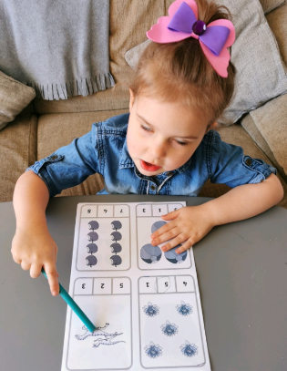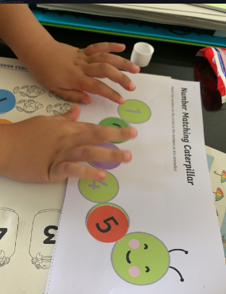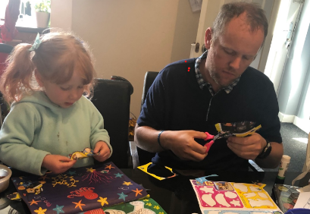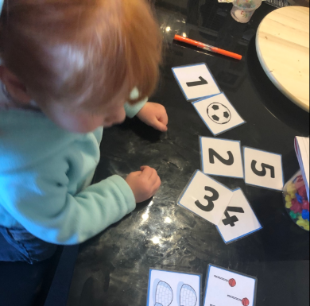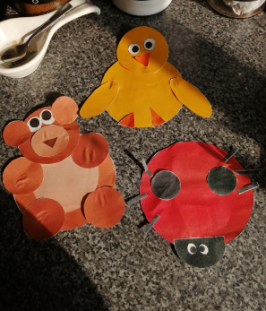

Sophia has been super busy earning dojos this week. Here she is counting objects and finding the correct number.

Mia has been busy matching the correct number of objects to the corresponding number. Also working with her Daddy cutting out pictures.

I have been busy at home, looking at all your fabulous work you have been sending me, and awarding dojo points.

When I am not busy looking at your work I have been doing lots of walking around the little town I live in. I have also been painting my house as all the walls were white.

Logan M

Has been very busy cutting numbers and the placing them in the correct order.

Logan D cut out and made a bear, ladybird and a chick. Fantastic cutting skills.

Look at our fantastic work

Hello Nursery

I hope you are all keeping safe at home.

I know you are working hard as I can see the work you are doing with your Parents and siblings. I have looked at some fantastic work this week. Well done to the children and your families. I am so proud of how hard you have worked.

Nursery’s News Letter

1st May 2020