

Hello Year 3

I hope you are all having another lovely week at home. The sunshine has started to come out again – get out and enjoy the outdoors. This week again, I am very impressed with all the amazing amounts of work I am receiving from you. Please don’t forget about the great websites we are using both MyMaths, Read theory and Epic. I can log on and see your progress, well done to the people who are accessing this so far you, are getting lots of high percentages on them all!

**Mrs Conroy’s Newsletter**

**Lottie-Joe** has been working super hard at home, she has been using BBC bite size to help her with her maths and English. Here she is doing some Art work carefully using her drawing skills. Well done Lottie!

**Lucas** is here completing his pied piper reading test too! These questions are set out like upper KS2 tests so I am really pleased and proud you are still attempting to answer these carefully using the text well done!

**Ksawery** has been working very hard again this week. Here is his work on the text The pied piper. Well done these are test style questions and very tricky so I am very proud!

My week

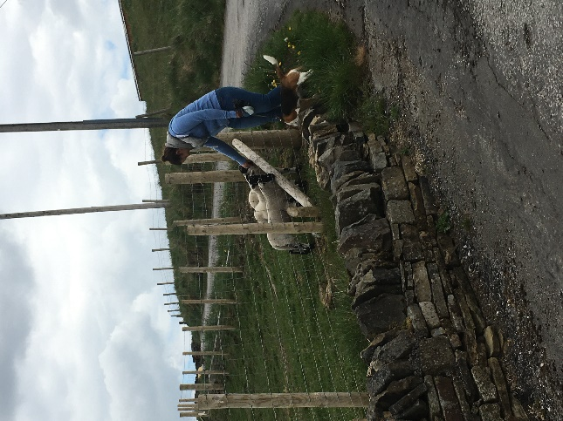

This week I have been working hard at home planning lots of lovely activities for us when we finally return. When I haven’t been working, I have been visiting my neighbours the lambs on the farm!

Work to celebrate

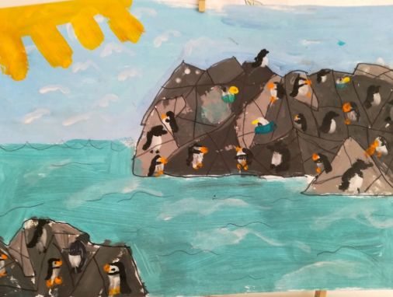

This beautiful piece of art work is from **Isla Cooper!** She has created a painting from her Rspb magazine of the Puffins at Bempton cliffs! Well Done Isla this is fantastic!

