

Hello Year 3

I hope you are all having another lovely week at home. This week again, I am very impressed with all the amazing amounts of work I am receiving from you. Please don’t forget about the great websites we are using both MyMaths, Read theory and Epic. I can log on and see your progress, well done to the people who are accessing this so far you, are getting lots of high percentages on them all!

**Mrs Conroy’s Newsletter**

Well done to Jasleen, here is her well written beautiful poster dedicated to the NHS and Keyworkers. This has been displayed in her local Morrison’s to show everyone. Excellent work.

Lottie- Joe has been creating something very special. After writing letters to her friends she is now creating a Time capsule to show what has been happening in the world at this time. Well done!

Lena has sent in her Roman Soldier and labelled all his key equipment. In our new topic about Romans it’s important to understand the Roman army. Well done Lena looks great!

My week

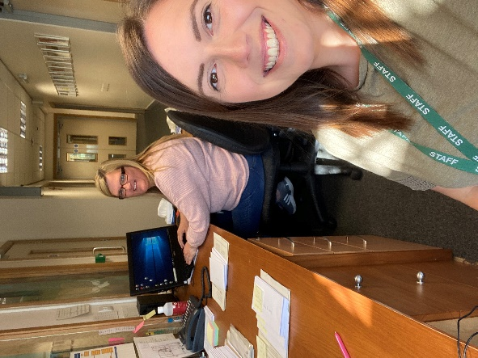

This week I have been working in the school office with Mrs Nightingale. We go out each day delivering meals and vouchers so it is lovely to see some people. We miss you all!

Work to celebrate

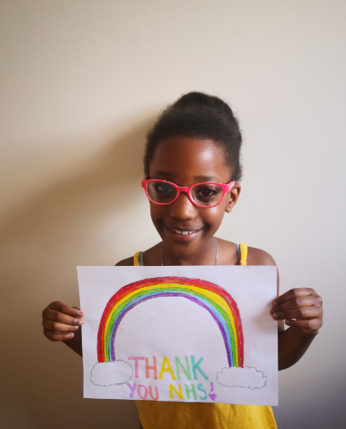

Here is Bailey showing us her lovely rainbow poster for the NHS workers who are protecting us each day. Well done Bailey.

