

Hello Year 3

We have had another lovely sunshine filled week. I have received lots of amazing examples of learning at home this week. Well done to everyone for continuing on even though it can be a struggle. Please don’t forget about the great websites we are using both MyMaths, Read theory and Epic. I can log on and see your progress, well done to the people who are accessing this so far – I can see a few more of you have tried hard to complete additional challenges.

My week

**Mrs Conroy’s Newsletter**



This week I have been working at home again. When I am not on my laptop – I have been for some lovely walks. Here is one in the woods. I hope you are all managing to get out walking too!

Work to celebrate

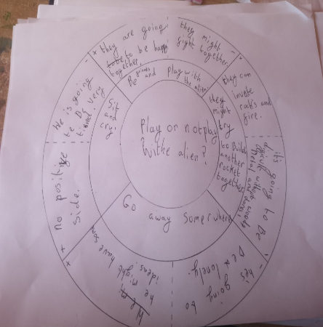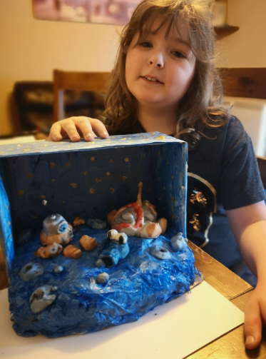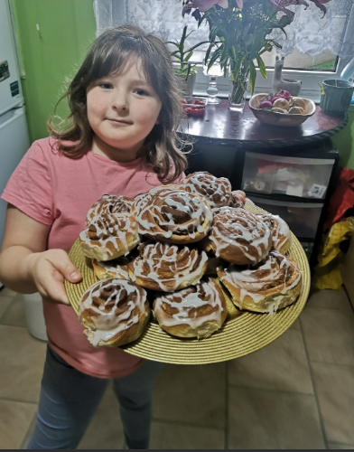

Julia has been working so hard this week- Here are three examples of the work she has done. Baking, Model making for her English work and she has produced a great decision wheel for the Alien story. Well done!

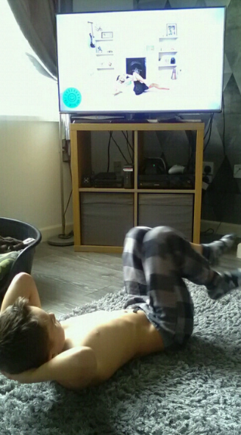

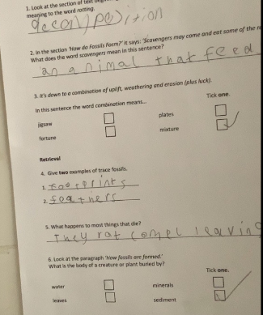

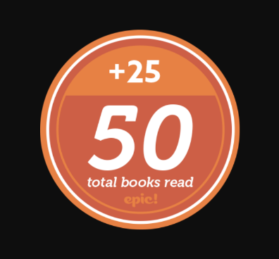

At the end of last week our class won a medal on getEpic! We have read this many books as a class in the short space of time already! Well done and keep going year 3

Lucas has been persevering with his PE! Here he is doing Joe wicks workouts. They are really tough! Keep going Lucas well done!

Ksawery has again been working hard on his reading comprehensions. I can see a real improvement in his answers! Well done Ksawery!