Dear Parents,

As you know, from Monday we will be opening school to more children in Nursery, Reception, Year one and Year 6. This means that teachers will be working in school and will not be available, as they have been, to support home learning.
We want to continue to offer home learning support to you and your children. We have set up a team who will continue to set and monitor work for children working from home. The team will be led by Miss Lea. Miss Lea’s team will set work and be available to help you and answer any questions over the coming weeks. They will be using the resources provided by the government through the national Oak academy for Maths, Writing and Reading. Your child’s summer theme for their year group will be covered by project based learning. This will be posted to Class DoJo.
Miss Lea has prepared the attached explanation of how to access the Oak Academy. If you have any questions please message the following staff, either on Dojo or by email. Class teachers will not check messages apart from on Friday afternoons. If you need to contact your child’s teacher, please ring the school office.
Miss Lea | Charlotte.lea@cca.bradford.sch.uk
Miss Bellwood | Katie.bellwood@cca.bradford.sch.uk
Mrs Maloney | Mel.maloney@cca.bradford.sch.uk
Mrs Holdsworth | Linda.holdsworth@cca.bradford.sch.uk
Mrs Clarke | Debbie.clarke@cca.bradford.sch.uk

As always if you need any help or support, please contact us through the school office,

Kind Regards

Philippa Foster

Christchurch Academy
meets
Oak National Academy

What is Oak National Academy?

Oak Academy is an online classroom and resource hub created by teachers. They provide high-quality, sequenced video lessons and resources for you to follow every day. https://www.thenational.academy/online-classroom/subjects/#subjects

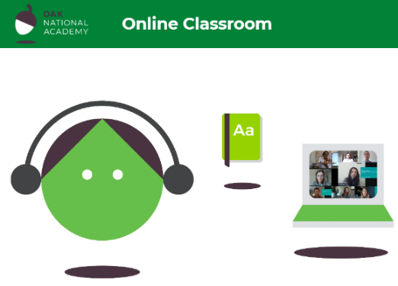

You can choose to pick individual lessons from a subject or you can choose schedule in which a variety of lessons are planned out for you each day to complete. We recommend that you select subject and complete the maths and literacy lessons. Each lesson is delivered by a virtual teacher and power-point video which is around 20 minutes long followed by a quiz to complete independently, giving you a chance to apply the knowledge you have just learnt.

What does it look like?

For example, a Year 1 Maths lesson would look like this. The learning objective may be LO: To Solve Word Problems. This is how it may look online. The word problem explained, strategies you could use to work out the answer followed by the independent task quiz. If you would like to re-cap any of the lesson, or repeat any exercise, you can always go back.
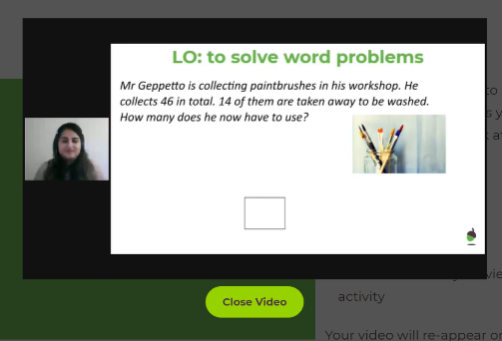
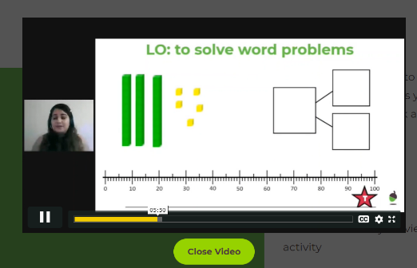

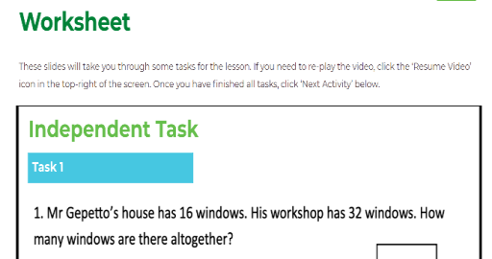

There is a lot of information on there to help you and it is very easy to navigate your way around the site and access the lessons.

Join them for assembly this Thursday!

Each week there will be an assembly held in partnership with TES, available from 11am Thursday. These are opportunities to join and to come together, hear from some inspirational guest speakers, and to think and talk about wider things affecting us.

