
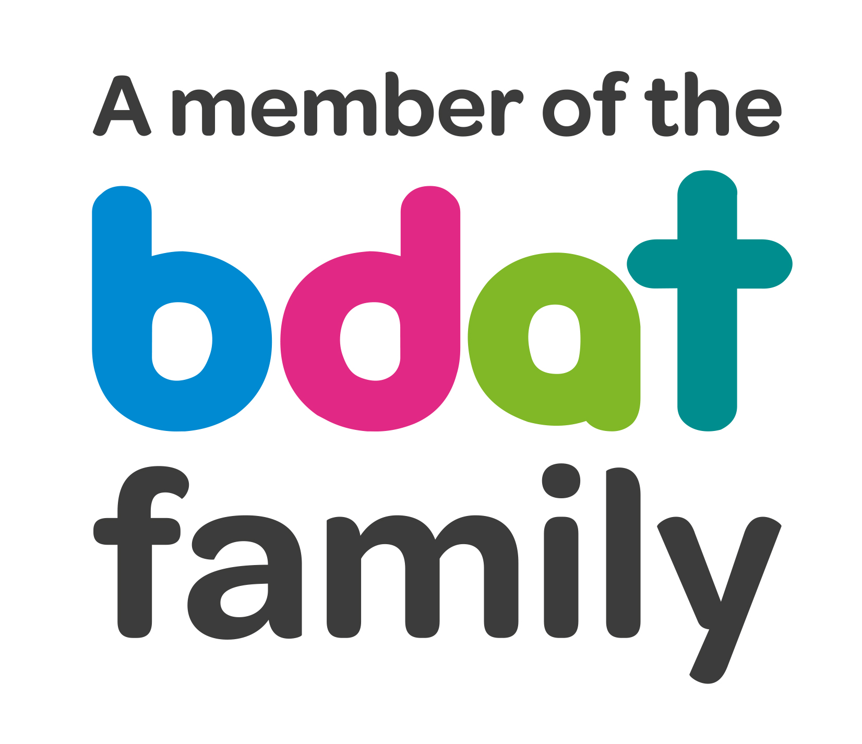
Christ Church Academy
Wrose Brow Road
Shipley
Bradford
BD18 2NT
01274 410349
admin@cca.bradford.sch.uk
Headteacher: Mrs Philippa Foster
Date: Monday 14th September 2020
Dear parents/carers,
Please DO NOT send your children to school if they have any covid symptoms. Get a test as soon as possible. Stay at home until you get the result.

Main symptoms
- a high temperature – this means you feel hot to touch on your chest or back (you do not need to measure your temperature)
- a new, continuous cough – this means coughing a lot for more than an hour, or 3 or more coughing episodes in 24 hours (if you usually have a cough, it may be worse than usual)
- a loss or change to your sense of smell or taste – this means you've noticed you cannot smell or taste anything, or things smell or taste different to normal

Most people with coronavirus have at least 1 of these symptoms.

What to do if you have symptoms
If you have any of the main symptoms of coronavirus:
- Get a test to check if you have coronavirus as soon as possible.
- Stay at home and do not have visitors until you get your test result – only leave your home to have a test.
- Anyone you live with, and anyone in your support bubble, must also stay at home until you get your result.

If children have provided a negative test result, they can return to school.
If children have symptoms, or a positive test result, they should stay at home for 10 days and only return when they are well. Any other children in the same household should stay at home for 14 days, unless they develop symptoms, in which case they should stay at home for 10 days after symptoms started.
Yours faithfully

Mrs. P Foster
Headteacher

