Christ Church Academy

School Business Manager Application Pack



* Letter from the Head Teacher
* Bradford Diocesan Academies Trust
* In and around Shipley
* How to find us
* Advertisement
* Job Description and Person Specification
* The selection process

Dear Applicant,

Thank you for your interest in the post of School Business Manager at Christ Church Academy. I would like to take this opportunity to tell you a little about our school. Christ Church Academy is a one form entry school for pupils aged 3 to 11 years. We are part of the Bradford Diocese Academies Trust (BDAT) and serve the community of Shipley in West Yorkshire.

The school became an Academy in August 2013 and this marks a break with the school’s past and a fresh chapter in its history. Our latest Ofsted in October 2016 confirmed that we are a GOOD school and we aim for consistently high standards of teaching and learning and outcomes for pupils and to ensure that Christ Church Academy becomes the local school of choice.

Our children enjoy coming to school and are keen to learn. Our staff are passionately committed to ensuring that our pupils achieve and they have high expectations for the children and for themselves. Many of our pupils are vulnerable in terms of their socio economic background and it is vital that their primary school experience is of a high quality and has a positive impact on their future life chances.

The role of School Business Manager is key to the leadership team of our school and the successful applicant will have the opportunity to work strategically to support the school’s goals.

I would strongly recommend that you come to visit us in order to gain insight into the deeply rewarding career that working with our pupils and staff has to offer.

Kind regards,

\\curric2k8\userdata\staff\p.foster\My Documents\Philippa_Signature.tif

Philippa Foster

Head teacher



**The BDAT Employee Pledge**

Bradford Diocesan Academies Trust recognises that if our schools are to succeed, **our teachers and school staff** are our most valuable asset. As such we work hard to be an employer and the schools of choice in Bradford.

We do this by:

* Relentlessly only **recruiting** the highest calibre of teachers who share our aspiration and ambitions for out pupils to succeed.
* Developing our teams by **talent spotting** and **rewarding** our next generation of leaders.
* Making sure BDAT is a good place to work so that **retain and grow the** expertise and skills of our people.

**Keep reading to find out more about our employee pledge which sets out what you can expect from us if you choose to join BDAT and what we will expect of you.**

**We will offer you:**

* Work in a value driven, student centred organisation where every child is support to reach their academic potential and accomplish their individual goals. <http://www.bdat-academies.org/about-us/bdat-mission-statement/>
* The prospect of working for an increasingly successful and growing Trust which is committed to providing high quality education for all of its students and to be the schools of choice. [www.bdat-academies.org](http://www.bdat-academies.org)
* A separate annual career development discussion with a senior leader resulting in a bespoke career development plan in addition to Performance Management.
* Ongoing assistance in developing your ‘craft’ of teaching.
* Assistance with career progression both within and outside the Trust.
* A competitive employees’ benefit scheme <http://www.bdat-academies.org/about-us/employee-benefit-scheme/>



**We will provide you opportunity to:**

* Have a week’s placement in one of the BDAT schools within the first two years.
* Shape the curriculum developments in an ever- changing world.
* Work with like-minded subject colleagues from the other Trust schools.
* Shadow colleagues both within the school and across BDAT.
* Support the development of teachers new to the profession or to their role.
* Gain the experiences required to meet external leadership qualifications such as Specialist Leadership in Education.

**In return we expect you:**

**To Model**

* The values of BDAT and your school at all times.
* Professional behaviours at all times.

**To Be**

* A consistently good teacher on a day to day basis.
* Committed to ongoing professional development.
* A team player and to adopt a ‘can do’ attitude.

**To**

* Place safeguarding of students at the heart of the work.
* Engage in constructive professional dialogue, giving and listening to feedback.
* Contribute to the development of students and staff.
* Meet Teachers’ Standards and Trust Leadership standards as appropriate to career stage expectation.

**Want to find out more?**

If you want the chance to join a Trust committed to developing the very best teachers and school staff in Bradford and if you like the sound of BDAT, our values, and the opportunities we can offer you:

* Check out our latest vacancies on [www.bdat-academies.org/vacancies](http://www.bdat-academies.org/vacancies)
* Follow us on twitter: #wearebdat

**Thank you for taking the time to read this information.**

**In And Around Shipley**

Shipley is an old market town and it retains a strong sense of identity. It still has its weekly market, though the market place itself has been rebuilt and is surrounded by modern shops. The adjacent library, health centre and swimming pool are also of recent origin.



Situated as it is on the Aire Valley, it has excellent rail and road links not only to the university cities of Bradford and Leeds (with their theatres, museums, restaurants and shops) but also to Ilkley (with its famous moor), Haworth and the Bronte country and, via the Settle-Carlisle railway, to the more distant Dales and the Lake District. The Leeds/Liverpool canal takes you across to the other side of the Pennines and Leeds/Bradford airport connects to the four corners of the globe.

Shipley's immediate neighbour is the UNESCO World Heritage Site of Saltaire, a model village built in the 19th century by the mill-owner Titus Salt to house his workers. The impressive mill buildings no longer produce textiles but have been converted into offices, shops, a restaurant, and the 1853 Gallery, which holds a large collection of the works of Bradfordian David Hockney. Most of the original community buildings are now occupied by Shipley College.



Over the bridge across the river is another remnant of the Victorian era, the Shipley Glen Tramway, built to carry people up to the village of Baildon and now operated by volunteers as a tourist attraction. It leads onto Baildon moor and the stone circle known as Soldier's Trench, which is thought to date from the Bronze Age.



Shipley is a pleasant place to live and work, with housing of all descriptions and access to every kind of sporting and leisure activity.

Christ Church Academy is committed to safeguarding and promoting the welfare of our pupils and expect all staff and volunteers to share this commitment. All staff are subject to an enhanced DBS check.

**How to find us**

**We Are Here**

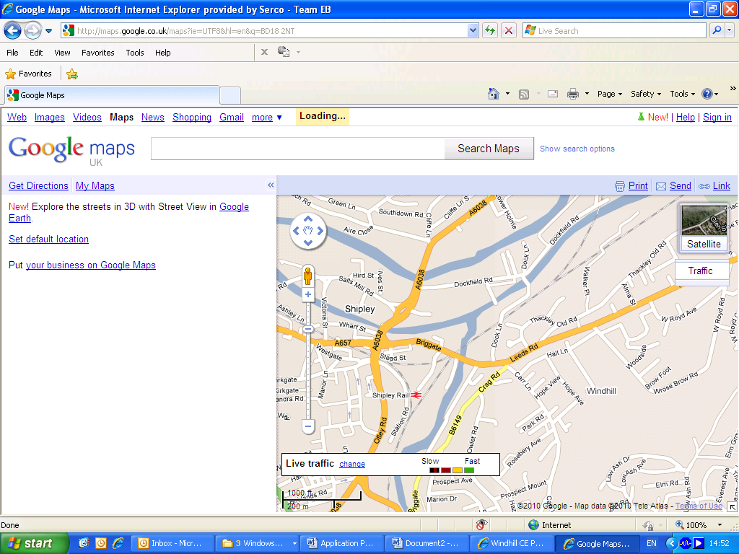



**Christ Church Academy**

**Wrose Brow Road, Shipley, BD18 2NT**

**Tel: 01274 410349**

**www.christchurchacademy.org.uk**

**Christ Church Primary Academy**

**Job Advertisement School Business Manager**

Christ Church Chruch of England Academy is part of the Bradford Diocesan Academies Trust. We are looking for a highly motivated, organised, forward thinker who can provide strategic vision and leadership in all aspects of school administration including financial management, resources, HR and payroll, premises, Health and Safety and income generation.

As part of the Leadership Team, the School Business Manager will support the Headteacher to drive school improvement and develop school systems to enable the highest quality education for our pupils.

**Successful applicants will:**

* Have effective interpersonal skills and ability to work as part of a team
* The ability to motivate and develop staff teams
* Excellent administration and organisational skills
* Excellent numeracy and communication skills
* Ability to work under pressure and prioritise effectively
* Good working knowledge of MS Office package and ideally SIMS
* Ideally have or willing to work towards their CSBM
* Be able to manage data in line with GDPR
* Have a genuine desire to have a positive impact on the lives of our pupils and families

**In return we can offer you:**

* The opportunity to make a real difference to the lives of our pupils, families and staff
* The opportunity to be a key member of our leadership team
* The opportunity to work with a motivated, professional and committed team of colleagues
* An active governing body
* The opportunity to be part of BDAT, a multi academy trust that provides excellent central support for School Business Managers including a central finance team, peer collaboration, sharing of expertise across schools and excellent CPD opportunities

**Term Time Equivalent Salary** In the officer range PO1 NJC point 27 (£28023) to NJC point 30 (£30201) per annum, depending on experience.

**Work Pattern:** 37 hours per week to meet the needs of the Trust and academy, some evening work will be required

**Closing date: 2.11.20**

**Shortlisting: 3.11.20**

**Interview date: 6.11.20**

**Start date:**

**Start Date-**As Soon As Possible

Christ Church Academy is committed to safeguarding and promoting the welfare of our pupils and expect all staff and volunteers to share this commitment. All staff are subject to an enhanced DBS check.

**Please contact Philippa Foster on 01274 410 349 to discuss the role further or arrange a visit.**

**Completed application forms should be sent to: Philippa.foster@cca.bradford.sch.uk**

**Business Manager Job Description**

**Introduction**

This post offers a unique opportunity for an ambitious applicant to join an established Bradford multi-academy Trust as a Business Manager across the primary sector.

The post will allow the right applicant the opportunity to utilise their finance and business operations skills across Christ Church CofE Primary Academy. The Trust uses PS Financials and Orovia BPS for the finance operation, along with other cloud based products such as Office 365. Experience of working as a Business Manager in an academy setting is highly desirable.

The post holder will be required to work in our academies as directed, and may also be required to support the work of the central team.

**Employer** Bradford Diocesan Academies Trust

**Reporting to** The postholder will be managed by the Headteacher.

**Supervises** the caretaker and administration staff

**Duration of Post** **Permanent and term time plus 2 weeks**

**Probationary period** Six months

**Term Time Equivalent Salary** In the officer range PO1 NJC point 27 (£28023) to NJC point 30 (£30201) per annum, depending on experience.

**Work Pattern:** 37 hours per week to meet the needs of the Trust and academy, some evening work will be required

**Closing date:**

**Interview date:**

**Start date:**

The role of the Business Manager relates to Christ Church CofE Primary Academy which is one school of seventeen within the Trust. There is a requirement to meet the needs of the academy as well as the Trust reporting needs.

**JOB PURPOSE:**

To support the strategic development of Christ Church CofE Primary Academy by working closely with the Headteacher and Senior Leadership to enable effective decision making and achievement of Academy aims.

To provide high quality strategic financial planning to ensure that the Academy makes best possible use of resources and is able to provide the best outcomes for pupils.

To maintain and monitor the efficient management of the academies’ budgets with Integrated Curriculum Financial Planning, along with maintaining an overview of personnel, premises, ICT and health and safety matters.

To ensure financial reporting is effective and compliant with ESFA Academies Financial Handbook and BDAT Policies.

To be responsible for maximising income generation by letting the premises to external users and supporting development of grant applications to support the school.

**RESPONSIBILITIES/DUTIES:**

Note: The term ‘Senior Leaders’ includes Executive Headteacher/Principal, Headteachers/Principals, Head of School, Head of School, Trust Directors of Finance and Operations and will vary depending on the structure within an academy.

**Financial Management**

• Work with the relevant Senior Leaders to develop a strategic plan for the staff and resources of each academy utilising Integrated Curriculum Financial Planning.

• Produce monthly management accounts to monitor and maintain the budget and forecast figures for the academy using the Trust’s budgeting software, BPS and PS Financials.

• Prepare a three year financial plan for the academy and as part of this exercise to prepare the annual budgets which support the financial plan.

• Meet regularly with the Senior Leaders to discuss monthly management accounts reports.

• Meet with budget holders as necessary to discuss budget spend.

• In conjunction with the relevant Senior Leaders, support the planning and implementation of capital purchase programmes.

• Liaise with funding agencies to identify and source additional funding and identify potential funding opportunities, agencies or government initiatives to ensure income generation from both diverse and obvious sources.

• Prepare financial reports, estimates and completion of financial returns as required by the Trust Board, CEO, Senior Leaders and Local Governing Body (LGB), Department for Education, Companies House and HM Customs and Excise and any other group or organisation for which this information is required.

• Ensure the effective operation of financial controls and ensure they receive value for money for all expenditures.

• Review a rolling 12 month cash flow forecast, identifying any concerns and ensuring they are raised to the Director of Finance or Finance Manager (FM) at the earliest opportunity.

• Work with the FM to manage and monitor internal recharges between the academy and Central, ensuring that costs are recharged on a timely basis.

• Meet regularly with key staff in the Central Finance Team to review management accounts and the Trial Balance.

• Review month end schedules prepared by FM for accuracy before submitting to Director of Finance.

• Authorise paylists, where appropriate authorisation has been received for payment from the delegated authority.

• Carry out a physical monthly reconciliation to PSF of petty cash.

• Attend all relevant Trust and LGB Committee meetings and ensure they are all given the necessary information, both at the meeting and in advance, to discharge their duties effectively.

• Work with key finance staff and the Trust auditors to support the audit requirements, ensuring that information is timely and accurate.

• In liaison with the FD and FM monitoring of contracts to ensure compliance, value for money and timely renewal as appropriate.

• Be responsible for the management of procedures which comply with statutory requirements such as Safeguarding Children and Young People, Data Protection and the Freedom of Information Act.

• Maintain and monitor Single Central Record, review with Headteacher.

• Work with the FD and FM to oversee and develop financial procedures within the Trust that are in line with the agreed financial practices.

**HR and Payroll**

• Support the strategic recruitment plan within each academy ensuring that staffing decisions are factored into the Academy’s budget.

• Maintain effective communication to ensure a co-ordinated approach on HR and payroll matters. Liaise with the Trust’s payroll and HR providers as necessary.

• Ensure all relevant parties (e.g. FM, Finance and HR Officer) are aware of changes to staffing so that relevant paperwork can be checked/authorised as necessary.

• Reconcile the payroll information on a monthly basis against budgeted costs and deal with any discrepancies. Ensure Headteacher authorises reconciliation and is fully aware of any variances and any necessary alterations are communicated with the payroll provider.

• Assist the Senior Team in the development of a staffing structure that meets financial considerations

**Leadership and Management**

• Contribute to the Trust’s culture and development by:

* Ensuring that staff are fulfilling their professional responsibilities in relation to financial matters and are carrying out their duties effectively through performance management.
* Attend leadership meetings (where requested) and ensure the content and outcomes of the meetings are reported back where relevant, to the finance staff.

• Prepare for and attend Trust and LGB meetings as part of the review cycle to assess the progress of financial matters.

• Share good financial practice across the Trust.

• Ensure an appropriate induction programme for new staff into finance is in place and provide excellent support for those members of staff who are new to a Trust/academy environment.

• Be an active and visible member of the academy’s community whilst developing partnerships and collaboration within the Trust.

**Premises Management**

• To develop a long term site plan with the Senior Leaders and Caretaker to ensure the site is maintained and developed.

• To monitor the contract used within site management and look for opportunities to secure improved value for money.

• To ensure that the site meets all Health and Safety requirements and effective and timely updating of the Health & Safety and Compliance Management System.

• To monitor the effectiveness of site and cleaning teams within the academy.

• To secure external grants to support the development of the site.

**Business Development**

• Develop customer relations strategies which add value to the academy.

• Develop the after school lettings to ensure the site is used efficiently and is providing an income stream to the academy to cover all costs.

• To monitor, evaluate and report on the quality of the service provided through discussions with users and evaluations of course members.

**Person Specification**

|  |  |  |  |  |  |  |  |
| --- | --- | --- | --- | --- | --- | --- | --- |
| **Personal Qualities, Qualifications & Experience** | | **Measured by** | | | | | |
| **Essential** | **Desirable** | **Application** | **Interview** | **Skill Test** | **Reference** |
| **General Requirements** | | | | | | | |
| 1. | Good general education | ✓ |  | ✓ |  |  |  |
| 2. | Good ICT skills | ✓ |  | ✓ |  | ✓ | ✓ |
| 3. | Able to work well within a team | ✓ |  | ✓ | ✓ |  | ✓ |
| 4. | Able to work well under pressure | ✓ |  | ✓ | ✓ | ✓ | ✓ |
| 5. | Good organisational skills | ✓ |  | ✓ |  |  | ✓ |
| 6. | Able to work accurately and with attention to detail | ✓ |  | ✓ |  | ✓ | ✓ |
| 7. | Ability to work on own initiative | ✓ |  | ✓ |  |  | ✓ |
| 8. | Good communication skills, both written and oral | ✓ |  | ✓ | ✓ |  | ✓ |
| 9. | Willing to develop personal skills through training | ✓ |  | ✓ | ✓ |  |  |
| 10. | Flexible and adaptable | ✓ |  | ✓ | ✓ | ✓ |  |
| 11. | Access to own vehicle insured for business use | ✓ |  |  | ✓ |  |  |
| **Post Specific Requirements** | | | | | | | |
| 1. | Line management experience | ✓ |  | ✓ | ✓ |  | ✓ |
| 2. | Accounting qualification (minimum technician level) | ✓ |  | ✓ |  |  |  |
| 3. | Experience in managing premises |  | ✓ | ✓ |  |  |  |
| 4. | Experience with income generation strategies |  | ✓ | ✓ |  |  |  |
| 5. | Experience with working with payroll systems |  | ✓ | ✓ |  |  |  |
| 6. | Good working knowledge of spreadsheet IT packages | ✓ |  | ✓ |  |  |  |
| 7. | One years working knowledge working within a school environment | ✓ |  | ✓ |  |  |  |
| 8. | Substantial experience in financial management | ✓ |  | ✓ |  |  |  |
| 9. | Supporting the Trust Finance Director and Operations Director to implement Trust strategies | ✓ |  | ✓ | ✓ |  |  |
| 10. | Achieved or working towards professional level accounting qualification (ACCA, CIMA, CIPFA or AAT) |  | ✓ | ✓ |  |  |  |
| 11. | Recognised ISBL accreditation or equivalent | ✓ |  | ✓ |  |  |  |
| 12. | Experience with working with payroll systems | ✓ |  | ✓ | ✓ |  |  |

## **Selection Process Guidance**

Our aim is to ensure that we recruit the right person for the job. We will ensure that the selection process is fair and without discrimination for or against any candidate based on age, ethnicity, sex, marital status, or sexual orientation. The person specification sets out the criteria used to assess candidates through the selection process.

We are committed to safeguarding our pupils and will assess the candidate’s suitability for working with children as part of the selection process. We will check the accuracy of all information and investigate any perceived anomalies. We take up references prior to interview and use these to verify the information you have given us. Firm offers of employment are never made without satisfactory references. All potential employees are subject to an enhanced disclosure form the Disclosure and Barring Service.

**Visits to the school**

Visits to the school are warmly welcomed by prior arrangement, you will not be disadvantaged if you are unable to visit. Please contact Mrs Philippa Foster on 01274 410349 to arrange a mutual appointment. The visit will give you an opportunity to ask questions about the role and the school to assess if this is somewhere you would like to work.

**Applications**

Please ensure that all parts of the application are completed. We do not accept CVs as part of the selection process. Please ensure that you demonstrate how your experience and skills make you suitable for the position. Applications can be submitted online, via email or via paper copy.

**Shortlisting**

We assess all applications against the person specification criteria using the evidence you provide in your application. This is done by a panel of senior staff, the Trust staff and governors. We carefully check all applications for anomalies.

Candidates who best meet the person specification will be invited to an interview. We will notify you by telephone with e-mail confirmation to follow. If you have not heard from us within 3 days of the shortlisting date, you have not been successful at this stage.

**References**

We request references for all candidates who are invited to interview. Requests will be made at the same time that candidates are invited to interview. Your first referee should be your current or last, employer.

**Interview Day**

The interview day will consist of several tasks and activities including a formal interview. These are designed to allow you to demonstrate your skills and abilities. You will be asked to bring proof of qualifications and identity on the day.

**Final Selection**

Following the tasks and formal interview, we will use the person specification as a guide to select the most suitable candidate for our school. We will then telephone each candidate to inform them of the outcome. We will give brief feedback during this telephone conversation.

**Offer of Employment**

We will make a verbal offer of employment by telephone on the day of the interview and this will be confirmed in writing. Any offer is made subject to:

* References satisfactory to us
* A satisfactory DBS check
* Provision of proof of identity and qualifications

**Terms and Conditions**

* The employer for this post is the Bradford Diocesan Academies Trust.
* An Enhanced DBS is required for this post.
* The post is subject to a three-month probationary period.

**Time line**

Application Closing Date:2.11.20

Shortlisting: 3.11.20

Interviews: 6.11.20