Key Vocabulary

Evidence | Gatherer | glacier | Happisburgh
Forensics | Archaeology | artefact | Mammoth
Fossils | climate | Hunter | Boxgrove
Palaeolithic | artefact | Cheddar Gorge | Stone Age
Prehistoric, also known as prehistory is the time period before records were taken. Records are some form of written history so during prehistoric times there was no form of a writing system. The term was first introduced into human existence in the 1830s in France when drawings were found on cave walls
What could these tools have been used for?
The Land That Time Forgot
In Topic we are learning about the development of Prehistoric man. We will explore how Early man lived and how his actions were linked with the climate and weather. We will explore early Hunters and gathers and compare how they lived to modern communities today?
Who were the First Men?
Early man lived in small groups, they moved from place to place. This time was part of the Ice Age. Man was continually moving to avoid the cold.
They hunted and gathered but made no shelters.

How did they live?

Year 3 TOPIC Knowledge Organiser (Autumn 1 2020)
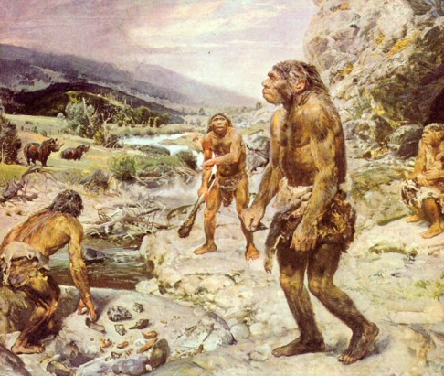

FASCINATING FACT
Boxgrove Quarry, once a gravel quarry, is now a Palaeolithic archaeological site. It is at Boxgrove in the English county of West Sussex. It is a Site of Special Scientific Interest.

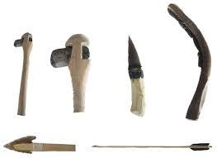
What Lessons can we learn from the actions of Adam and Eve?

