
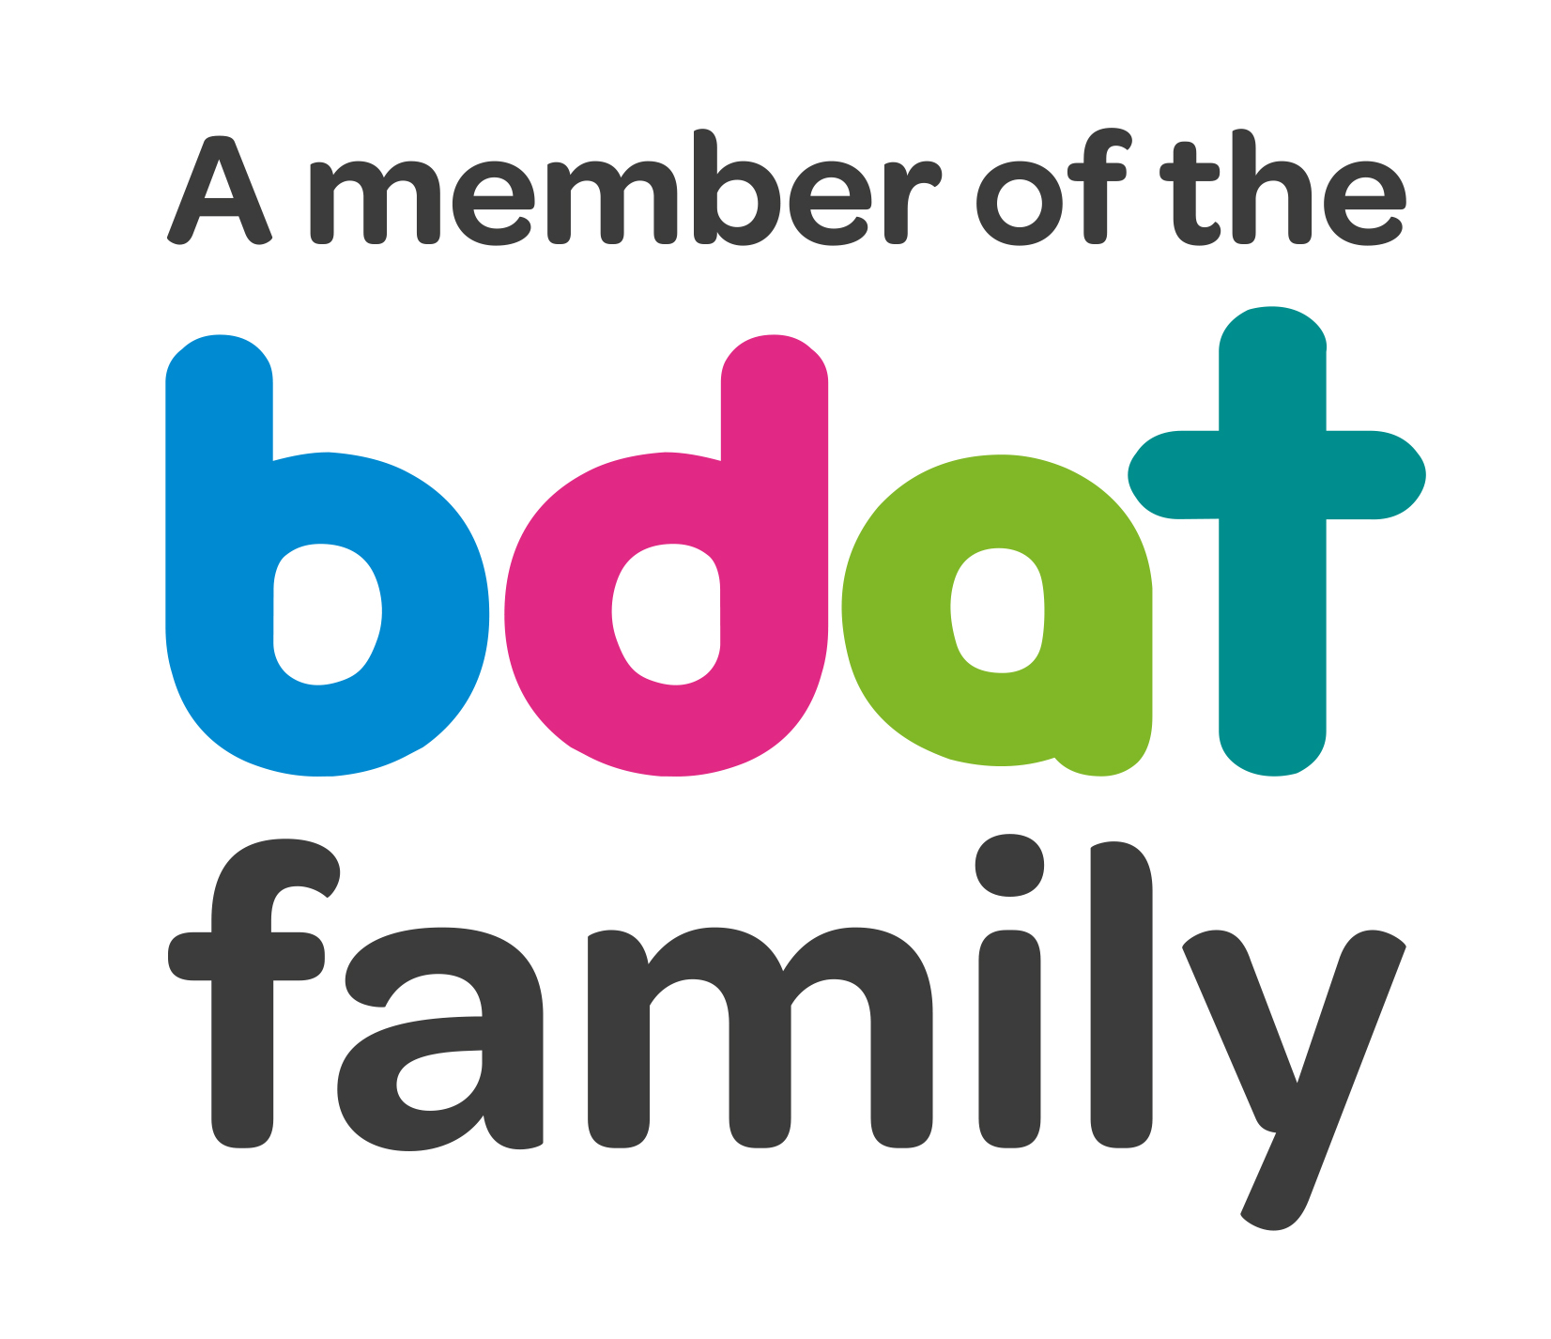
Christ Church Academy
Wrose Brow Road
Shipley
Bradford
BD18 2NT
01274 410349
admin@cca.bradford.sch.uk
Headteacher: Mrs Philippa Foster

Date: 07.01.21

Remote Learning at CCA:

Dear Parents/carers,

As you are aware we have been using the system Class dojo within school for some time to allow teachers to communicate directly with you on a daily basis. During the pandemic, we have used this system to allow us to communicate the learning your child may need when working at home.

Moving forward we would like to continue to use this system to communicate with yourselves as parents, as we feel it is important for you to have an overview of their learning, however we are now introducing a new platform (Microsoft Teams) to allow teachers and pupils to communicate in a more in depth way. This software will also allow teachers to live stream, provide video tutorials and give children a direct communication tool to use for their remote learning.
We understand that Home learning for parents can be a difficult challenge, so we expect the new system to allow children to be able to work more independently but also gain the input they need from their teacher.

What to expect:
- Each week an outline of the child’s learning will be posted on a Monday to class dojo to inform you the parents of what work is expected.
- Lesson information, resources and links to videos and invites to Teams chats will be posted to Microsoft teams for the children to access and engage with on a day to day basis.
- A schedule of lessons and work will be provided by the class teacher on Microsoft Teams.
- Teachers will expect the work back each day to mark so that they can plan and adapt for the next lessons.
- Teachers will be available to chat to children online to provide feedback each day at specified times.

What you need to do:
- Read the attached instruction booklet, this will give you a breakdown of how to logon to Microsoft teams. Additional information is provided about assignments; teachers will go through online safety and how to use the system in the first scheduled lesson on Monday so do not worry about explaining this part.
- The class teacher will send you your child’s new Microsoft teams logon information via class dojo to allow you to do this. If you are not on class dojo they will ring you to inform you of this.
- Make sure your child follows the timetable, hands in work on time and engages with live sessions.

Guidance released from the DFE on the 4th January states:

Remote education
When teaching pupils remotely, we expect schools to:
· set assignments so that pupils have meaningful and ambitious work each day in a number of different subjects
· set work that is of equivalent length to the core teaching pupils would receive in school, and as a minimum:
· primary: 3 hours a day, on average, across the school cohort
· secondary: 4 hours a day, with more for pupils working towards formal qualifications this year
· provide frequent, clear explanations of new content, delivered by a teacher or through high-quality curriculum resources or videos
· have systems for checking, at least weekly, whether pupils are engaging with their work, and inform parents immediately where engagement is a concern
· gauge how well pupils are progressing through the curriculum using questions and other suitable tasks, and provide feedback, at least weekly, using digitally facilitated or whole-class feedback where appropriate
· enable teachers to adjust the pace or difficulty of what is being taught in response to questions or assessments, including, where necessary, revising material or simplifying explanations to ensure pupils’ understanding

Further information on our approach to Remote learning can be found in our ‘remote Learning policy on the school website. ‘Our school – Policies- Remote learning policy October 2020’

We are aware that for some families with multiple children in both primary and secondary schools, sharing a laptop will be difficult. In particular, several secondary schools are live streaming their whole schedule which, we know, will pose problems for parents. Therefore, we are proposing that our teachers pre-record their lesson inputs for the children to watch at a time convenient for them. Children will then be expected to attend a live session with their teacher for feedback. We will do our very best to ensure that teachers are available daily to support children as well as teach the children in school who are key workers/vulnerable but hope that you understand that you understand that events within school may occasionally mean that live sessions can’t take place.

We will be going ‘live’ with learning and this system from Monday 11th January 2021
We understand that it can be difficult to set up on a new system, so if you have any difficulties doing this or would like some help please do not hesitate to contact the school directly.

Yours sincerely,


Headteacher Christ Church Academy

