
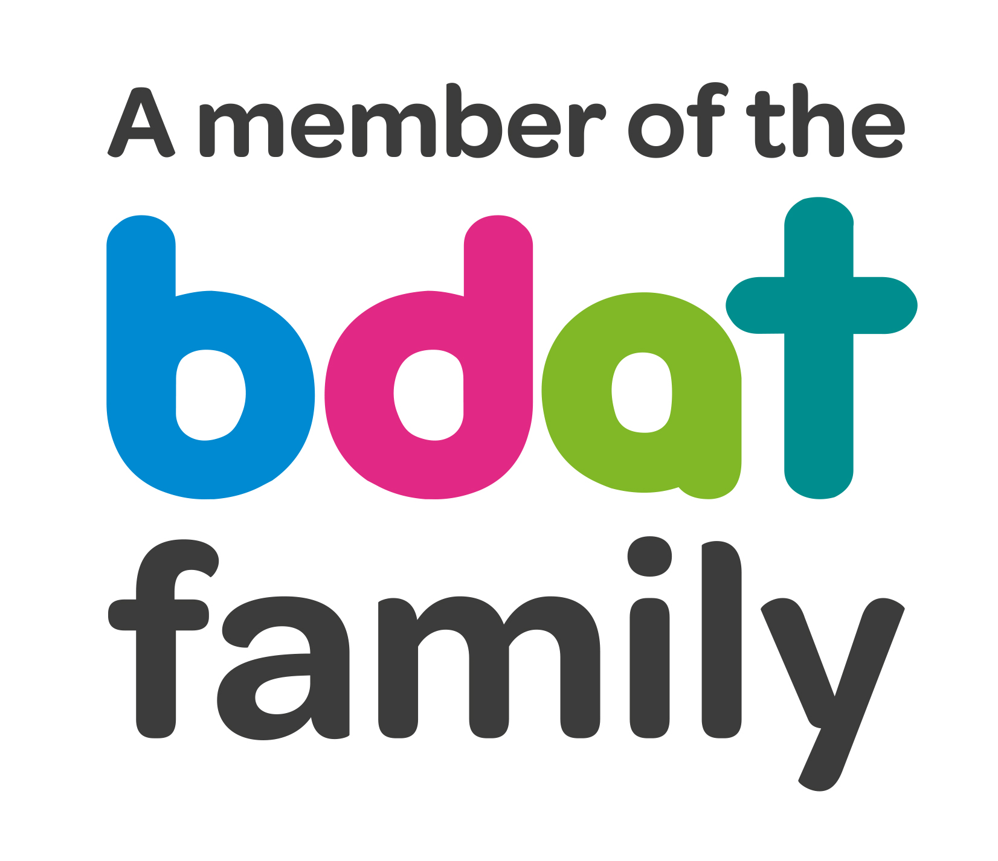
Christ Church Academy
Wrose Brow Road
Shipley
Bradford
BD18 2NT
01274 410349
admin@cca.bradford.sch.uk
Headteacher: Mrs Philippa Foster

Date: Friday 28th May 2021

Dear parents and carers,

Contact tracing over May half-term
Schools and colleges continue to play an important role in contact tracing for pupils, students and staff. We recognise the challenges of this responsibility during holidays, but this remains vitally important in the continued national effort to limit the spread of the virus.
- If pupils test positive for COVID-19 during half-term, having developed symptoms more than 2 days since being in school or college, no action is needed. Parents and carers should follow contact tracing instructions provided by NHS Test and Trace.
- However, where pupils test positive having developed symptoms within 2 days of being in school i.e. Saturday and Sunday, you are asked to self-isolate and advise us of any close contacts, as the individual may have been infectious whilst in school.
- Please inform school of a positive test either by email to Philippa.foster@cca.bradford.sch.uk, or message Mrs. Foster on Class Dojo between close of school Friday and the end of Sunday 30th May.

Obviously if pupils test positive during half term, they must not attend school for ten days after symptoms started.

Have a lovely half term holiday and we will see you on Monday 7th June 2021.

Yours faithfully

Mrs. P Foster
Head Teacher

