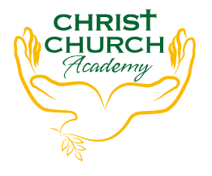
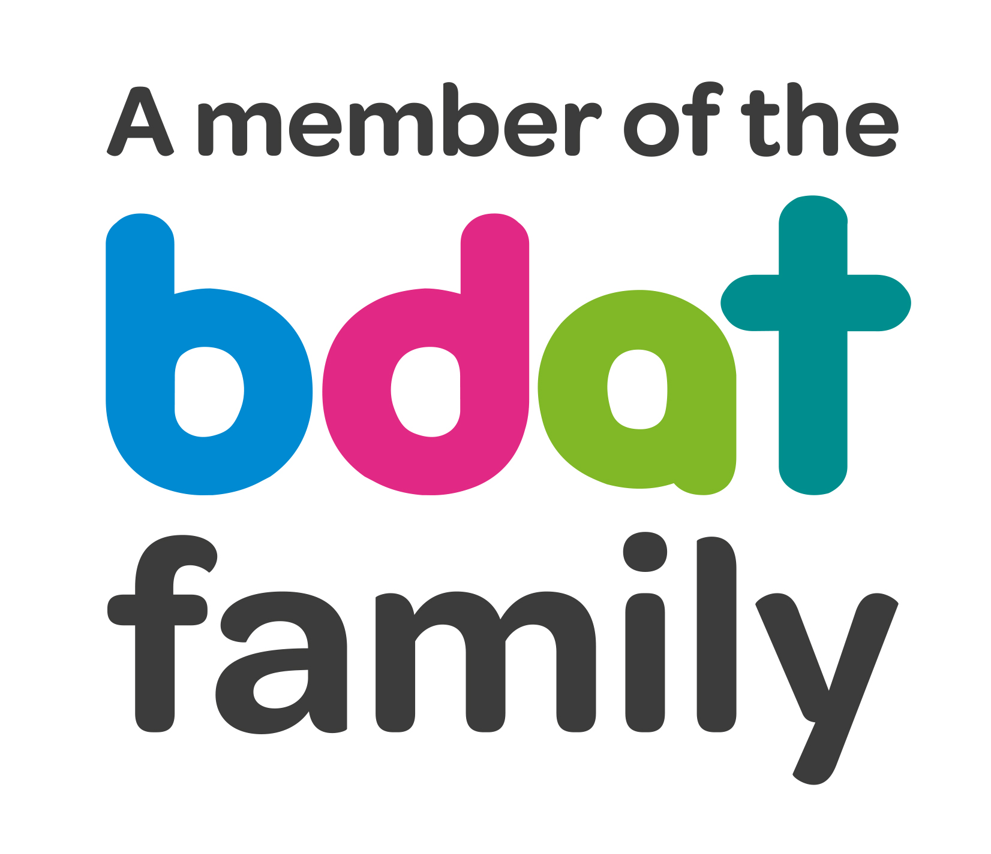
Christ Church Academy
Wrose Brow Road
Shipley
Bradford
BD18 2NT
01274 410349
admin@cca.bradford.sch.uk
Headteacher: Mrs Philippa Foster

Date: Tuesday 28th September 2021

YEAR 6 TRIP TO TROPICAL WORLD, LEEDS
– MONDAY 18TH OCTOBER 2021

As part of Year 6 topic this term Miss Clarke would like to take the children to Tropical World to learn about Rainforests.

The trip will cost £21.75 per child. This price includes entry to Tropical World, the Rainforest workshop and coach travel.

Children will leave school on 18th October at 9am, and will return to school at approximately 3:15pm – we will text parents if the coach is late returning to school. Children should arrive at school no later than 8:30am.

- Please pay £21.75 on Parent Pay. You can pay in instalments if you prefer, as long as the full amount is paid by Friday 15th October. If you are experiencing any difficulties in paying, particularly if your child receives pupil premium, please get in touch with the school office.

- Please ensure you log onto Parentpay this week to give your consent for your child to attend.

- Please provide a packed lunch for your child. If your child is in receipt of free school meals, school will provide a packed lunch.

If you have any queries, please contact the school office.

Yours sincerely,

Mrs P. Foster
Head Teacher

