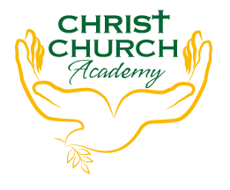
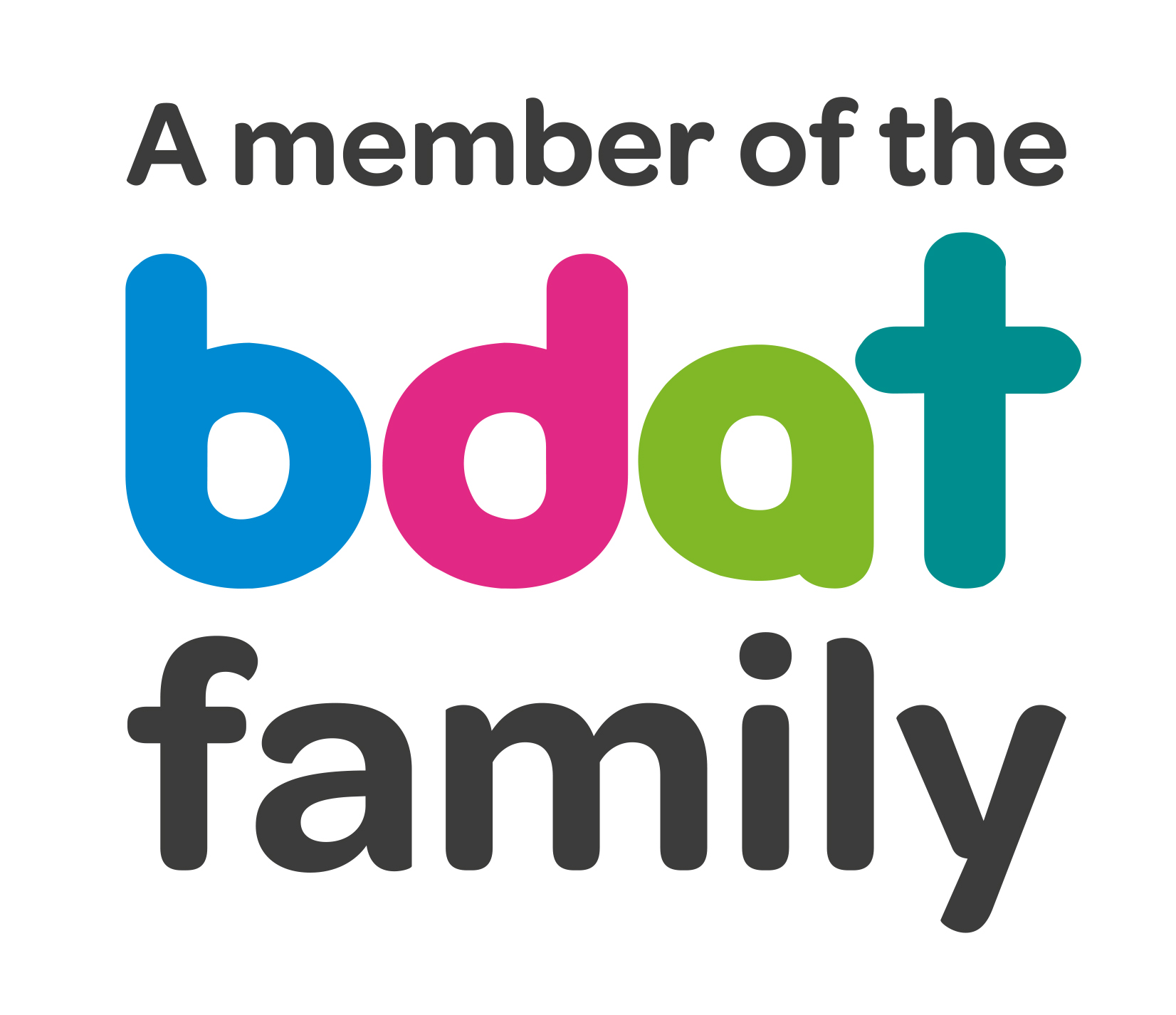
Christ Church Academy
Wrose Brow Road
Shipley
Bradford
BD18 2NT
01274 410349
admin@cca.bradford.sch.uk
Headteacher: Mrs Philippa Foster

Date: Tuesday 28th September 2021

Dear parents/carers,

Free Online Safety Parent Workshop
Wednesday 6th October 2pm to 3pm

Do you know what your child is watching on their mobiles or tablets? Do you know how to use parental controls? Would you like some advice about online safety?

We would like to invite you to come into school to hear from PC Danny about this important matter, on Wednesday 6th October.

Mrs. Nightingale will provide free refreshments so please join us in the school hall. It would be great to see as many parents/carers as possible.

Yours faithfully,

Miss L. Grimshaw
Safeguarding Lead

