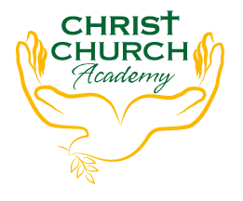

Christ Church Academy
Wrose Brow Road
Shipley
Bradford
BD18 2NT
01274 410349
admin@cca.bradford.sch.uk
Headteacher: Mrs Philippa Foster
Date: Wednesday 13th October 2021

Dear Parents

We are holding a special event on Wednesday 20th October. It will be called Elmer’s Day. This day will be a celebration of how wonderful it is to be different.

On this day the children can come to school dressed in their favourite colour.

We will be reading all our favourite Elmer stories and playing lots of Elmer games.

The children have really enjoyed reading about Elmer this term and this special day will add to their enjoyment. I hope you will encourage your child to take part in this event and I am looking forward to seeing all their colourful outfits.

Mrs Goodall
Reception teacher


