
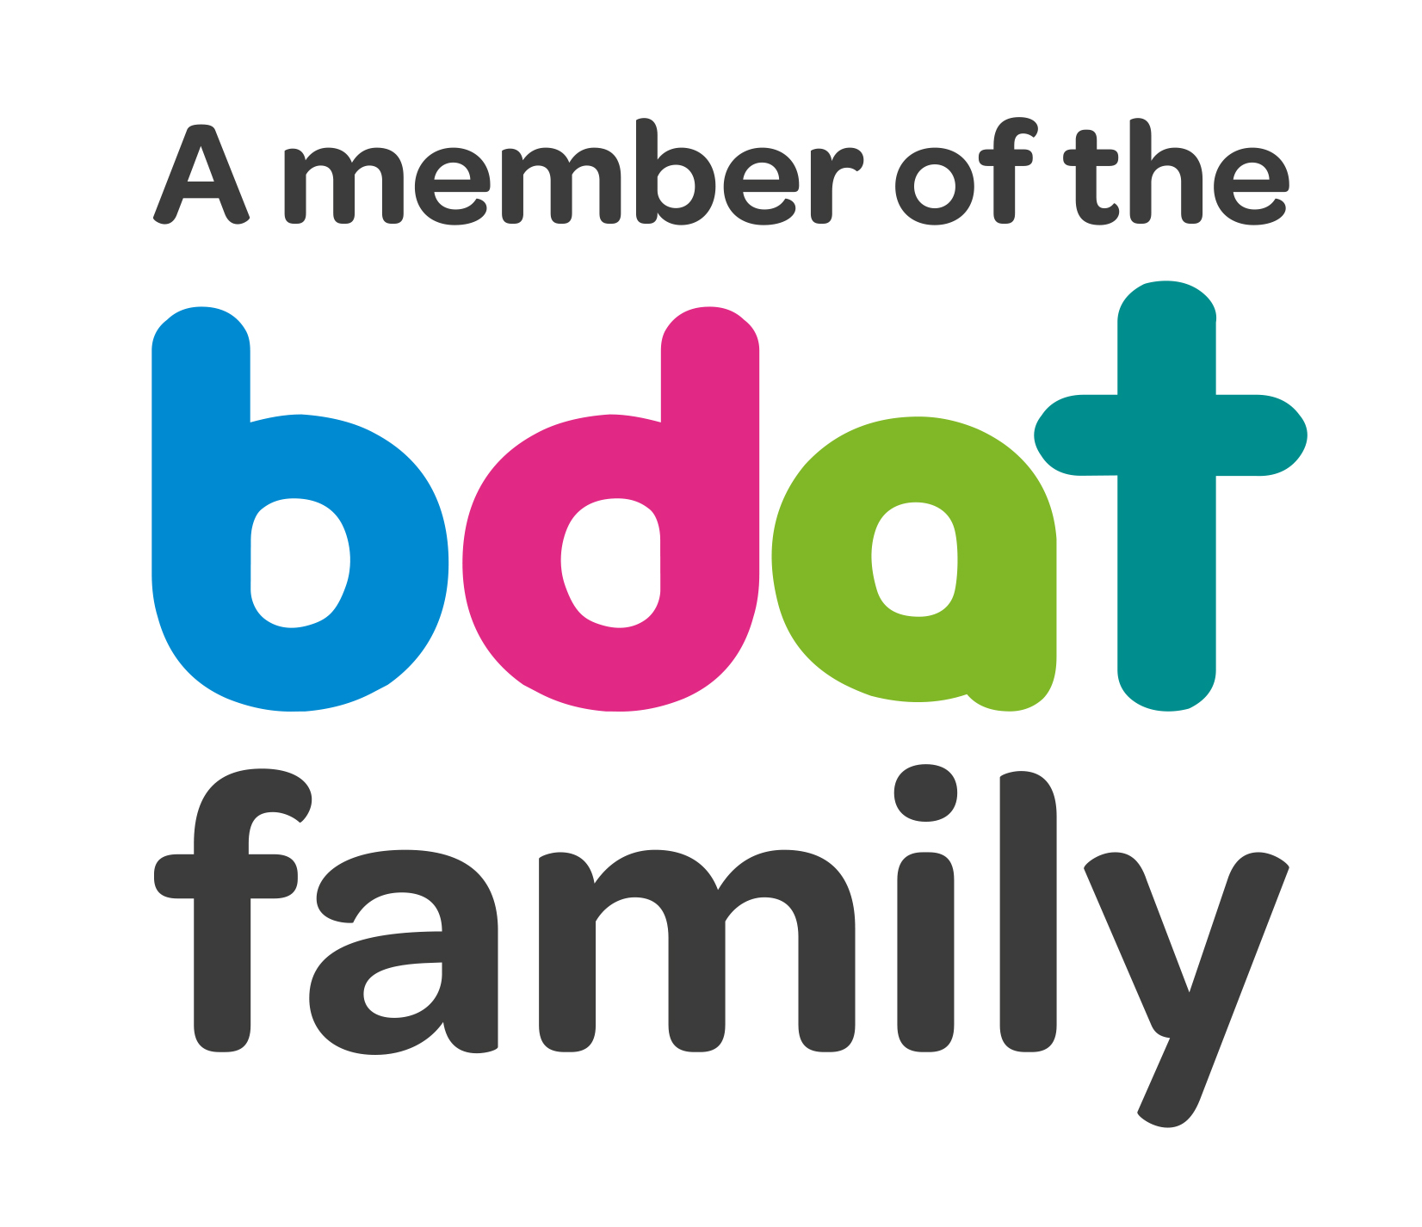
Christ Church Academy
Wrose Brow Road
Shipley
Bradford
BD18 2NT
01274 410349
admin@cca.bradford.sch.uk
Headteacher: Mrs Philippa Foster
Date: Friday 1st October 2021

Dear parents/carers,

Re: Jellybeans

I am delighted to let you know that we are continuing to offer our very popular Cook and Eat sessions with Karina from Windhill Community Centre in our Jellybeans after school club. Karina will join us from Thursday 14th October until Thursday 9th December. This is offered at no additional cost to parents.

We also have our resident PE coach, Josh, running fun energetic games sessions every Tuesday and Wednesday in Jellybeans. Josh will be staying with us throughout this academic year as he also provides the PE lessons for each class throughout the week.

On Monday and Friday afternoons our staff do a variety of activities such as painting or crafting, or the children may choose quiet time reading or watching TV. Snacks are always provided.

Jellybeans opening times and prices are as follows: -

Breakfast: From 7:30am £3
After School: £5 until 5pm; £8 until 5:45pm when Jellybeans closes.
There is a 10% discount for siblings.

All sessions must be paid for weekly via your ParentPay account. You can also pay in advance for the month/term etc. if you choose.

If you are interested in using Jellybeans, please contact the school office.

Yours faithfully,

Mrs. F. Best
Office Manager

