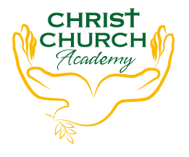
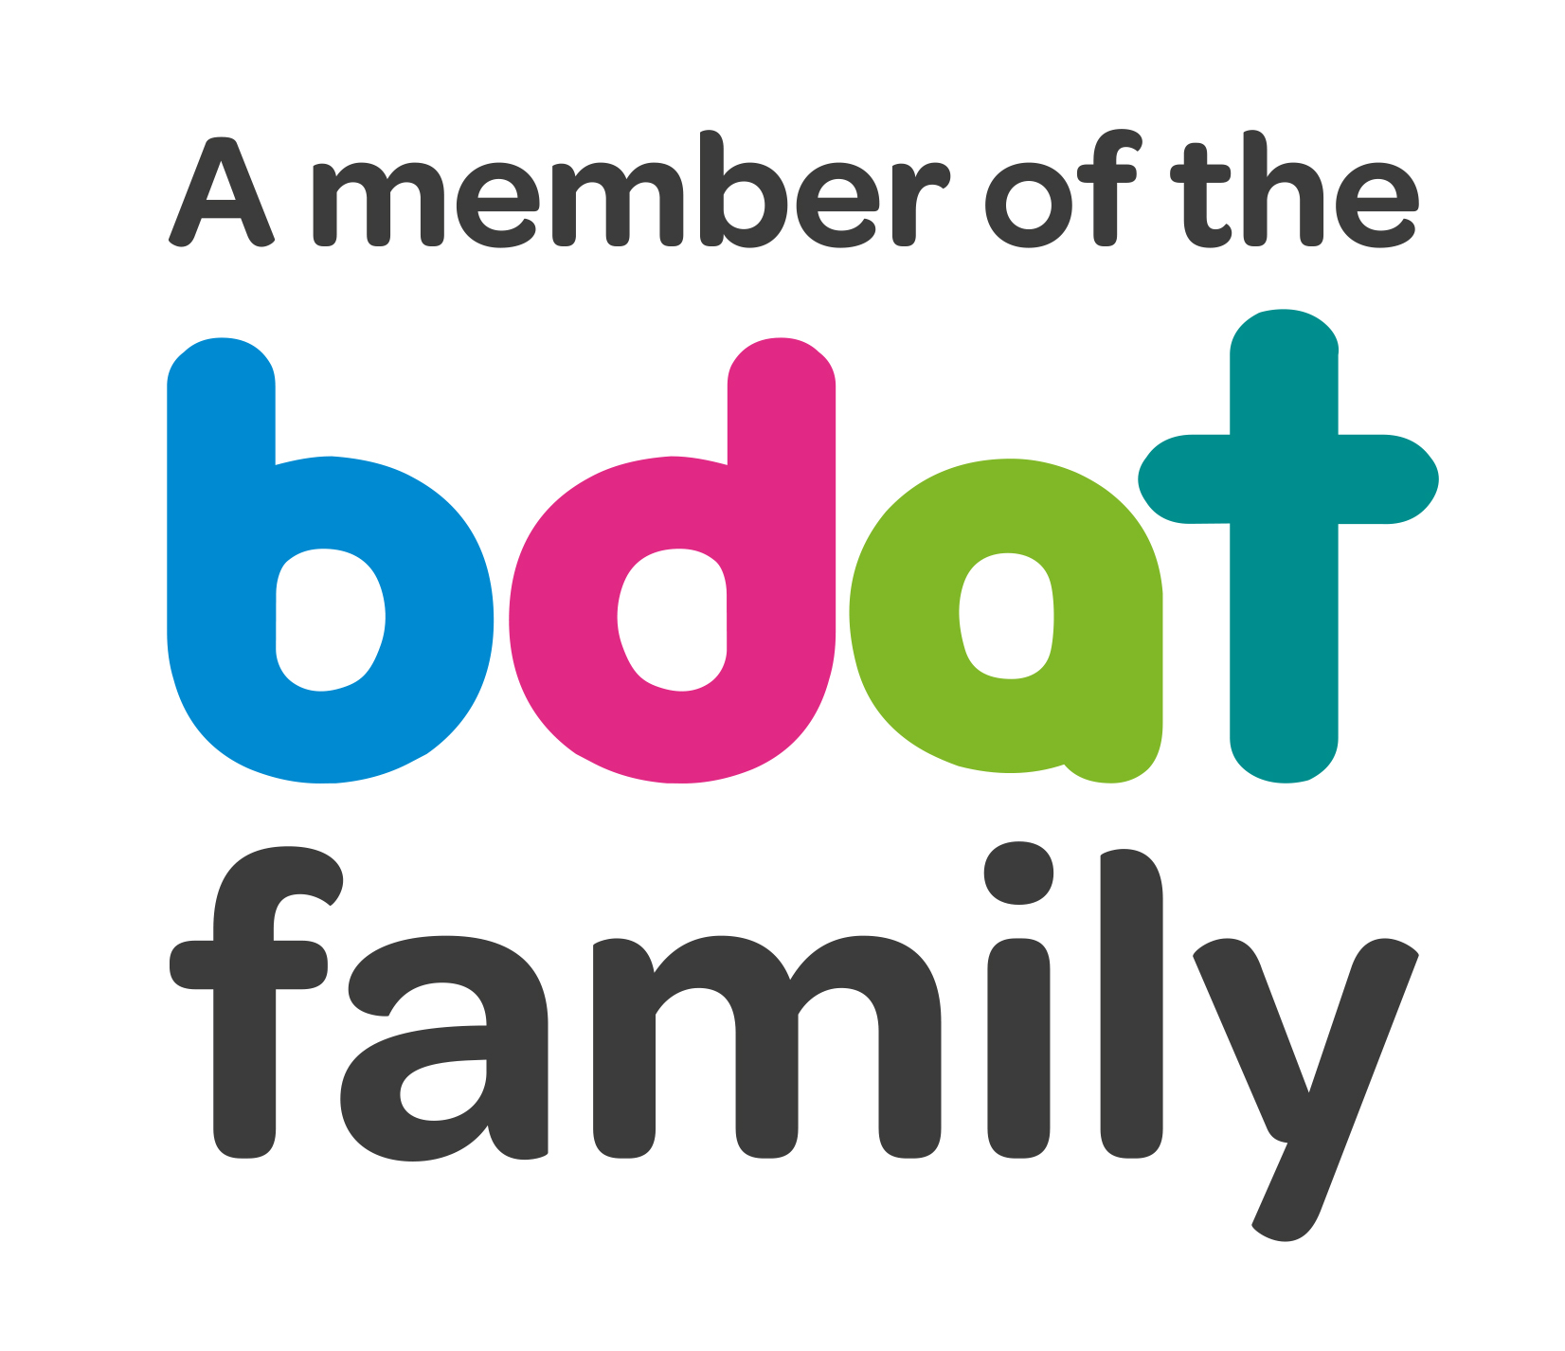
Christ Church Academy
Wrose Brow Road
Shipley
Bradford
BD18 2NT
01274 410349
admin@cca.bradford.sch.uk
Headteacher: Mrs Philippa Foster

Date: Tuesday 5th October 2021

YEAR 3 TRIP TO MEDIA MUSEUM, BRADFORD
– FRIDAY 19TH NOVEMBER 2021

As part of Year 3 Science Miss Robinson would like to take the children to Bradford Media Museum to see ‘Light it up’ and visit the Wonderlab.

The trip will cost £10 per child. This price includes entry to the Media Museum and coach travel.

Children should arrive at school no later than 8:50am and can be collected at the usual time of 3:10pm.

- Please pay £10 on Parent Pay. You can pay in instalments if you prefer, as long as the full amount is paid by Friday 12th November. If you are experiencing any difficulties in paying, particularly if your child receives pupil premium, please get in touch with the school office.

- Please ensure you log onto Parentpay this week to give your consent for your child to attend.

- Please provide a packed lunch for your child. If your child is in receipt of free school meals, school will provide a packed lunch.

- School uniform (and a coat) must be worn.

If you have any queries, please contact the school office.

Yours sincerely,

Mrs P. Foster
Head Teacher

