CCA Newsletter
October 2021

It’s been a great start to the new school year and we’ve all really enjoyed welcoming the children back to a more ‘normal’ school routine. Thank you to all our fantastic parents and carers for your continued support.
Staff Changes
We would like to welcome Miss Mavor who will be joining us as our new Nuture+ leader and Mrs Winter who joined us this term as a teaching assistant. Mrs Winter will work in reception with Mrs Goodall and Mrs Broadbent. We would also like to congratulate Miss Outram in her new role as Nursery Teacher this year.
Sadly, Miss Parnham will be leaving us to take up a new role with the NHS, supporting young people’s mental health. We are really going to miss Miss Parnham as she has been a fantastic member of our team, but we wish her all the very best in her new career.
Positive Parental Engagement Mark of Excellence
We are proud to have been awarded the ‘Positive Parental Engagement Mark of Excellence’ by the Exceed Institute in partnership with Leeds Beckett University Carnegie School of Education. Mrs Nightingale received the award at a recent ceremony.
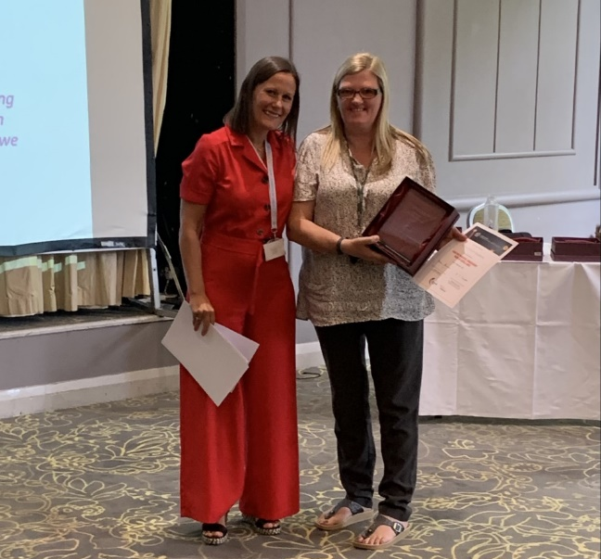

Open Days for Nursery and Reception
If you know anyone looking for a Nursery or Reception place (for next year) we are welcoming visitors to look around the school during October and November. They just need to ring the office on 01274 410349 to make an appointment.
MUGA pitch (Multi-use Games Area)
We are expecting our new MUGA pitch to be installed during the half term holiday – this is going to make a big improvement to the children’s playground and their PE lessons. We have also just ordered lots of new sports equipment to enhance their PE lessons with Josh. The children are really enjoying having a dedicated PE coach!
Holiday Camp October half term
Don’t forget to book your child’s free place on our sports camp this half term! There are limited places available. You just need to provide a packed lunch. Book at https://www.premier-education.com/parents/venue/
Jellybeans
We have lots of activities going on in Jellybeans this year. Our PE coach, Josh, delivers fun games sessions in Jellybeans every Tuesday and Wednesday. We also have Cook and Eat sessions on Thursday with Karina from the community centre. If you are interested in the breakfast or after-school club, please contact the school office.
Emails to Parents
Please note that in an effort to save paper, time and costs we are now sending all letters to parents by email. Please check your inbox every day so you are not missing out! All newsletters will also be sent by email in future.
Social Media
Please take a look at our new improved website –we hope you like it as much as we do! The website contains all the information you need about school, our staff and the work your child’s classes are doing every term.
Please follow us on Facebook and Twitter – we put regular updates online and often share things we think you may find useful. We would love it if you would give us a few likes and comments!

Dates for your Diary
Harvest Festival – date to be confirmed
Tuesday 19th and Wednesday 20th October – Parents’ evening
Thursday 21st October – School closes for half term
Monday 18th October – Year 6 trip to Tropical World
Tuesday 2nd November – flu vaccinations for Reception to Year 6
Friday 19th November – Year 3 trip to the Media Museum

