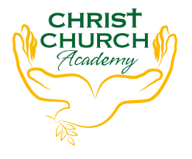
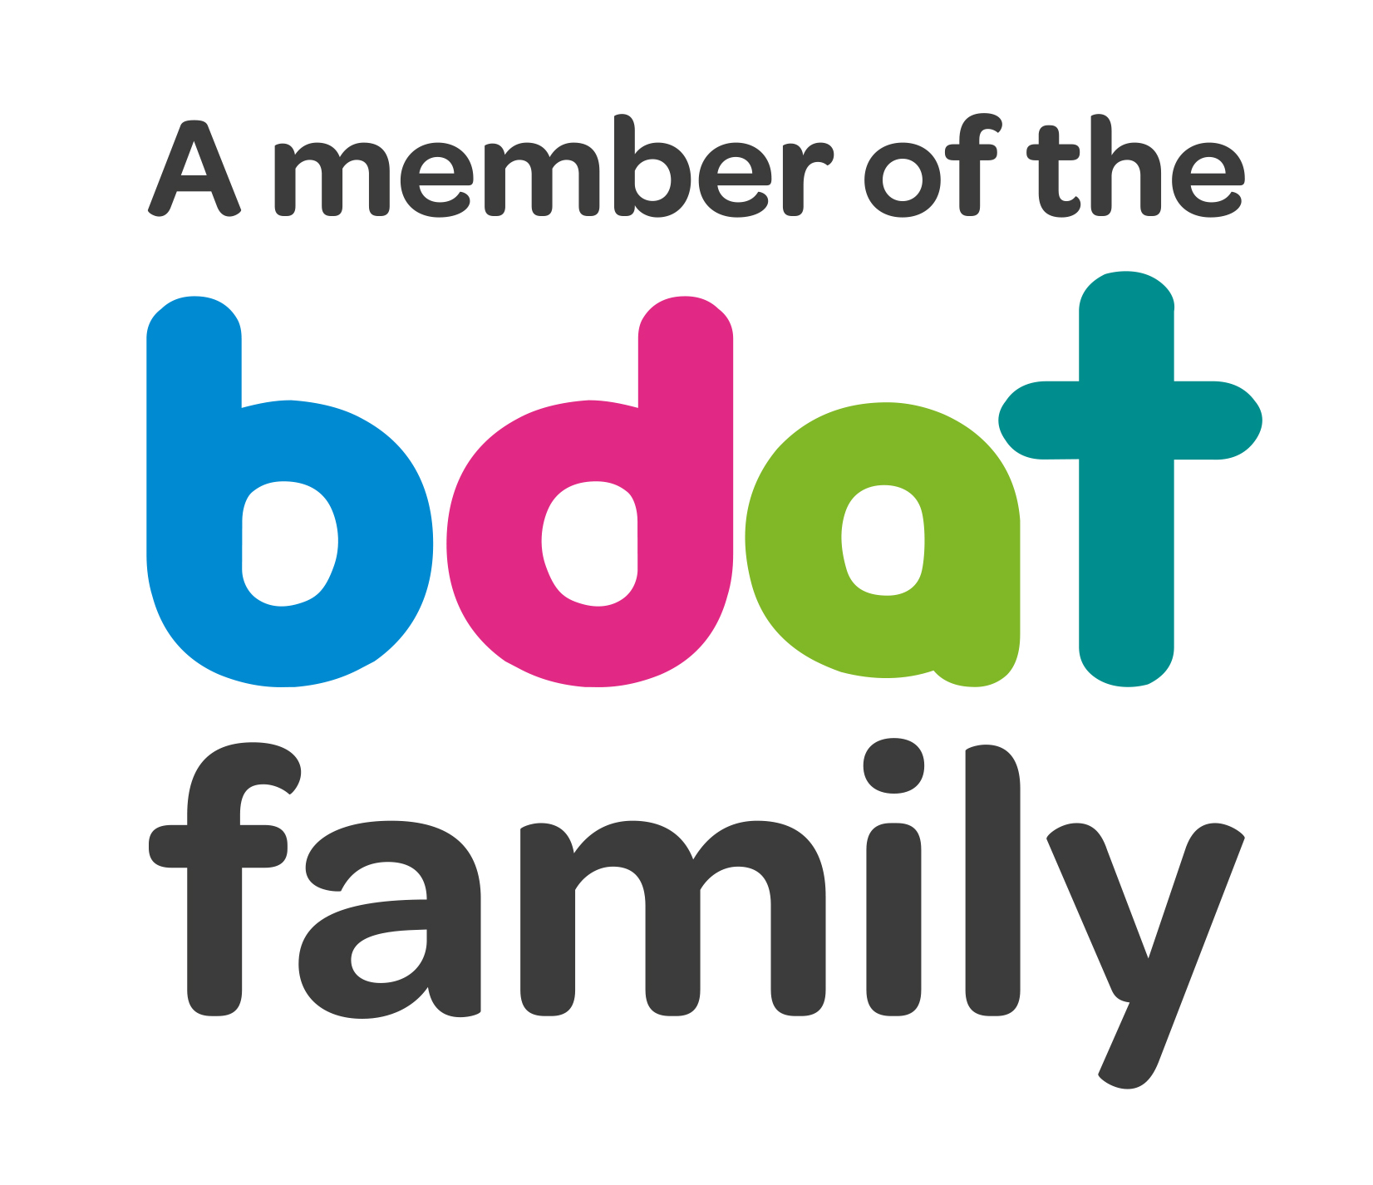
Christ Church Academy
Wrose Brow Road
Shipley
Bradford
BD18 2NT
01274 410349
admin@cca.bradford.sch.uk
Headteacher: Mrs Philippa Foster
Date: Monday 15th November 2021

Dear parents and carers,
Re: Attendance
Since our return to school in September 2021 the government has advised that school attendance is again compulsory. After so much disruption to children’s education over the past year, the most important thing is that the school and parents work together to get children back into school.
This means that unless a child has corona virus and therefore has to isolate, the usual rules on school attendance apply, including:
- parents’ duty to send their child/children to school regularly where they are of compulsory
school age;
- schools’ responsibilities to record attendance and follow up absence
- the option for local authorities to again consider the use of legal sanctions, including penalty
notices and prosecution in court.
If you are worried about your child/children attending school, the first port of call is to discuss your concerns with the school directly.
We will inform you of your child’s attendance every half term using Class Dojo. If your child’s attendance is less than 90% they are classed as a ‘Persistent Absentee’ and a separate letter will be sent to you. This is to help you keep their attendance on track.
I attach our ‘Attendance in a Nutshell’ – please take a minute to read it.
If you have any queries, please contact the school office.
Yours faithfully
Mrs. Best
Attendance Team

