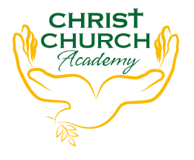
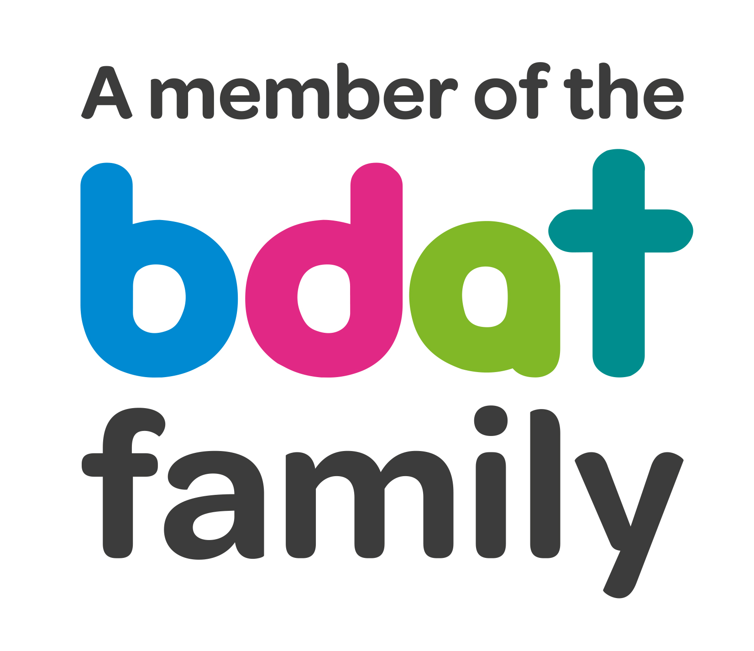
Christ Church Academy
Wrose Brow Road
Shipley
Bradford
BD18 2NT
01274 410349
admin@cca.bradford.sch.uk
Headteacher: Mrs Philippa Foster
Date: 10th November 2021

Dear Parents and Carers
Peripatetic Music Lessons September 2021
I am pleased to share the following information about the range of instrumental music lessons available in school.
We have peripatetic music teachers who visit school each week from Bradford Music and Arts service, providing lessons on a wide range of instruments.
The cost of music service lessons is £59 per term for a 20-minute small group lesson each week, or £162 per term for a 20-minute individual lesson each week. Parents are billed directly by Bradford Music and Arts service, and there is also an additional charge for instrument hire if required.
Children will receive a minimum of thirty lessons through the academic year. To apply for lessons on any of the instruments commencing September 2021, please complete the online form on the Music & Arts Service website, available at:
https://www.bradfordmusiconline.co.uk/site/music-lessons/application-form-for-lessons/
Please ensure you put down your 3 instrument choices to give you more chance of getting a lesson in September 2021.
For information on how to hire or buy an instrument, please visit:
https://www.bradfordmusiconline.co.uk/site/music-lessons/where-to-buyhire-aninstrument/
We would like to point out that most music lessons are timetabled during the school day.
Please note that there can be no guarantee of a space being available on any instrument, and therefore it is advised that you apply for lessons as soon as possible to avoid disappointment.
If your child is already learning an instrument and wishes to continue lessons, there is NO NEED to fill in a new form.
If you require more information about the different instruments, use this link:
https://www.bradfordmusiconline.co.uk/site/music-lessons/demonstration-videos/
I look forward to seeing plenty of new young musicians in the new academic year!

School Music Co-ordinator

