Key Vocabulary
Suffrage | The right to vote in political elections.
Revolt | To take violent action against an established ruler.
Civil War | A war between citizens of the same country.
Rebels | People who resist those who rule.
Divine Right | The right to rule through the will of God. Answers to no one else.
Legislation | The process of making laws
Amendment | A minor change or addition to improve a piece of legislation.
Campaign | Work in an organised way to achieve a goal.
Aftermath of the Magna Carta
Following the Magna Carta, where the barons persuaded King John to allow some freedoms, there were still some injustices which needed addressing. The Black Death, which swept through the world, paved the way for peasants to demand higher wages and end the Feudal System. People continued to push for equality, fairer justice and a fairer distribution of wealth through the Peasants’ Revolt. The invention of the new printing press in 1480 meant that those were literate had access to reading materials and scientists and philosophers could share their idea about change. Monarchy still had great power, but, when this was unjust, a civil war broke out in order to ensure that they King did not rule with absolute power. A Bill of Rights was subsequently introduced to allow MPs to speak freely in Parliament without fear of punishment. This paved the way for the Representation of the People Act which allowed some men the right to vote. The Suffrage Movement addressed the fact that women were banned from voting. Amendments were made until all women and men over 18 were allowed to vote.

Year 5 knowledge organiser – How have people come together to change our country? Spring term.

The Black Death
1348-1350

Modern activism
20th Century- now

Parliament Act
1911

Bill of Rights
1689

Printing Press Invented
1480

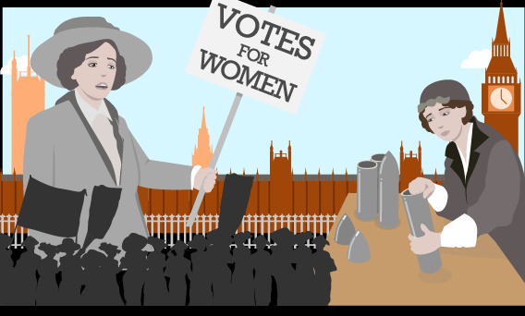
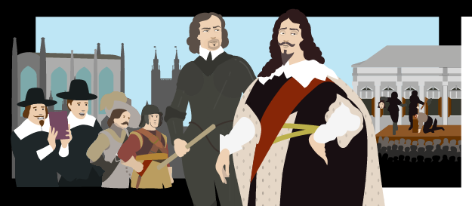
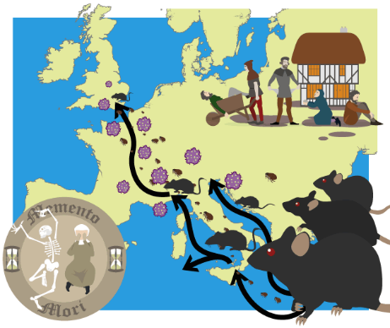
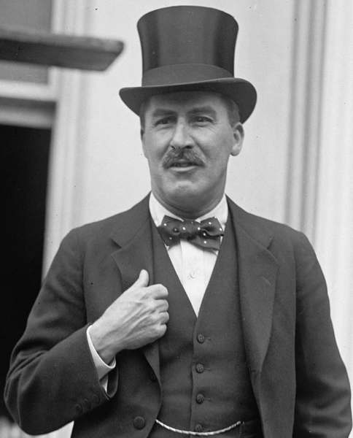
The campaign for women’s suffrage.

Charles I and the Civil War

Spread of the Black Death and Peasants’ Revolt

Suffragette Movement
20th Century

Representation of the People Act 1832
1679

Civil War
1642-1651

The Peasants’ Revolt
1381

