
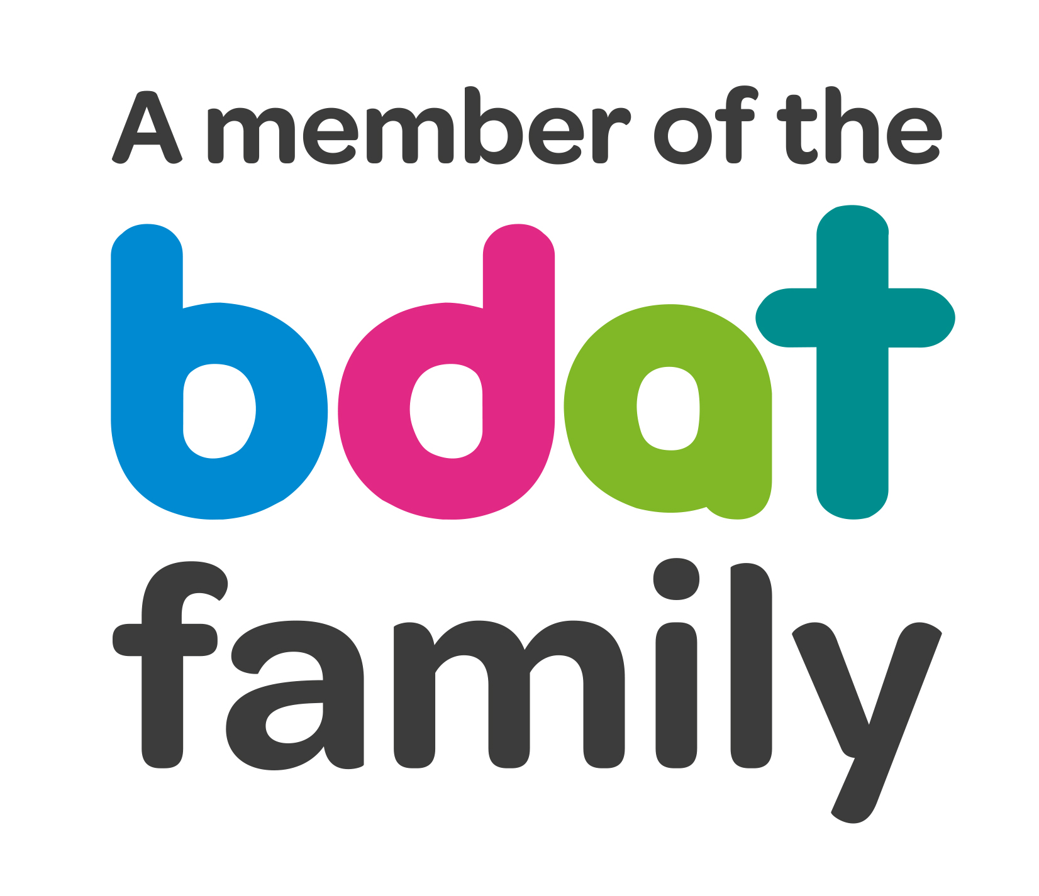
Christ Church Academy
Wrose Brow Road
Shipley
Bradford
BD18 2NT
01274 410349
admin@cca.bradford.sch.uk
Headteacher: Mrs Philippa Foster
Date: Wednesday 12th January 2022

Dear parents/carers,

We are delighted to offer two after-school clubs this half term. They are fun rugby activities with a coach from Bradford Bulls; and football with Anna, who already comes to school every lunch time for KS2.

Football is open to girls and boys from Years 4, 5 and 6, and is every Friday starting 14th January.

Rugby is open to girls and boys in Reception, Years 1, 2 and 3, and is every Tuesday starting 18th January.

Please complete and return the form if you would like your child to attend. The clubs are free and run from 3:10pm until 4:15pm. Children must be collected promptly at 4:15pm from the school hall.

Places are limited and will be allocated on a first come first served basis, and priority is given to children who have not attended previously. Please return this form by Thursday 13th January. You will receive an email if your child has a place in the club.

……………………………………………………………………………………………………………………………………………………………………….

FOOTBALL - give permission for my child to attend the football after school club for Years 4-6.

Childs name……………………………………………………………………….Year……………………………………………………….

Signed……………………………………………………………………………… Name……………………………………………………….

Emergency contact number……………………………………………………..

Year 6 will be allowed to walk home alone – if you want your child to walk home please tick here

……………………………………………………………………………………………………………………………………………………………………

RUGBY- I give permission for my child to attend the fun rugby activities after school club for Years R-3.

Childs name……………………………………………………………………….Year……………………………………………………….

Signed……………………………………………………………………………… Name……………………………………………………….

Emergency contact number……………………………………………………..

