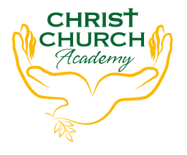
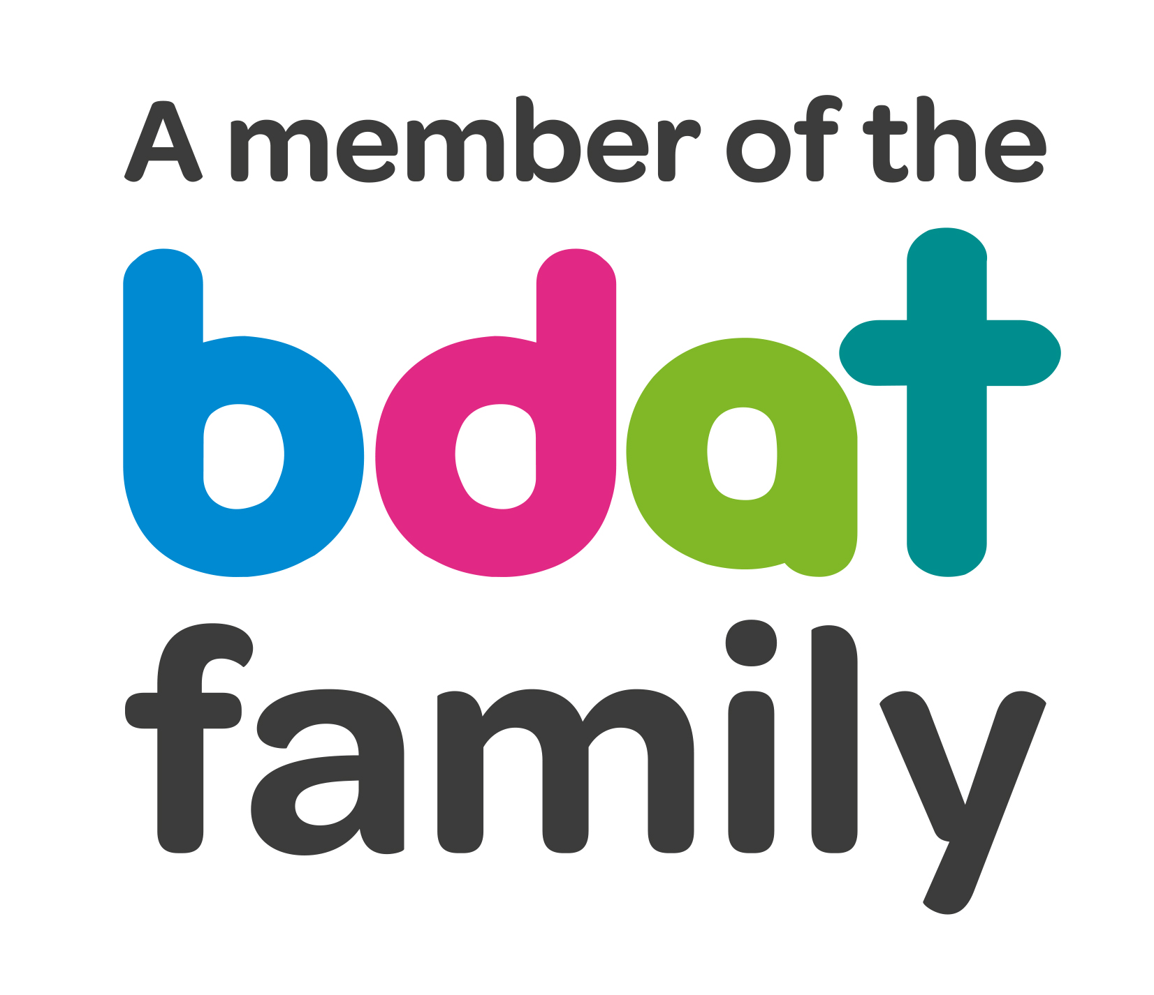
Christ Church Academy
Wrose Brow Road
Shipley
Bradford
BD18 2NT
01274 410349
admin@cca.bdat-academies.org
Headteacher: Mrs Philippa Foster

Date: Thursday 17th February 2022

Dear parents and carers,

YEAR 6 TRIP TO THE LION KING, BRADFORD ALHAMBRA
– WEDNESDAY 18TH MAY 2022

Miss Clarke would like to take Year 6 to Bradford Alhambra to see The Lion King. This is a post-SATs treat and is linked to Year 6 lessons on ‘Hamlet’.

The trip is heavily subsidised and will cost £12 per child. This price includes train travel and the theatre ticket. The children are also fundraising to pay for part of the trip, and the PSA is funding half of the cost.

Children should arrive at school at 8:50am as normal. After lunch Miss Clarke and staff will take the children on the train to Bradford and the Alhambra theatre. They will return to school sometime after 5pm, but we will advise the time at a later date.

- Please pay £12 on Parent Pay. You can pay in instalments if you prefer, as long as the full amount is paid by Tuesday 17th May. If you are experiencing any difficulties in paying, particularly if your child receives pupil premium, please get in touch with the school office.

- Please ensure you log onto Parentpay this week to give your consent for your child to attend.

- School uniform (and a coat) must be worn.

If you have any queries, please contact the school office.

Yours sincerely,

Mrs P. Foster
Head Teacher

