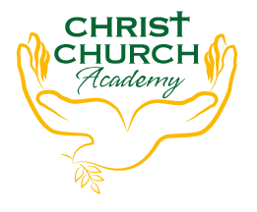
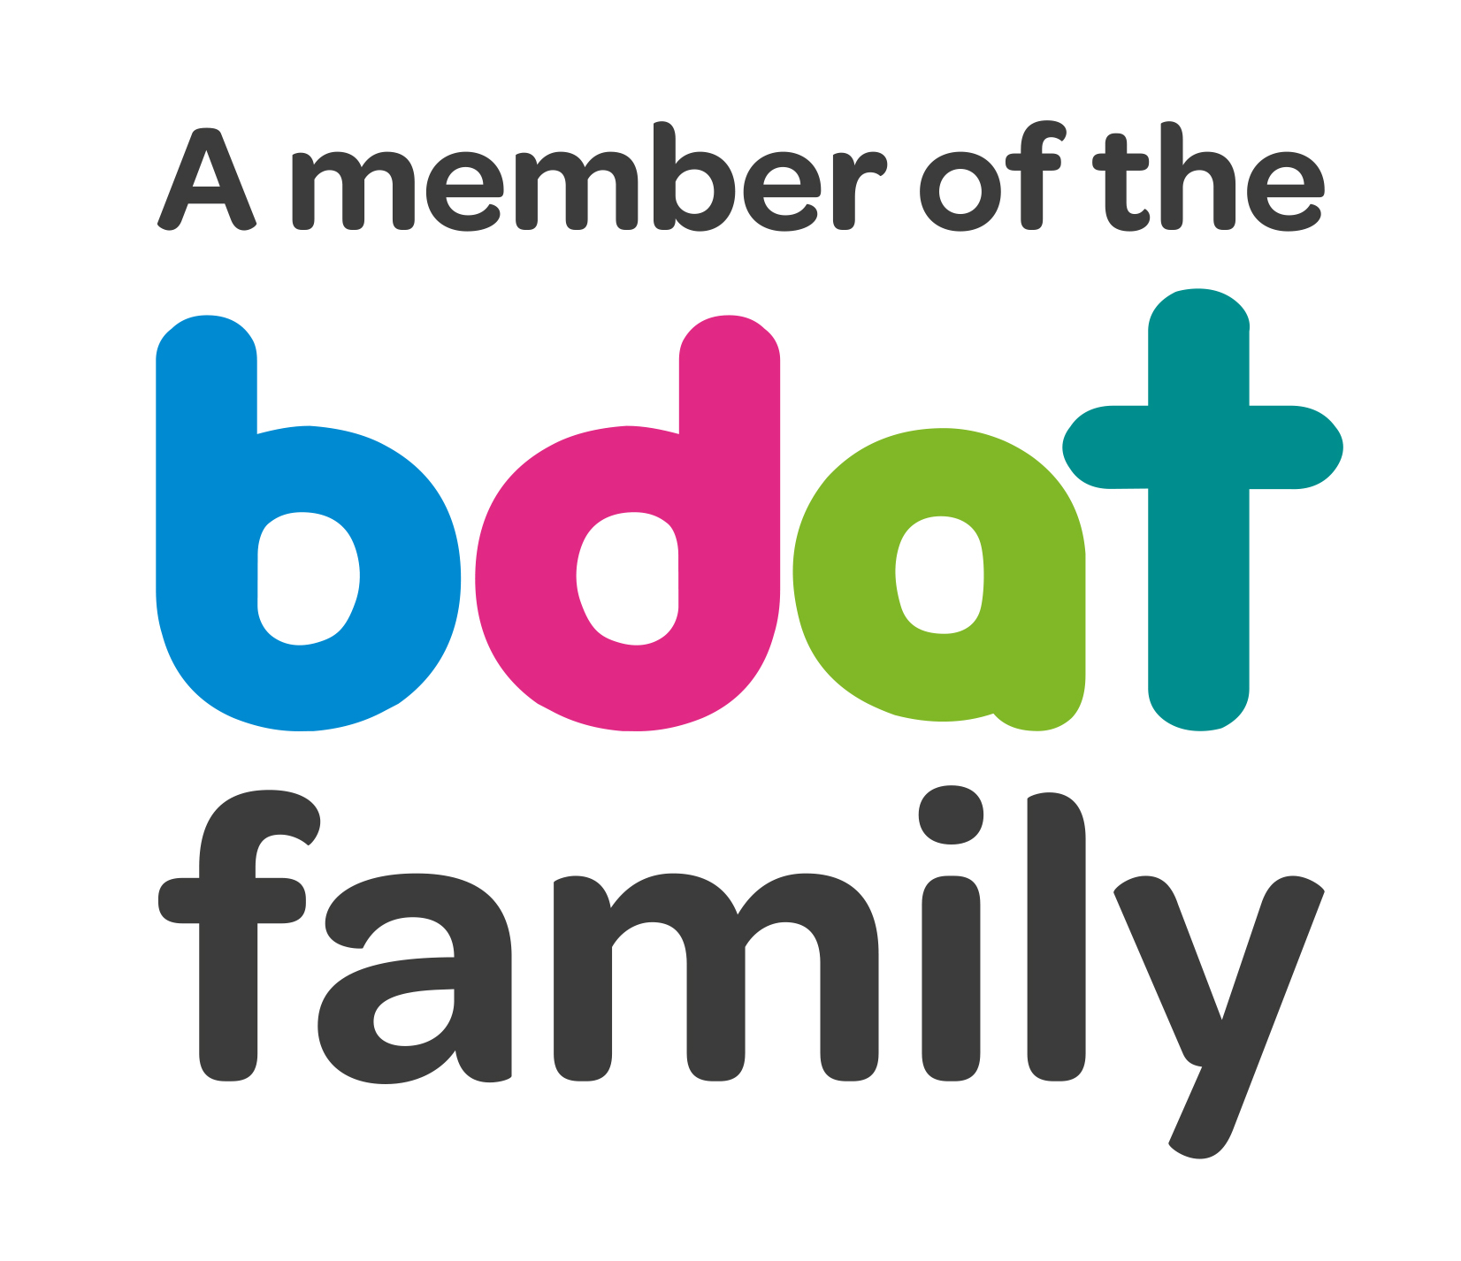
Christ Church Academy
Wrose Brow Road
Shipley
Bradford
BD18 2NT
01274 410349
admin@cca.bradford.sch.uk
Headteacher: Mrs Philippa Foster
Date: Thursday 3rd March 2022

Dear parents/carers,

AFTER SCHOOL CLUBS – PLEASE READ CAREFULLY

We are delighted to offer several after-school clubs this half term. They start next week, commencing Monday 7th March 2022 and end on Friday 8th April.

Prices and times are shown below. Children must be collected promptly from the school hall, except for Cook and Eat which is in the bungalow.

Please tick the box indicating which club your child would like to attend and return this form asap. Places are limited and will be allocated on a first come first served basis, but priority is given to children who have not attended previously.

You will receive an email if your child has a place in the club.

Mondays  Film Club ‘til 5pm  Reception to Year 6  £5 – (for the half term) pay on ParentPay this weekend | Tuesdays  Choir ‘til 4:15pm  Year 3 to Year 6  Free | Thursdays  Cook and Eat ‘til 4:15pm  (in bungalow)  Year 1 to Year 6  Free | Fridays  Girls football ‘til 4:15pm  Year 3 to Year 6  Free

I give permission for my child to attend the club ticked above.

Childs name……………………………………………………………………….Year……………………………………………………….

Signed……………………………………………………………………………… Name……………………………………………………….

Emergency contact number……………………………………………………..

Year 6 will be allowed to walk home alone – if you want your Y6 child to walk home please tick here

