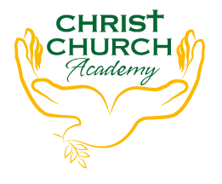
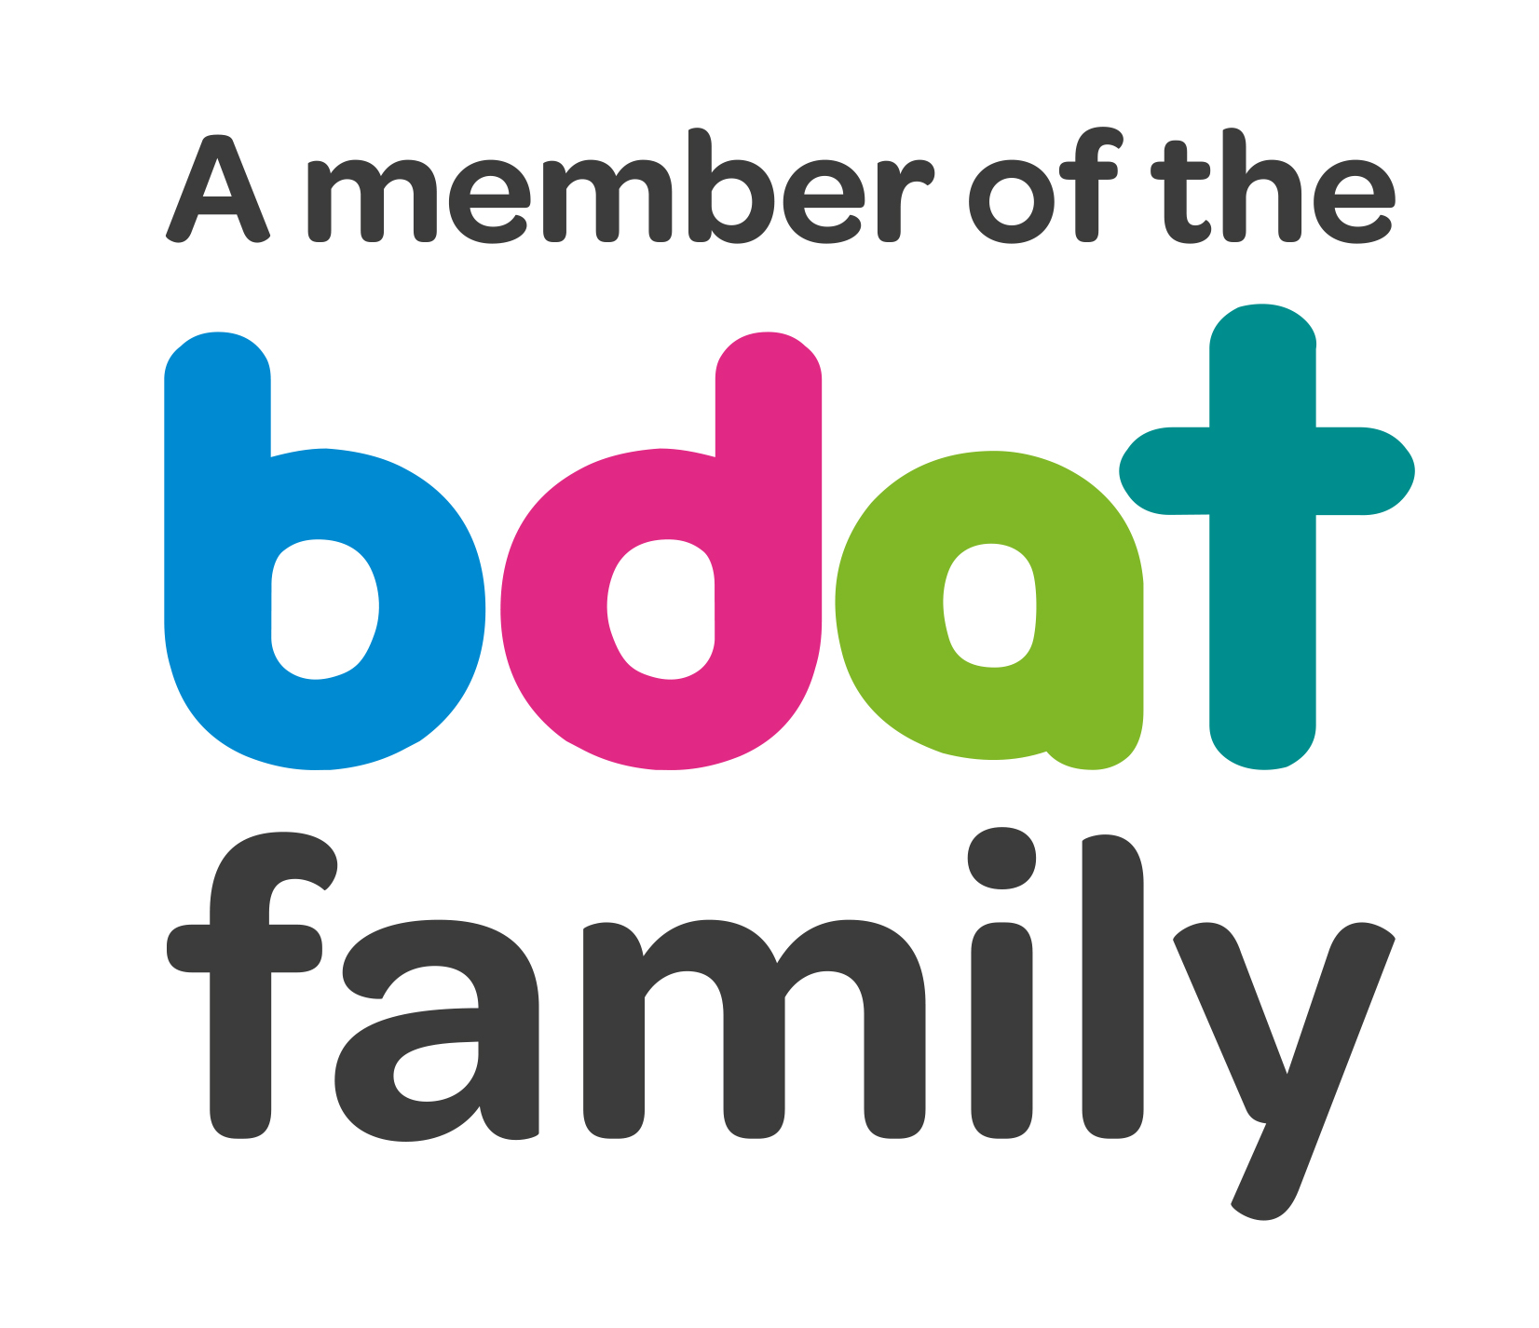
Christ Church Academy
Wrose Brow Road
Shipley
Bradford
BD18 2NT
01274 410349
admin@cca.bdat-academies.org
Headteacher: Mrs Philippa Foster

Date: 25th March 2022

YEAR 6/4 EDUCATIONAL VISIT – Country Trust North Yorkshire 6th until 8th July 2022

We are delighted to be able to offer, once again, a residential visit to North Yorkshire sponsored and supported by The Country Trust. This year we are inviting Year 6 and Year 4, with Year 6 taking priority.

This trip is heavily subsidised both by the County Trust and School and we have managed to keep the cost the same as previous years. The cost will be £100 per child. This price includes all travel, accommodation and food, three days activities including pony trekking, trout fishing, and visiting White Scar caves.

This visit will take place from the morning of Wednesday 6th July until the afternoon of Friday 8th July 2022. Full details will be available in due course; however, we have attached a kit list to this letter to enable you to see what is required for the residential.

As we need to finalise arrangements, we need to know who is interested in this visit. We do only have a limited number of spaces so please return the slip below by Friday 8th April 2022 to express your interest. Spaces will be allocated by first come first served basis. If trip is oversubscribed, we will pick names at random.

Yours sincerely,

Mrs P. Foster
Head Teacher
----------------------------------------------------------------------------------------------------------------------------------------------

I would like my child……………………………………………………………………..to be considered to visit North Yorkshire from 6th till 8th July 2022.

Signed………………………………………………………………Parent / Carer

Date…………………………………………………………………

