
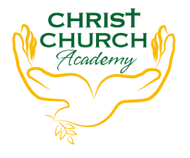
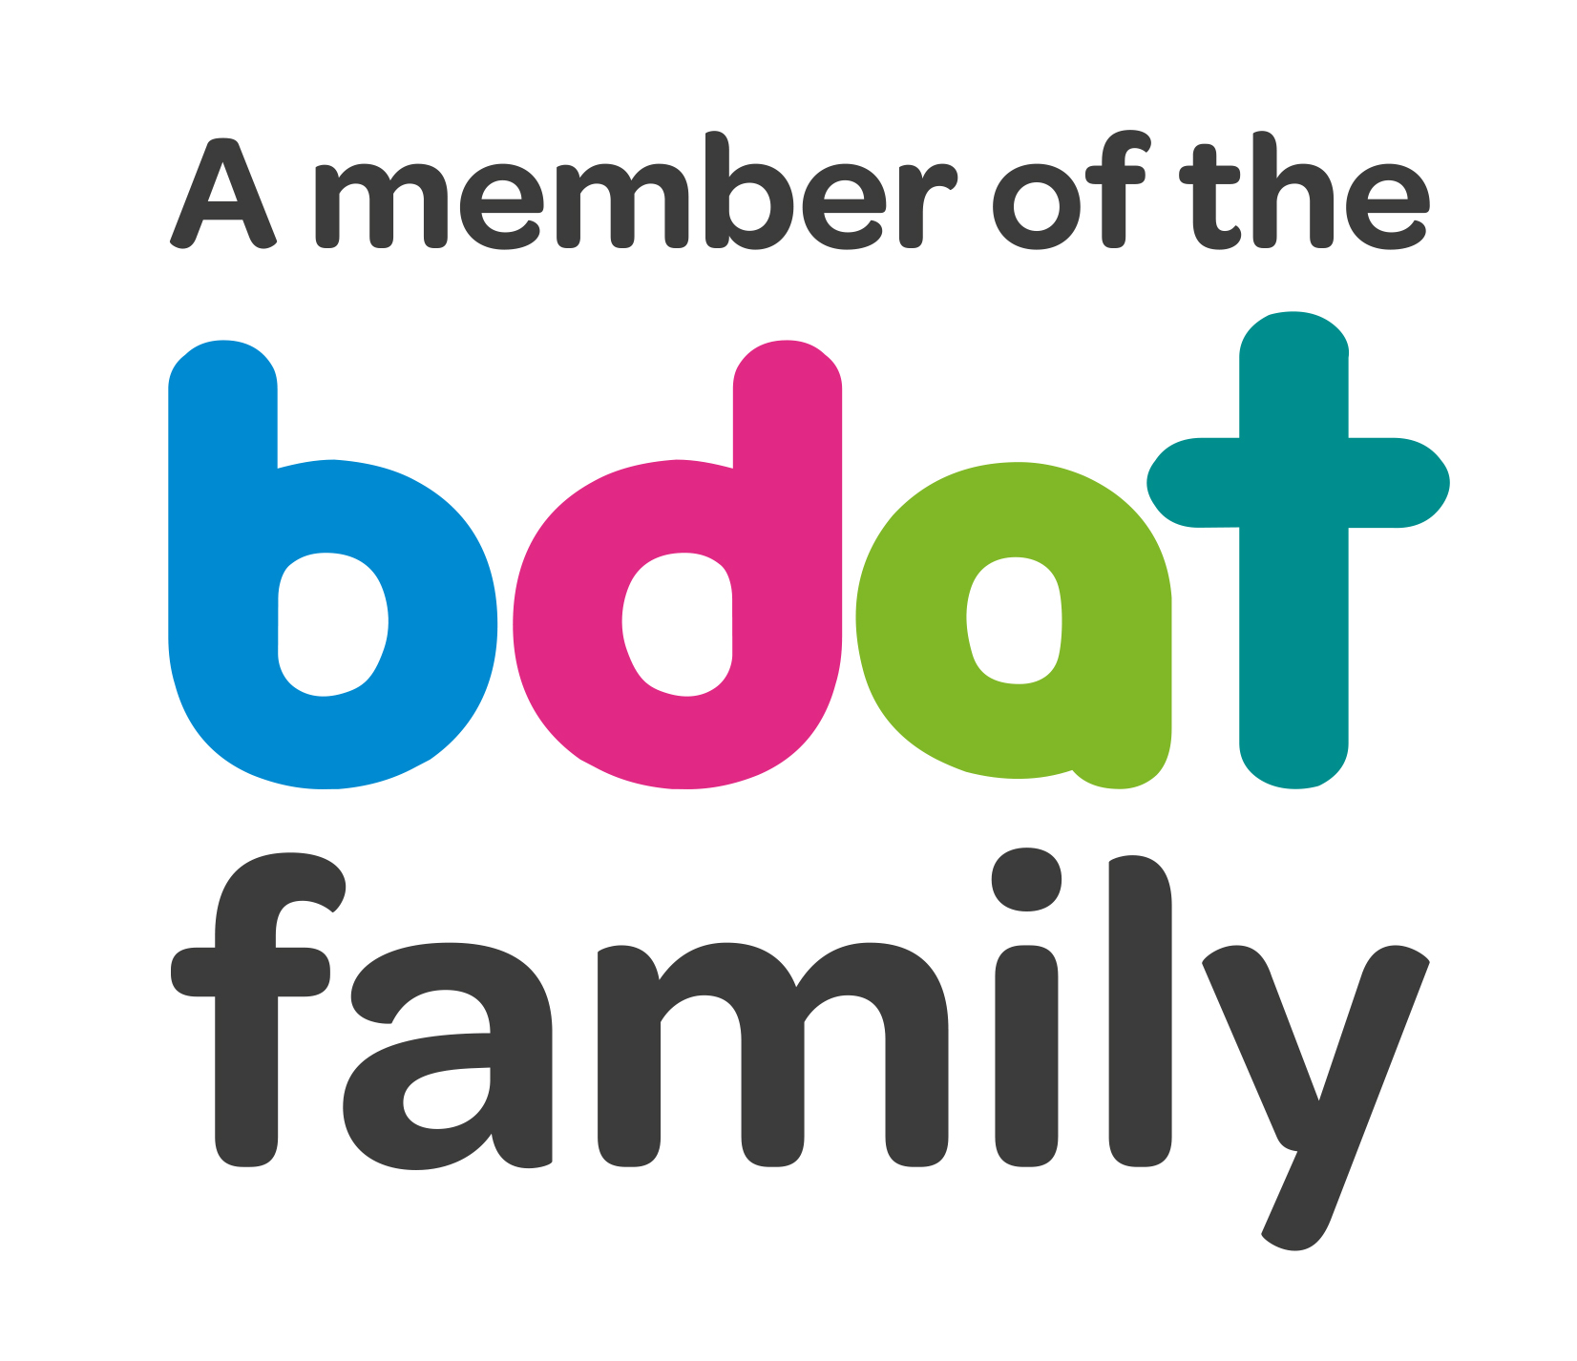
Christ Church Academy
Wrose Brow Road
Shipley
Bradford
BD18 2NT
01274 410349
admin@cca.bdat-academies.org
Headteacher: Mrs Philippa Foster

Date: Wednesday 9th March 2021

Dear Parent/Carer,

Comic Relief Red Nose Day – Friday 18th March

We are looking forward to Red Nose Day which is taking place on Friday 18th March this year. Children can come to school either dressed as a superhero or simply in non-uniform - for a donation of £1 for Comic Relief. All money raised will go directly to Comic Relief.

Please DO NOT donate via your ParentPay account. Simply click on the following link https://app.parentpay.com/ParentPayShop/Foc/Default.aspx?shopid=6156

A limited number of red noses are on sale in school office now and cost £1.50 each. Please bring exact change of £1.50 per nose.

Thanks in advance for your generosity.

Yours Sincerely,

Carole Nightingale
Learning Mentor

