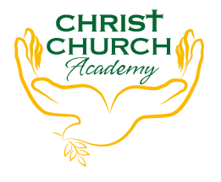
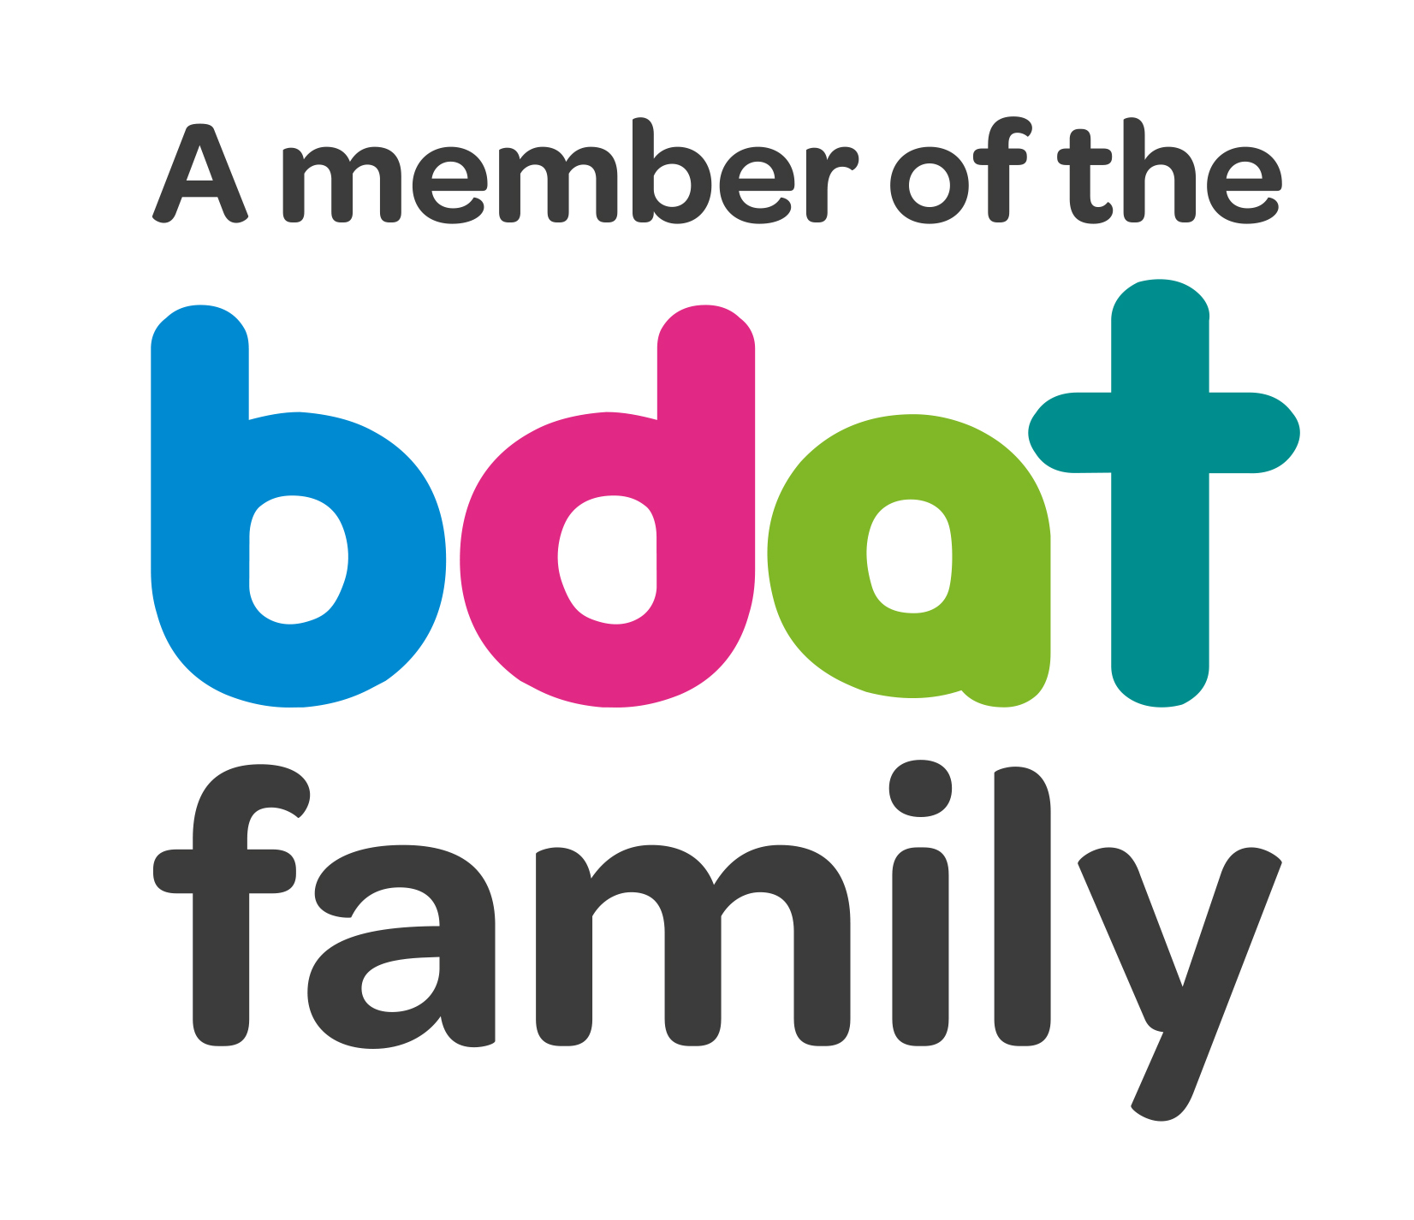
Christ Church Academy
Wrose Brow Road
Shipley
Bradford
BD18 2NT
01274 410349
admin@cca.bradford.sch.uk
Headteacher: Mrs Philippa Foster

Date: Wednesday 27th April 2022

YEAR 4 TRIP TO MEDIA MUSEUM, BRADFORD
– THURSDAY 19TH MAY

As part of Year 4 Science Mr Dow would like to take the children to Bradford Media Museum to see ‘Bring the Thunder’ and visit the Wonderlab.

To keep costs to a minimum, and due to the escalating cost of coach travel, children will be taken to Bradford on the train. The trip will cost just £2 per child.

Children should arrive at school no later than 8:50am and can be collected at the usual time of 3:10pm.

- Please pay £2 on Parent Pay by Wednesday 18th May. If you are experiencing any difficulties in paying, particularly if your child receives pupil premium, please get in touch with the school office.

- Please ensure you log onto Parentpay this week to give your consent for your child to attend.

- Please provide a packed lunch for your child. If your child is in receipt of free school meals, school will provide a packed lunch.

- School uniform (and a coat) must be worn.

If you have any queries, please contact the school office.

Yours sincerely,

Mrs P. Foster
Head Teacher

