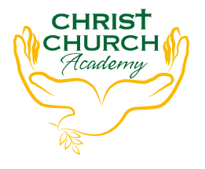
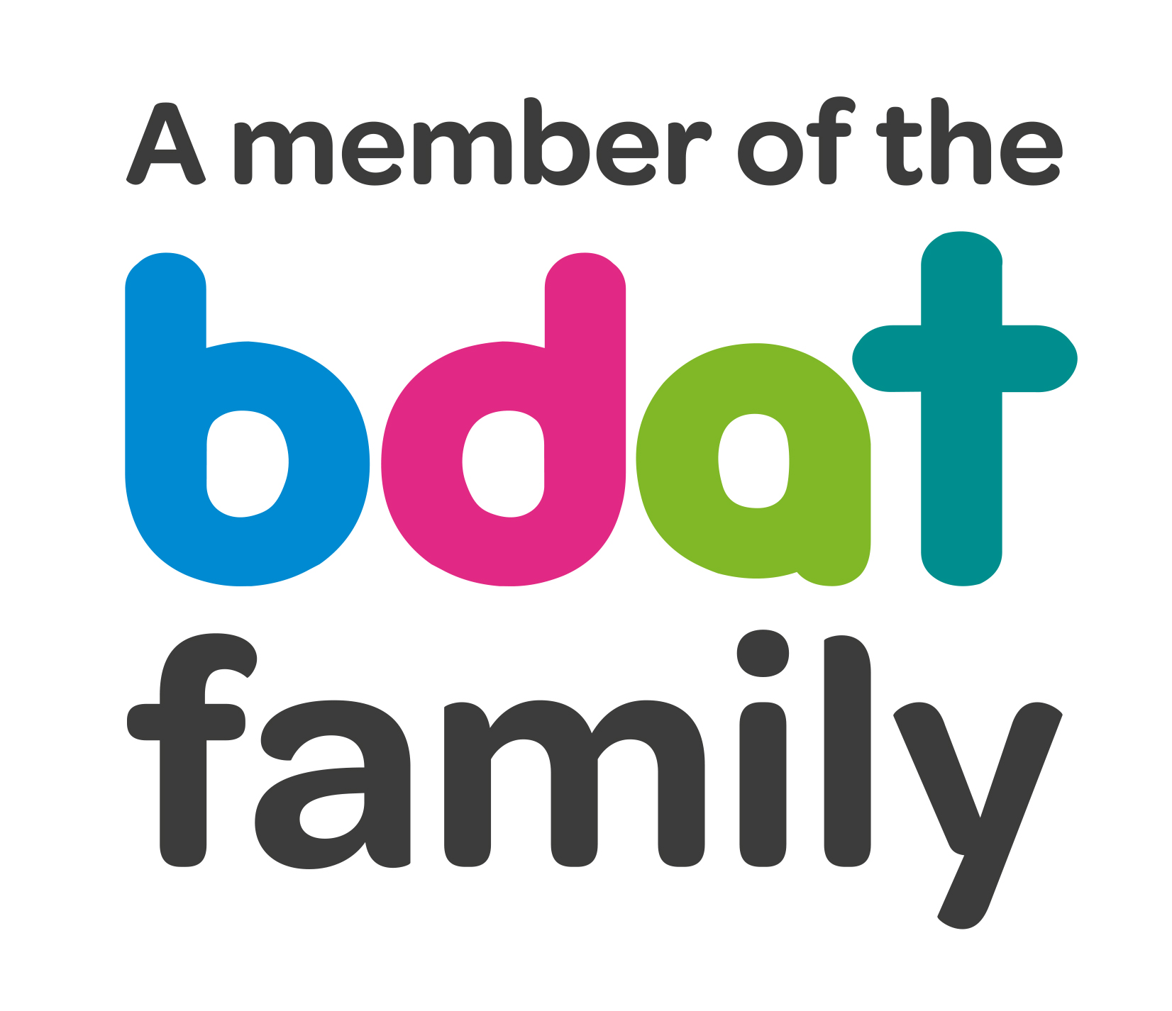
Christ Church Academy
Wrose Brow Road
Shipley
Bradford
BD18 2NT
01274 410349
admin@cca.bradford.sch.uk
Headteacher: Mrs Philippa Foster

Date: 27th April 2022

YEAR 4 TRIP TO WHITE SCAR CAVES AND WENSLEYDALE CREAMERY
– WEDNESDAY 6TH JULY 2022

As part of school’s annual trip to Yorkshire dales we would like all Year 4 children to enjoy a day trip to White Scar Caves and Wensleydale Creamery.

The trip will cost £15 per child. This price includes a train ticket to Ribblehead, entry to the caves and creamery, and coach travel back to school at end of the day.

Children should arrive at school no later than 8:50am and can be collected from school at 4.30pm.

- Please pay £15 on Parent Pay. You can pay in instalments if you prefer, as long as the full amount is paid by Friday 1st July. If you are experiencing any difficulties in paying, particularly if your child receives pupil premium, please get in touch with the school office.

- Please ensure you log onto ParentPay this week to give your consent for your child to attend.

- Please provide a packed lunch for your child. If your child is in receipt of free school meals, school will provide a packed lunch.

- Children should wear comfortable clothes suitable for the weather, sturdy footwear and bring a raincoat. Depending on the weather please provide sunhat and sun cream if necessary.

If you have any queries, please contact Mr Dow or the school office.

Yours sincerely,

Mrs P. Foster
Head Teacher

