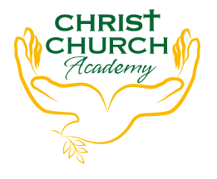
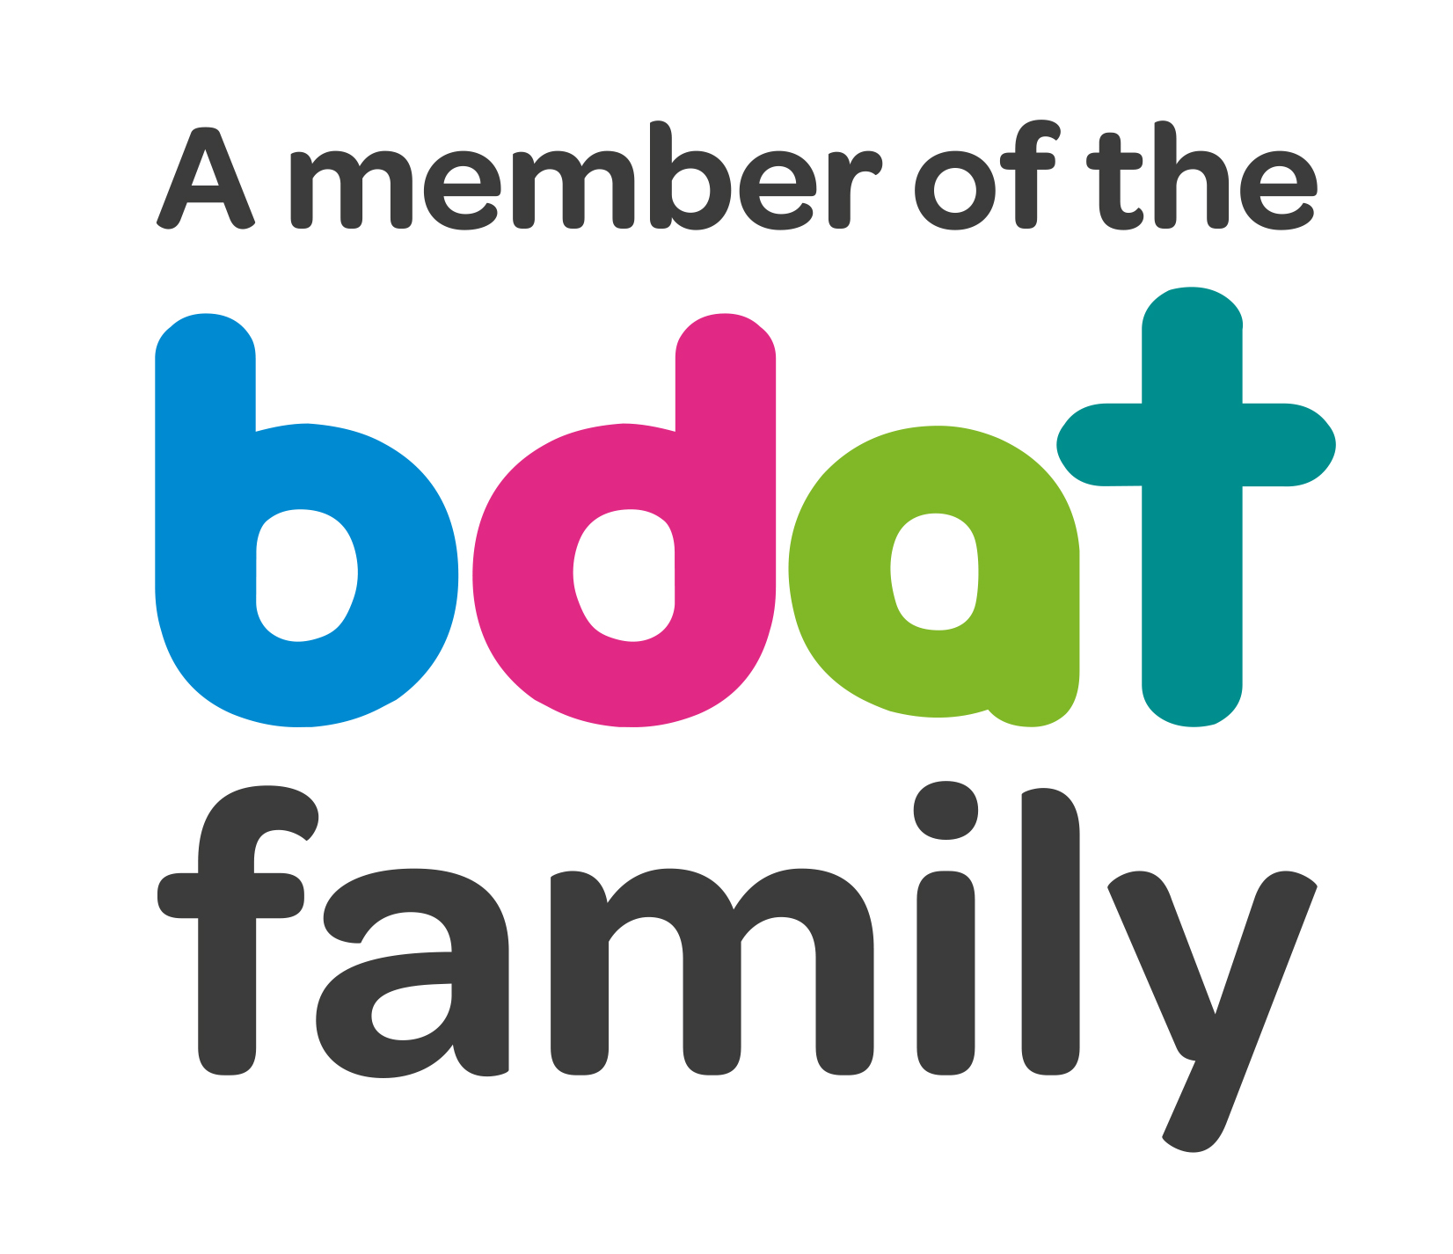
Christ Church Academy
Wrose Brow Road
Shipley
Bradford
BD18 2NT
01274 410349
admin@cca.bdat-academies.org
Headteacher: Mrs Philippa Foster

Date: 27th April 2022

YEAR 4 EDUCATIONAL VISIT – Country Trust North Yorkshire 6th until 8th July 2022

We are delighted to be able to offer, once again, a residential visit to North Yorkshire sponsored and supported by The Country Trust. You have shown an interest in this trip, and I am happy to inform you that your child has secured place.

This trip is heavily subsidised both by the County Trust and School and we have managed to keep the cost the same as previous years. The cost will be £100 per child. This price includes all travel, accommodation, three days activities including pony trekking, trout fishing, and visiting White Scar caves.

Please note that you are required to provide a packed lunch for the first day. If your child is in receipt of FSM school will provide packed lunch.

This visit will take place from the morning of Wednesday 6th July until the afternoon of Friday 8th July 2022. We have attached itinerary and a kit list to enable you to see what is required for the residential.

Please pay deposit of £10 via ParentPay by 6th May 2022.

We have set up a payment plan via ParentPay or you can pay the full amount on ParentPay if you prefer.

Yours sincerely,

Mrs P. Foster
Head Teacher

