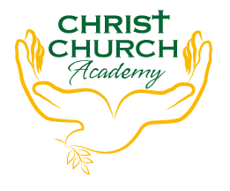
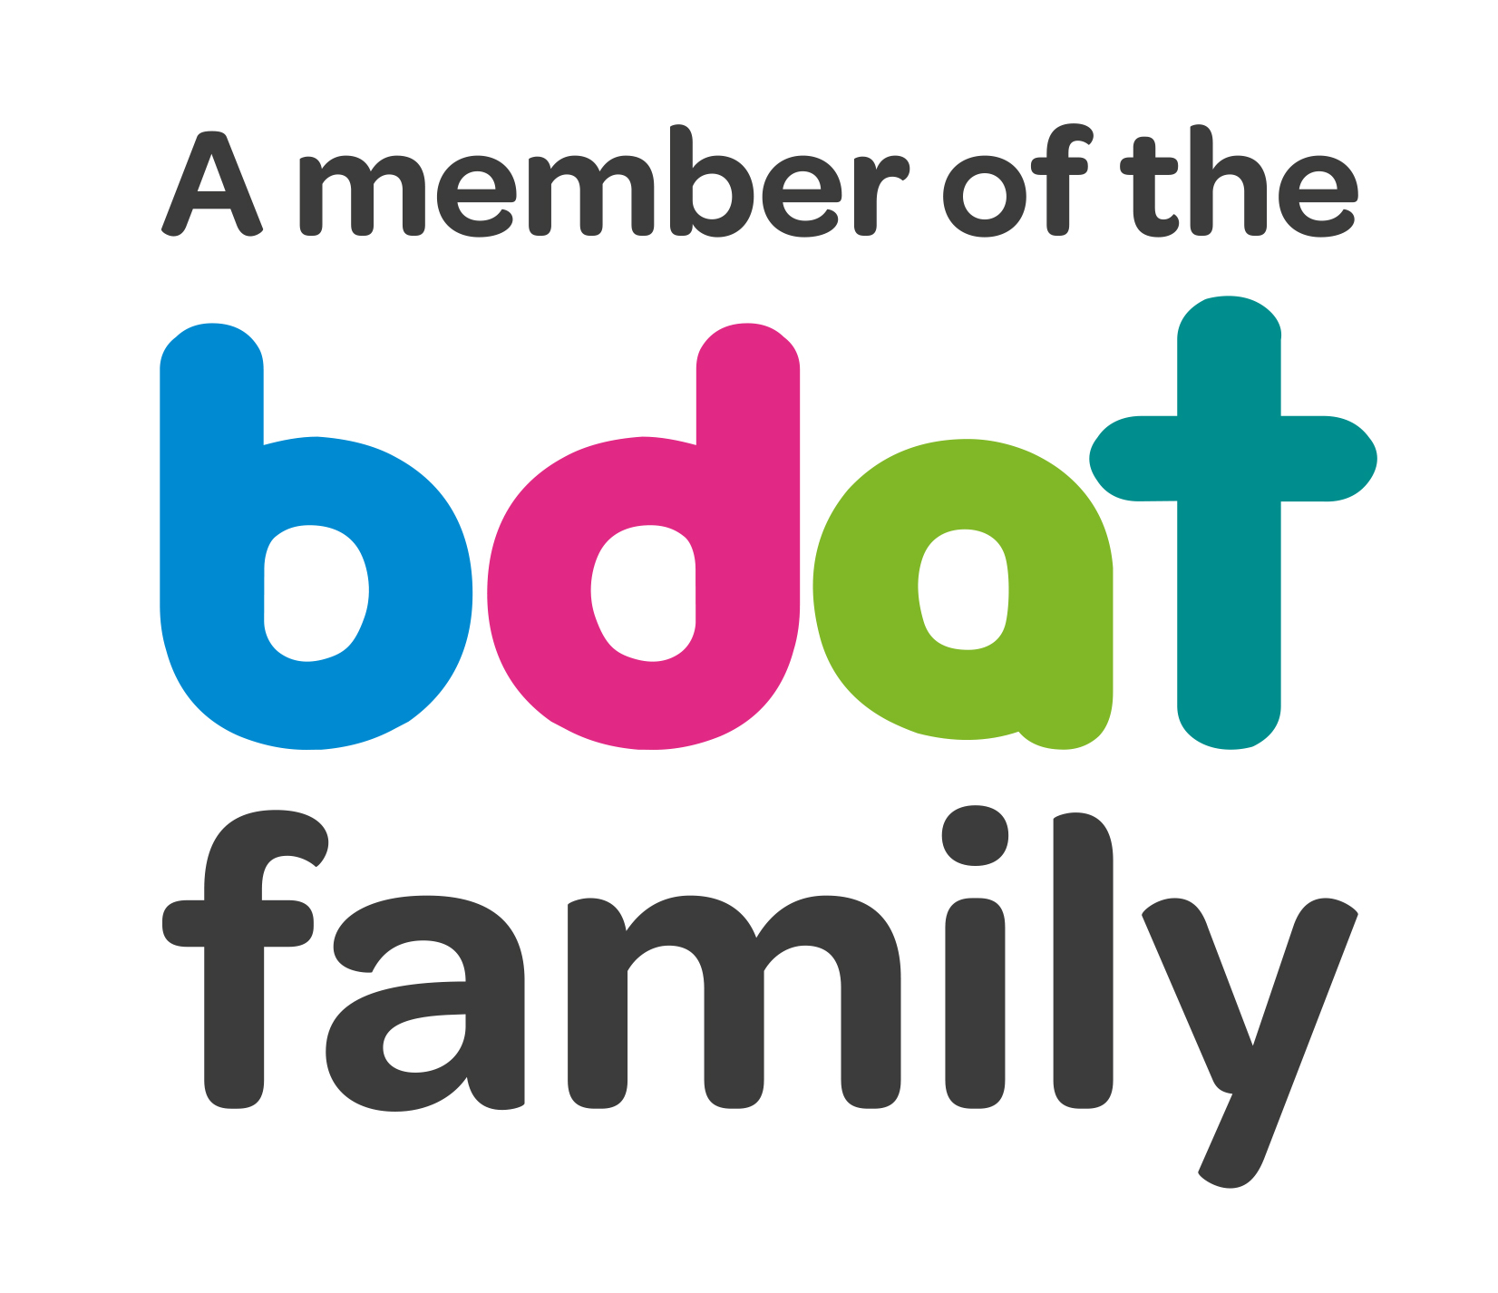
Christ Church Academy
Wrose Brow Road
Shipley
Bradford
BD18 2NT
01274 410349
admin@cca.bradford.sch.uk
Headteacher: Mrs Philippa Foster
Date: 30th June 2022

Dear parents and carers,

SPORTS DAY

This year we can hold Sports day on the field between school and the community centre. It will be held on Thursday 14th July 2022, weather permitting. Parents are welcome to join us to watch the events.

Below are the timings for the day and the events the children will be taking part in:

Start: 9:30am
Break for picnic lunch: 11:45am-1pm
(The children will return to school to eat their lunch and use the toilets)
Event end: 2.30pm
Children return to school and collect belongings before going home at 3:10pm

Events taking place:
- 100M Sprint
- 3 x throwing events (ie discus)
- Egg and spoon race
- Three-legged race
- Sponge relay
- Sack race
- Teachers race
- Parents race
- Wheelbarrow race

This year we will take part in events in four teams (Red, Blue, Green and White). We are asking that children wear a t-shirt of their teams colour for the day.

Your child is in team ………………………………..

Please ensure your child comes to school with a water bottle and if it is likely to be a warm day, a sunhat and sun cream, as we will be down on the field area for long periods of time.

If you have any questions don’t hesitate to contact us.

Yours faithfully,

Amy Conroy
Assistant Headteacher

