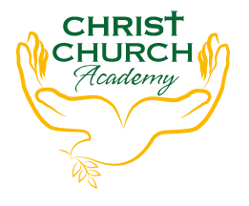

Christ Church Academy
Wrose Brow Road
Shipley
Bradford
BD18 2NT
01274 410349
admin@cca.bdat-academies.org
Headteacher: Mrs Philippa Foster

Date: Friday 1st July 2022

Dear Parents,
On Tuesday 5th July we will be having our moving up morning. This is an opportunity for children to meet their new class teacher and start to get to know them.
After school there will be a ‘meet the teacher’ evening. Teachers will give a short presentation and will be available to answer any questions you might have about next year.
We have staggered the timings for the presentations so that parents can attend for children in different year groups. Timings are as follows:
3.20 – 3.30 | Year 1 Mrs Gallagher
3.30 – 3.40 | Year 2 Mrs Martin
3.40 – 3.50 | Year 3 Mr Dow
3.50-4.00 | Year 4 Mrs Parker
4.00 – 4.10 | Year 5 Miss Robertson
4.10 -4.20 | Year 6 Miss Clarke

Reports will also go home on Tuesday and your child’s current class teacher will be available that evening to meet with you if you would like to discuss anything about your child’s report.
This year we will be saying goodbye to Mrs Goodall who will be retiring, Miss Lea who will be taking up a part time role at a Harrogate school and using her non-teaching time to concentrate on her career as an artist; and Miss Outram who will be traveling to Australia. I’m sure you join with me in thanking them for their tremendous contribution to our school over the years and wishing them well in their next chapters.
Yours faithfully,

Mrs. P. Foster
Headteacher

