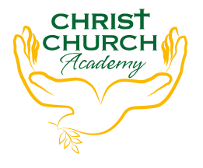
Christ Church Academy
Wrose Brow Road
Shipley
Bradford
BD18 2NT
01274 410349
admin@cca.bradford.sch.uk
Headteacher: Mrs Philippa Foster

Date: 30th June 2022

Dear parents and carers,

SPORTS DAY

Nursery and Reception Sports day will be held on the morning of Friday 15th July 2022 from 9:30am.
Parents are welcome to join us to watch the events.

Events taking place:
- Sprint
- Throwing events
- Egg and spoon race
- Three-legged race
- Sponge relay
- Sack race
- Parents race
- Wheelbarrow race

This year we will take part in events in four teams (Red, Blue, Green and White). We are asking that children wear a t-shirt of their teams colour for the day.

Your child is in team ………………………………..

Please ensure your child comes to school with a water bottle and if it is likely to be a warm day, a sunhat and sun cream, as we will be down on the playground for long periods of time.

If you have any questions please contact us.

Yours faithfully,

Amy Conroy
Assistant Headteacher

